Physical Education (J587) |  |  |  |  |  |  |  |  |  | Duration: 60 mins
  Please note that you may see slight differences between this paper and the original.
  Candidates answer on the Question paper.
  OCR supplied materials:
  Additional resources may be supplied with this paper.
  Other materials required:
  - Pencil
  - Ruler (cm/mm)
Candidate forename |  |  |  |  |  |  | Candidate surname
Centre number |  |  |  |  |  |  | Candidate number
INSTRUCTIONS TO CANDIDATES
- Write your name, centre number and candidate number in the boxes above. Please write clearly and in capital letters.
- Use black ink. HB pencil may be used for graphs and diagrams only.
- Answer all the questions, unless your teacher tells you otherwise.
- Read each question carefully. Make sure you know what you have to do before starting your answer.
- Where space is provided below the question, please write your answer there.
- You may use additional paper, or a specific Answer sheet if one is provided, but you must clearly show your candidate number, centre number and question number(s).
INFORMATION FOR CANDIDATES
- The quality of written communication is assessed in questions marked with either a pencil or an asterisk. In History and Geography a Quality of extended response question is marked with an asterisk, while a pencil is used for questions in which Spelling, punctuation and grammar and the use of specialist terminology is assessed.
- The number of marks is given in brackets [ ] at the end of each question or part question.
- The total number of marks for this paper is 60.
- The total number of marks may take into account some 'either/or' question choices.

1 Which one of the following describes the correct pathway of air through the respiratory system?
Put a tick (✓) in the box next to the correct answer.
A Mouth, trachea, bronchiole, bronchi, alveoli 
B Nose, trachea, bronchi, bronchiole, alveoli
- Mouth, trachea, alveoli, bronchi, bronchiole
- Nose, bronchi, bronchiole, trachea, alveoli
2(a) | State the function of valves in the heart.  ………………………………………………………………………………………………………………………………. | [1]
(b) | The bicuspid and tricuspid valves are structures in the heart.  Name one other valve in the heart. (1 mark)
[1]

- Flexion and extension are two types of movement which are involved to allow circumduction around a joint.
Name the other three movements needed for circumduction around a joint to occur.
1.

2.

3.

[1]
- Define stroke volume.

[1]

5(a) Describe capillarisation.

[1]

(b) Capillarisation is a short term effect of exercise.
Is this statement true or false? Draw a circle around your answer.

True False

[1] 6(a) Fig. 1 shows a footballer after they have kicked a ball.
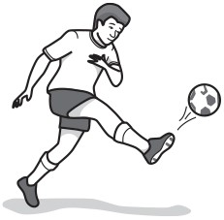
Fig. 1
Name one agonist and one antagonistic muscle acting at the knee when performing the action in Fig. 1.
- Agonist: [1]

(b) Antagonist: [1]

7. Muscular hypertrophy is a disease in which a performer loses strength.
Is this statement true or false? Draw a circle around your answer.
True False
[1]
- Which one of the following states the correct names for the two bones in the lower leg?
Put a tick (✓) in the box next to the correct answer.
  - Tibia and Fibia
  - Tibula and Fibia
  - Tibia and Fibula
  - Tibula and Fibula
[1]
- Other than the ribs, name a bone that protects the heart and lungs when controlling the ball with your chest in football.

[1]

10 Describe the function of the intercostal muscles during inspiration. (1 mark)

- Fig. 2 shows a diagram of the heart.
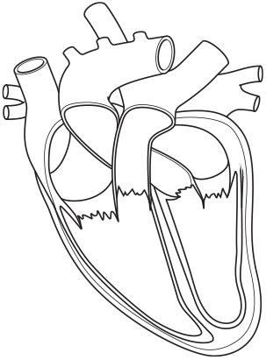
Fig. 2
Using Fig. 2, draw an X to indicate the location of one of the semilunar valves. [1]
- Fig. 3 shows some of the structures of the respiratory system.
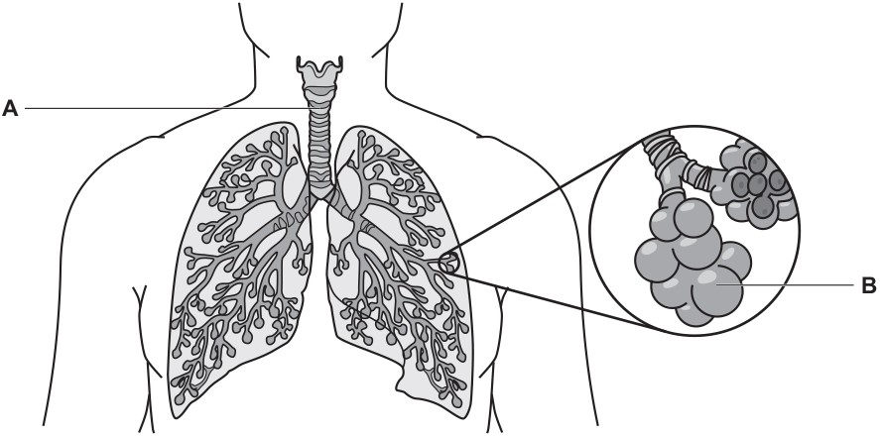
Fig. 3
Name the structures labelled A and B.

A =

B =

[2]

13(a)Table 2 shows the distribution of blood (%) at rest and during a cross country race.
 | Distribution of blood (%)
Part of the body | Rest | Cross country race
Liver | 25 | 1.5
Heart | 5 | 5
Kidneys | 20 | 1
Muscle | 20 | 80
Skin | 10 | 5
Other | 20 | 7.5
Table 2
Use Table 2 to answer the following questions:

(i) Identify the part of the body that receives the most blood during exercise.

[1]

(ii) Identify the part of the body that receives the most blood at rest.

[1]

(b) Explain the effects of the redistribution of blood during exercise.

[3]

(c) One function of the skeleton is the production of red blood cells.

(i) Describe the role of red blood cells during a cross-country race.

[2]

(ii) State three other functions of the skeleton during a cross-country race.
1.

2.

3.

3 marks
14 Describe the role of a fixator muscle.

[1]

- Basketball and netball players put a lot of stress on their knees during a match.
Describe, using practical examples from basketball or netball, the role of ligaments, tendons and cartilage at the knee.
Ligaments:

Tendons:

Cartilage:

(6marks)
- Describe four long-term benefits that hockey training can have on the respiratory system.
1

2

3

4

[4]
17. Name the part of the body that the vertebrae protect.

[1]

18. Which one of the following correctly names the articulating bones in the elbow joint?
Put a tick (✓) in the box next to the correct answer.
- Humerus, biceps, radius 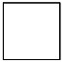
- Humerus, radius, ulna
- Humerus, scapula, ulna
- Radius, carpals, ulna
[1]
19(a)Define the following terms:

(i) Tidal volume:

[1]

(ii) Minute ventilation:

[1]

(b) Explain the effects of exercise on tidal volume and minute ventilation.

[2]

20
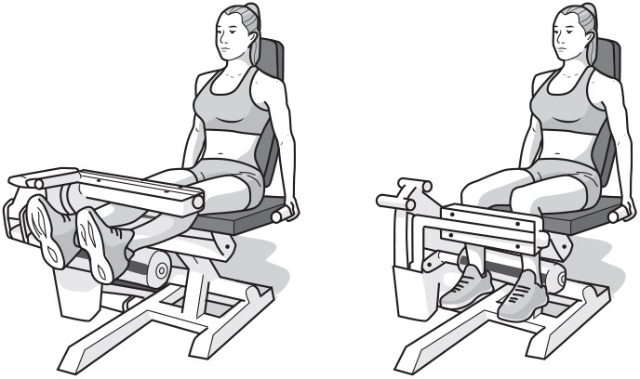
Fig. 22

(i) Name the leg muscle that contracts during the extension phase of the exercise in Fig. 22.

[1]

(ii) Explain how the pair of muscles at the knee work together during the extension phase of the exercise in Fig. 22.

[2]

(iii) Name the two articulating bones at the hip during the movement in Fig. 22.
1.

2.

[2]
- Describe one difference between aerobic and anaerobic exercise.
Give a practical example of each type of exercise.
Difference:

Example of aerobic exercise:

Example of anaerobic exercise: [2]

- A cricket player has just caught a hard ball.
Name a bone in the hand that is at risk from injury as a result of the impact of the ball being caught.

[1]

23 During exercise cardiac output changes.

(i) Explain what is meant by the term cardiac output.

[1]

(ii) State how cardiac output changes during exercise.

[1]

24 Describe the role of tendons during physical activity.

[1]

25

(i) Describe the differences between the pulmonary artery and the pulmonary vein.

[4]

(ii) Name the blood vessel responsible for returning deoxygenated blood back to the heart and into the right atrium.

[1]

26 Describe how the septum affects blood flow through the heart.

[1]

END OF QUESTION PAPER

