Edexcel
A Level
Economics B

Topic: Themes 1 – 4

Student Independent Learning Booklet


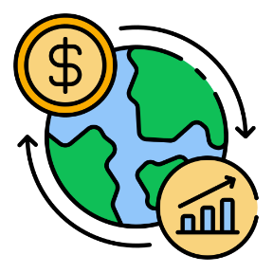
Useful Online Resources:

Edexcel A Level Economics –
https://qualifications.pearson.com/en/qualifications/edexcel-a-levels/economics-b-2015.html
Physics and Maths Tutor –
https://www.physicsandmathstutor.com/economics-revision/a-level-edexcel-b/
Seneca Learn –
https://app.senecalearning.com/
Study Rocket –
https://studyrocket.co.uk/revision/a-level-economics-b-edexcel
YouTube (EconPlusDal) –
https://www.youtube.com/@EconplusDal
YouTube (Tutor2u) –
https://www.youtube.com/@tutor2u-official/search?query=economics

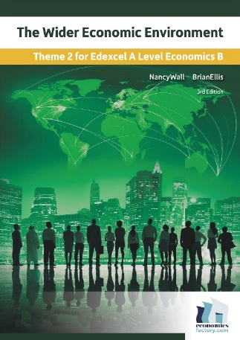
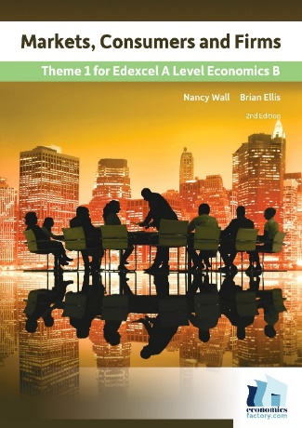
Revision Guides and Workbooks:

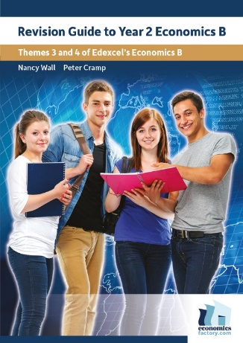
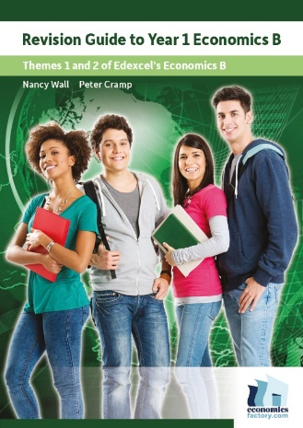

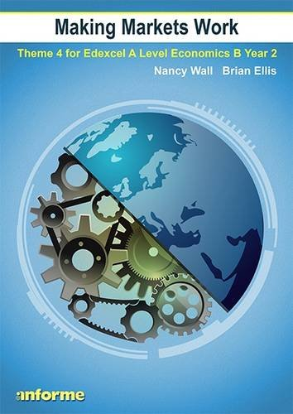
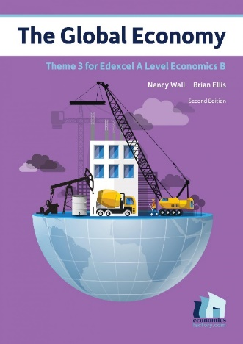

Pearson Edexcel Course Textbooks

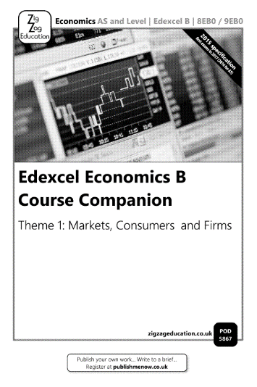
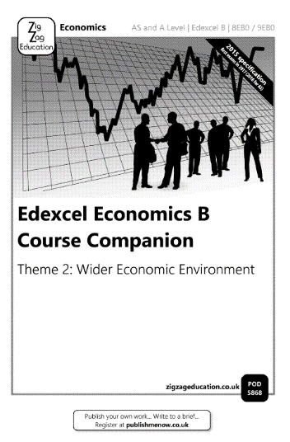
CGP Exam Board Specific Revision Guide and Practice Book

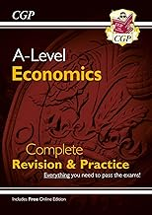

Zigzag Course Companion Books
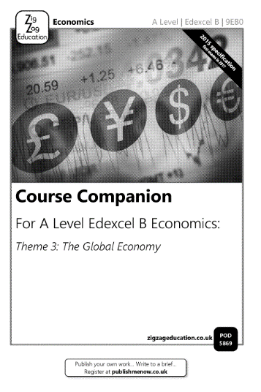
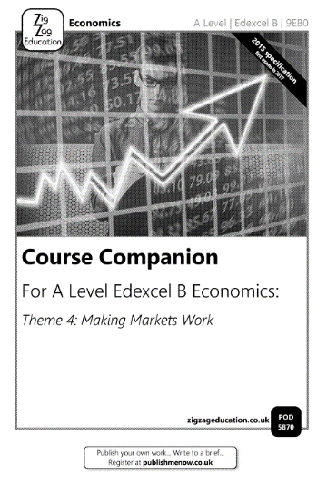

Notes:

………………………………………………………………………………………………………………………………………………………………………………………………………………………………………………………………………………………………………………………………………………………………………………………………………………………………………………………………………………………………………………………………………………………………………………………………………………………………………………………………………………………………………………………………………………………………………………………………………………………………………………………………………………………………………………………………………………………………………………………………………………………………………………………………………………………………………………………………………………………………………………………………………………………………………………………………………………………………………………………………………………………………………………………………………………………………………………………………………………………………………………………………………………………………………………………………………………………………………………………………………………………………………………………………………………………………………………………………………………………………………………………………………………………………………………………………………………………………………………………………………………………………………………………………………………………………………………………………………………………………………………………………………………………………………………………………………………………………………………………………………………………………………………………………………………………………………………………………………………………………………………………………………………………………………………………………………………………………………………………………………………………………………………………………………………………………………………………………………………………………………………………………………………………………………………………………………………………………………………………………………………………………………………………………………………………………………………………………………………………………………………………………………………………………………………………………………………………………………………………………………………………………………………………………………………………………………………………………………………………………………………………………………………………………………………………………………………………………………………………………………………………………………………………………………………………………………………………………………………………………………………………………………………………………………………………………………………………………………………………………………………………………………………………………………………………………………………………………………………………………………………………………………………………………………………………………………………………………………………………………………………………………………………………………………………………………………………………………………………………………………………………………………………………………………………………………………………………………………………………………………………………………………………………………………………………………………………………………………………………………………………………………………………………………………………………………………………………………………………………………………………………………………………………………………………………………………………………………………………………………………………………………………………………………………………………………………………………………………………………………………………………………………………………………………………………………………………………………………………………………………………………………………………………………………………………………………………………………………………………………………………………………………………………………………………………………………………………………………………………………………………………………………………………………………………………………………………………………………………………………………………………………………………………………………………………………………………………………………………………………………………………………………………………………………………………………………………………………………………………………………………………………………………………………………………………………………………………………………………………………………………………………………………………………………………………………………………………………………………………………………………………………………………………………………………………………………………………………………………………………………………………………………………………………………………………………………………………………………………………………………………………………………………………………………………………………………………………………………………………………………………………………………………………………………………………………………………………………………………………………………………………………………………………………………………………………………………………………………………………………………………………………………………………………………………………………………………………………………………………………………………………………………………………………………………………………………………………………………………………………………………………………………………………………………………………………………………………………………………………………………………………………………………………………………………………………………………………………………………………………………………………………………………………………………………………………………………………………………………………………………………………………………………………………………………………………………………………………………………………………………………………………………………………………………………………………………………………………………………………………………………………………………………………………………………………………………………………………………………………………………………………………………………………………………………………………………………………………………………………………………………………………………………………………………………………………………………………………………………………………………………………………………………………………………………………………………………………………………………………………………………………………………………………………………………………………………………………………………………………………………………………………………………………………………………………………………………………………………………………………………………………………………………………………………………………………………………………………………………………………………………………………………………………………………………………………………………………………………………………………………………………………………………………………………………………………………………………………………………………………………………………………………………………………………………………………………………………………………………………………………………………………………………………………………………………………………………………………………………………………………………………………………………………………………………………………………………………………………………………………………………………………………………………………………………………………………………………………………………………………………………………………………………………………………………………………………………………………………………………………………………………………………………………………………………………………………………………………………………………………………………………………………………………………………………………………………………………………………………………………………………………………………………………………………………………………………………………………………………………………………………………………………………………………………………………………………………………………………………………………………………………………………………………………………………………………………………………………………………………………………………………………………………………………………………………………………………………………………………………………………………………………………………………………………………………………………………………………………………………………………………………………………………………………………………………………………………………………………………………………………………………………………………………………………………………………………………………………………………………………………………………………………………………………………………………………………………………………………………………………………………………………………………………………………………………………………………………………………………………………………………………………………………………………………………………………………………………………………………………………………………………………………………………………………………………………………………………………………………………………………………………………………………………………………………………………………………………………………………………………………………………………………………………………………………………………………………………………………………………………………………………………………………………………………………………………………………………………………………………………………………………………………………………………………………………………………………………………………………………………………………………………………………………………………………………………………………………………………………………………………………………………………………………………………………………………………………………………………………………………………………………………………………………………………………………………………………………………………………………………………………………………………………………………………………………………………………………………………………………………………………………………………………………………………………………………………………………………………………………………………………………………………………………………………………………………………………………………………………………………………………………………………………………………………………………………………………………………………………………………………………………………………………………………………………………………………………………………………………………………………………………………………………………………………………………………………………………………………………………………………………………………………………………………………………………………………………………………………………………………………………………………………………………………………………………………………………………………………………………………………………………………………………………………………………………………………………………………………………………………………………………………………………………………………………………………………………………………………………………………………………………………………………………………………………………………………………………………………………………………………………………………………………………………………………………………………………………………………………………………………………………………………………………………………………………………………………………………………………………………………………………………………………………………………………………………………………………………………………………………………………………………………………………………………………………………………………………………………………………………………………………………………………………………………………………………………………………………………………………………………………………………………………………………………………………………………………………………………………………………………………………………………………………………………………………………………………………………………………………………………………………………………………………………………………………………………………………………………………………………………………………………………………………………………………………………………………………………………………………………………………………………………………………………………………………………………………………………………………………………………………………………………………………………………………………………………………………………………………………………………………………………………………………………………………………………………………………………………………………………………………………………………………………………………………………………………………………………………………………………………………………………………………………………………………………………………………………………………………………………………………………………………………………………………………………………………………………………………………………………………………………………………………………………………………………………………………………………………………………………………………………………………………………………………………………………………………………………………………………………………………………………………………………………………………………………………………………………………………………………………………………………………………………………………………………………………………………………………………………………………………………………………………………………………………………………………………………………………………………………………………………………………………………………………………………………………………………………………………………………………………………………………………………………………………………………………………………………………………………………………………………………………………………………………………………………………………………………………………………………………………………………………………………………………………………………………………………………………………………………………………………………………………………………………………………………………………………………………………………………………………………………………………………………………………………………………………………………………………………………………………………………………………………………………………………………………………………………………………………………………………………………………………………………………………………………………………………………………………………………………………………………………………………………………………………………………………………………………………………………………………………………………………………………………………………………………………………………………………………………………………………………………………………………………………………………………………………………………………………………………………………………………………………………………………………………………………………………………………………………………………………………………………………………………………………………………………………………………………………………………………………………………………………………………………………………………………………………………………………………………………………………………………………………………………………………………………………………………………………………………………………………………………………………………………………………………………………………………………………………………………………………………………………………………………

Independent Reading and Research

Past Exam Questions and Mark Schemes

