**What does a successful A-level Economics student look like?**

|  |  |  |  |  |
| --- | --- | --- | --- | --- |
| **After every lesson** |  | **After each chapter** |  | **Throughout** |
| **REVIEW YOUR NOTES**  Are they complete? Do you need to re-draw or write anything so that it will make sense in 6 months’ time? Do not waste time making notes pretty! Check against the specification. |  | **KEEP ON TOP OF REVISION**  Create a concise flash card of definitions or processes you need to know by rote (use mark-scheme language). Use them! Test yourself each evening. |  | **JOIN IN**  Get involved in department events: open evenings, clubs for younger students, online events, university lectures etc |
| **CHECK YOUR UNDERSTANDING**  Decide what you don’t yet “know” and what you don’t yet “understand”. Cover up definitions and processes and see what you can say out-loud. |  | **TEST YOURSELF**  You need to identify what you can still recall and what you can’t recall anymore. Use “look, cover, write, check” for definitions and processes (AO1 knowledge). |  | **READ**  BBC News  Books  Magazines  Summarise what you read into 5 bullet points of key information. |
| **READ THE TEXTBOOK**  Read your textbook and revision guide. Are there any other facts, diagrams, examples, analogies etc that you need to add into your notes? |  | **PAST PAPER QUESTIONS**  Finish off your exam questions booklet. Check all of your answers strictly against the mark-scheme. Learn the mark-scheme language. |  | **EVALUATE**  Every time you see a Economics-based headline, read the article and try to evaluate the evidence. Think sample size and make-up, stats tests, etc |
| **COMPLETE ASSIGNED HOMEWORK**  Attempt exam questions without your notes. Switch colour and fill in gaps using your notes. As soon as work comes back marked, read the feedback add corrections using the mark scheme. You are welcome to re-submit your improved work to your teacher. |  | **TIMING**  For smaller tests, you should be studying throughout so final ‘revision’ can be done in the week before your test.  For larger exams you will need to start a few months ahead of the date |  | **YOUTUBE**  YouTube is great for taking your A Level knowledge to a higher level. Keep a record of things you’ve watched. |
| **POST-IT REMINDERS**  Use post-its to remind yourself which parts of your homework you needed to use your notes for or concepts you don’t understand yet, and questions you need to ask. |  |  | **REVISE REGULARLY**  Schedule time to review older chapters regularly. Follow the advice in the “after each chapter” section. |
| **ASK QUESTIONS**  Email your teacher to arrange a time to talk through a concept you don’t understand or ask in the next lesson. |  |  | **NO DISTRACTIONS!**  When you do sit down to work, make sure you leave your phone in another room. Focus on what you’re doing. |

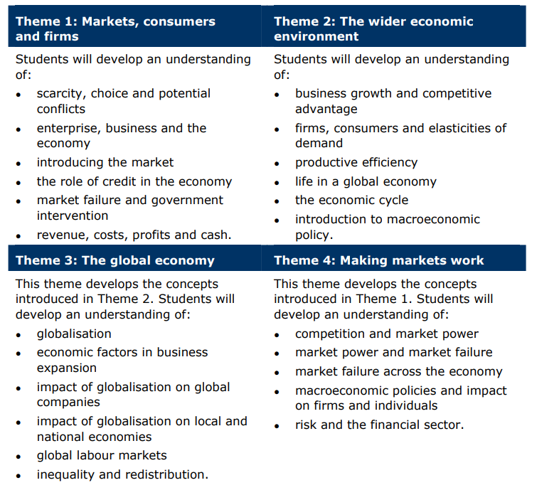

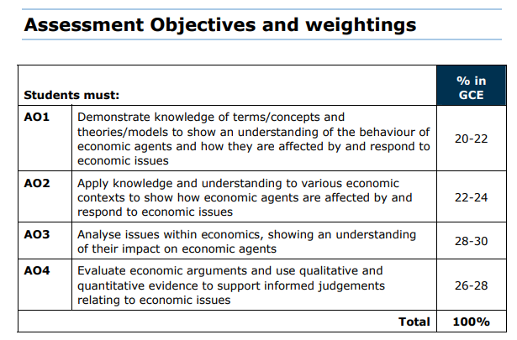

|  |  |  |
| --- | --- | --- |
| **External Assessment – Pearson EdExcel B** | | |
| **Paper 1:** Markets and How They Work   * 2 hours, 100 marks * 35% of qualification | **Paper 2:** Competing in the Global Economy   * 2 hours, 100 marks * 35% of qualification | **Paper 3:** The Economic Environment and Business   * 2 hours, 100 marks * 30% of qualification * Pre-release issued in November |