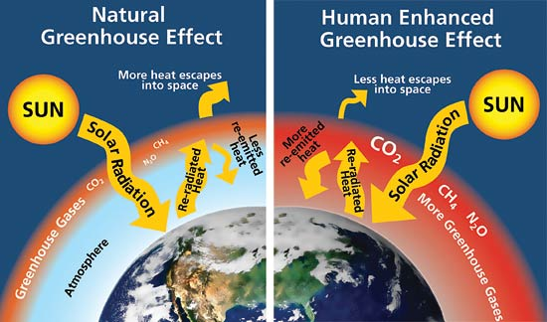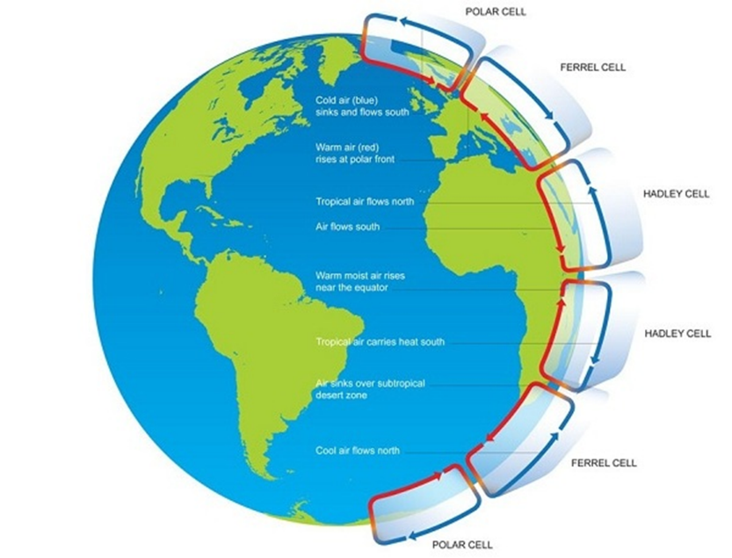

**Global Atmospheric Circulation:**

**Human Activities and Climate Change:**

**Impacts of Climate Change:**

Weather and

Climate

**Oceanic Circulation:**

**Natural Climate Change:**

**Evidence for Past Climate Change:**

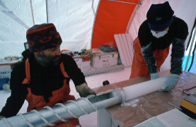

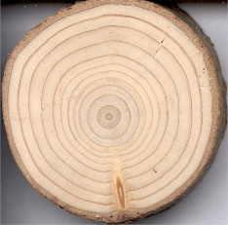

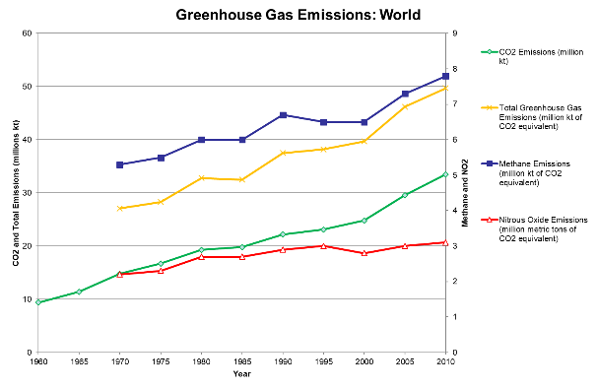

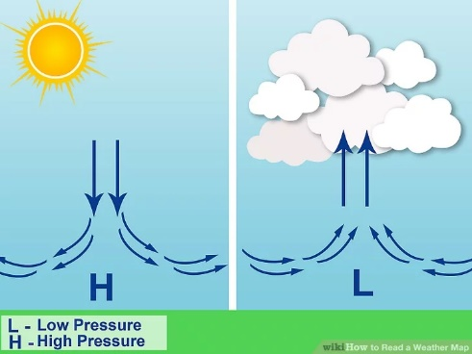

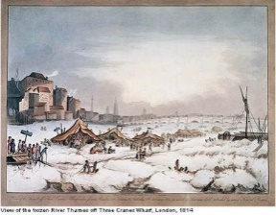

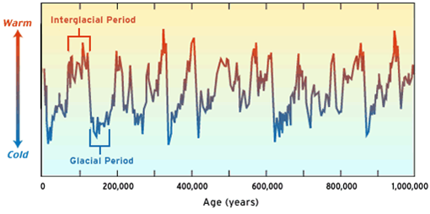

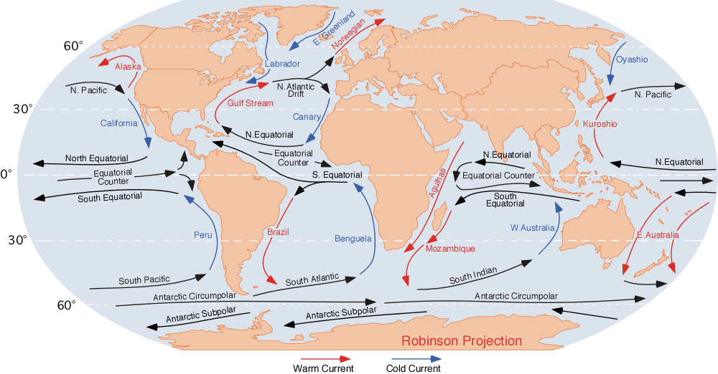

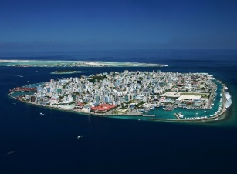

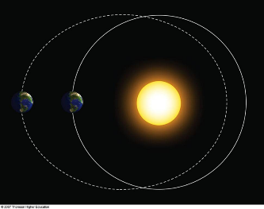

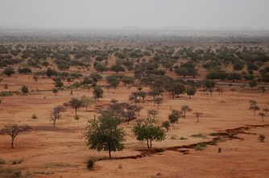

[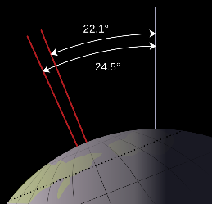](https://www.google.co.uk/url?sa=i&rct=j&q=&esrc=s&source=images&cd=&cad=rja&uact=8&ved=0ahUKEwjflKu0_IHOAhWBoxoKHe3uBw4QjRwIBw&url=https://en.wikipedia.org/wiki/Milankovitch_cycles&bvm=bv.127521224,d.ZGg&psig=AFQjCNHEnEJ7iBfaQxhLrLisDl-cpnVgUg&ust=1469101476392490)

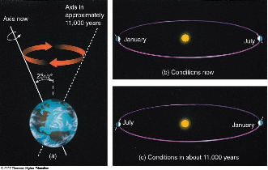

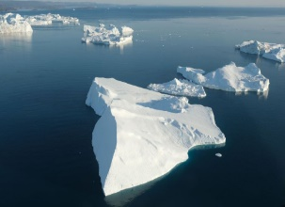

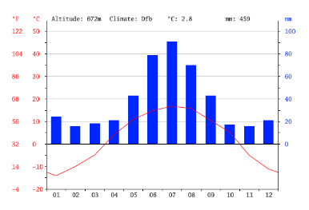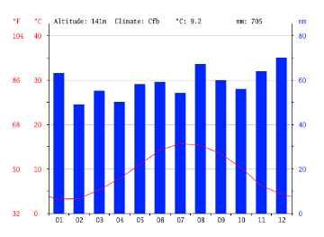

Birmingham, UK

Edmonton, Canada

**Typhoon Hagibis (Japan, 2019) Case Study:**

**Tropical Cyclone (Characteristics and Formation):**

**Past Climate of the UK:**

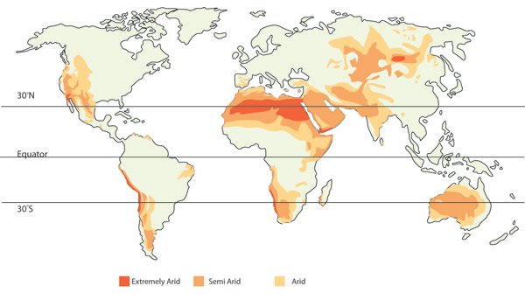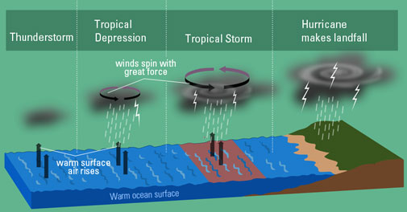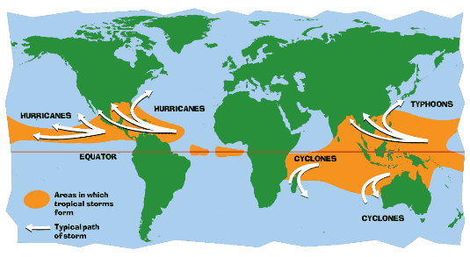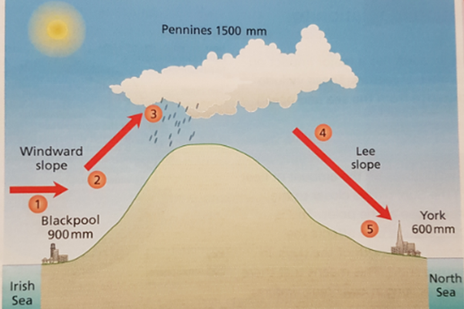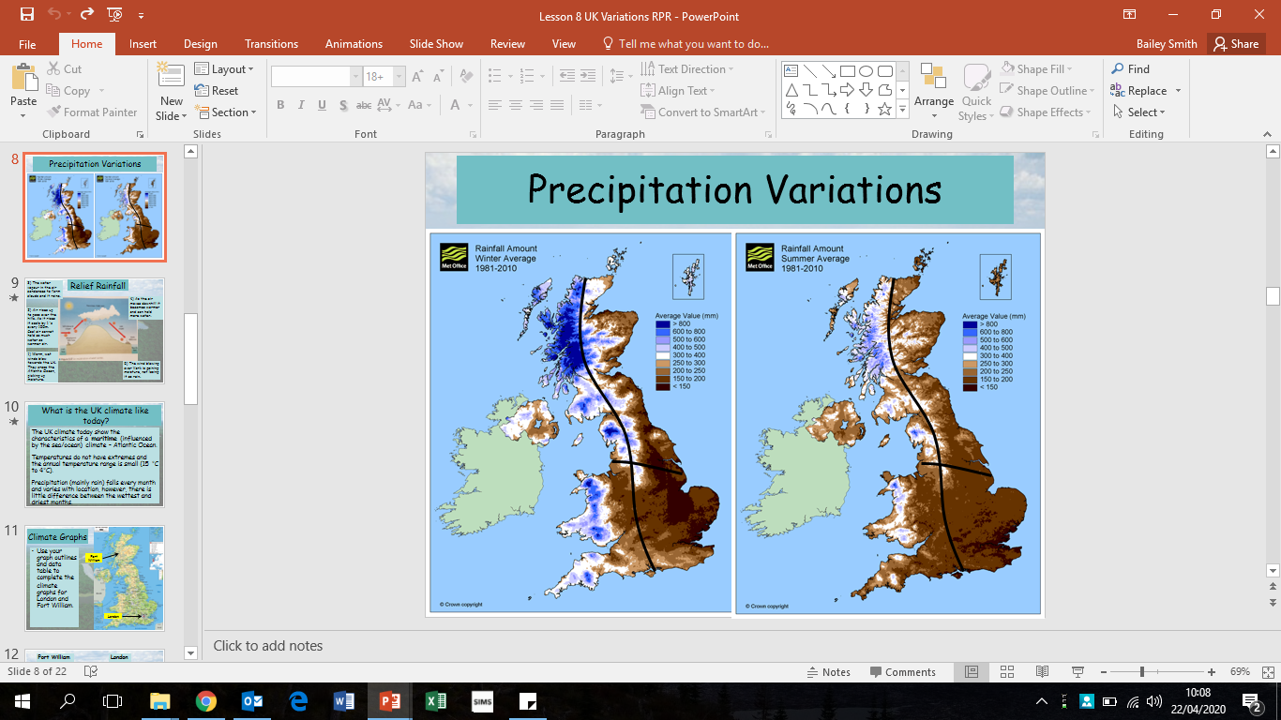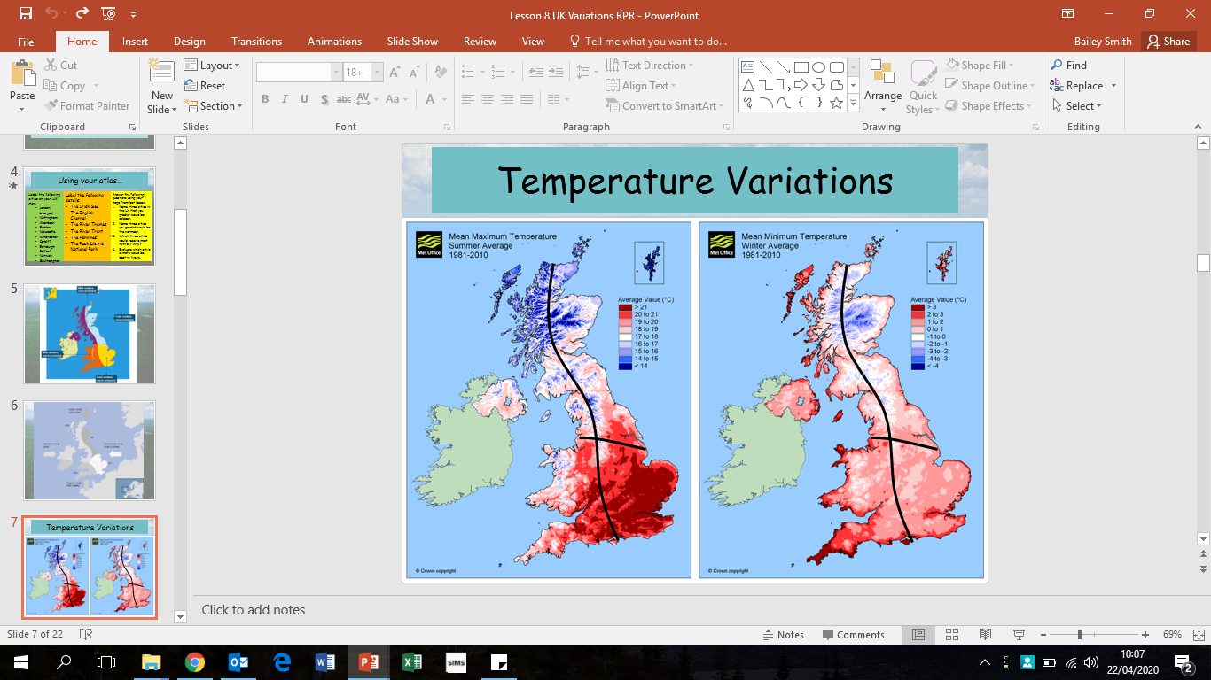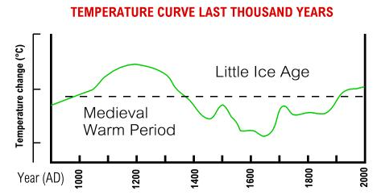

**California (2014-present) Case Study:**

**Namibia (2013-present) Case Study:**

**Drought (Causes and Characteristics):**

**Cyclone Idai (Mozambique, 2019) Case Study:**

**Spatial Variation in the UK Climate:**