**Hurricane Sandy**

On October 23rd 2012, the government of Cuba warned the eastern states of the country about the imminent approach of Hurricane Sandy. The hurricane continued north affecting 24 states of the USA, causing particularly severe damage in New Jersey and New York. The hurricane had different social, economic and environmental impacts on Cuba and the USA, however, because of the different stages of development of the two countries.

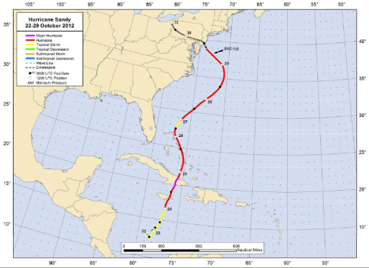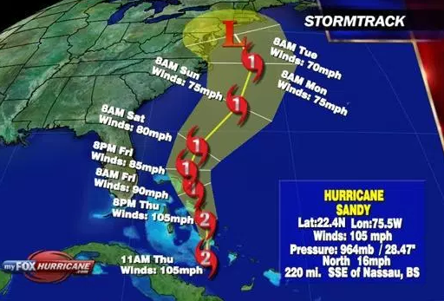

|  |  |
| --- | --- |
| Cuba | USA (New York, New Jersey, Connecticut) |
| **Social impacts**  There was no electricity or fresh water  11 people were killed  17,000 homes were destroyed and 226,000 were damaged  More than 55,000 people evacuated because of the storm surge  **Economic impacts**  Total losses in the Santiago de Cuba area came to £50 million  Roads to the airport were blocked, so no tourists could arrive or leave the island, causing loss of revenue  Total losses of US$2 billion  5% drop in Cuba’s GDP  **Environmental impacts**  Around 2600 hectares of banana crops were destroyed  In Santiago de Cuba trees were uprooted and stripped of their leaves  Coffee plantations in mountainous areas were swept away  Areas close to the coast were flooded, with beaches being swept away, destroying wildlife habitats | **Social impacts**  117 people were killed  Roughly 9 million homes had power cuts  650,000 homes were damaged or destroyed  250,500 cars were destroyed by flood water  The streets and subways of New York were flooded  **Economic impacts**  Total insurance claims in New Jersey were US$3.3 billion  US$1.1 billion was spent repairing the damage to sewage and water pipes in New York and New Jersey  Total damage cost in New York was US$19 billion  **Environmental impacts**  The storm surge meant sea water got into fresh water habitats, which had severe impacts on wildlife from Delaware Bay to Long Island South  Around 1.5 billion litres of sewage was released into the Raritan river in New Jersey  Around 90% of beaches in New York and New Jersey were damaged; on average the beaches were 9-12mm narrower after the hurricane  1.5 million litres of oil was spilt into the stretch of water between New Jersey and Staten Island, damaging wildlife and killing fish and birds |

|  |  |  |
| --- | --- | --- |
| **Responses** | **Cuba** | **USA** |
| **Individuals** | Many people moved in with relatives or friends; others took shelter in state workers’ holiday homes where basic food was provided.  They used materials provided by the government and other organisations to rebuild their own homes.  The people of Cuba have no home insurance. | After the hurricane, people moved in with relatives and used shelters.  People rebuilt their homes but used builders rather than doing it themselves.  Americans have home insurance but those affected also received aid from the government and other organisations. |
| **Organisations** | The UN provided US$5.5 million to Cuba from the CERF and US$1.5 million in emergency funds.  Venezuela sent 650 tonnes of aid, including non-perishable food, potable water and heavy machinery. Russia and Japan also sent humanitarian aid.  In the seven months following the hurricane, the Cuban Red Cross delivered support with the help of the Norwegian, Spanish and German Red Cross and Red Crescent Societies. The relief aid went to around 25,000 families and included roofing materials, mattresses, clean drinking water and hygiene and kitchen kits.  The World Food Programme responded immediately with US$1 million to assist the 788,000 people in the worst affected areas of Cuba with a one-month food ration from December 2012 to February 2013. | Extensive erosion to Delaware Bay beaches affected breeding grounds of horseshoe crabs. The Canadian Rivers Institute worked with other NGOs and public agencies to restore these beaches by clearing rubble and replenishing sand to provide a nesting area for horseshoe crabs.  The Red Cross had 17,000 trained workers (90% were volunteers) providing over 300 response vehicles, 74,000 overnight stays and 17 million meals and snacks, among other aid.  AmeriCares, an American charity, responded quickly by sending in teams of relief workers to hard-hit areas, sending aid shipments, providing funding and deploying a mobile medical clinic. In the two years following, AmeriCares has provided US$7.1 million in aid which has benefited 450,000 people. |
| **Governments** | The government sent teams of electricians from all over the island to Santiago province within hours of the hurricane hitting.  Government announced a 50% price cut for construction materials and interest free loans to repair damage. Corrugated iron sheets, metal rods and cement were made available.  Local government officials collected and used data about damage so that appropriate help could be sent.  Military teams were mobilised quickly to clear the streets of rubble and around 6.5 million square metres of trees. | The US government approved US$60.3 billion in aid.  They promised improved weather forecasting, especially of storm surges.  Federal Emergency Management Agency teams and resources were put in place to help people even before the hurricane had caused any problems.  FEMA and the Army Corps of Engineers worked with state and local governments to quickly reopen most of the beaches in New Jersey.  The Department of Agriculture promised US$6.2 million for emergency food assistance, infrastructure and economic programmes to help repair farmland and flood plains. |

**Revision tasks**

1. State four characteristics of tropical cyclones.
2. Explain why tropical cyclones can be hazards.
3. Construct a table showing two economic, environmental and social impacts of Hurricane Sandy on Cuba and the USA.
4. How did the help given by the government of Cuba differ to that given by the government of the USA? Try to give reasons why this might be different (hint: development).
5. Choose two of the responses by organisations to the disaster in Cuba and explain why this help was given.

**Sample Questions (8 marks)**

1. Discuss why the impacts of Hurricane Sandy were different in Cuba than in the USA.
2. Using a named example, assess the impacts of hurricanes on developed and developing countries.
3. Using a named example, evaluate the responses to hurricanes on developed and developing countries.
4. Examine why the responses in developing countries are often less effective than in developed countries.
5. Assess the impacts of a tropical cyclone on a developing country.
6. Assess the impacts of a tropical cyclone on a developed country.
7. Evaluate the different responses to the impact of a tropical cyclone on people in a named developing country.