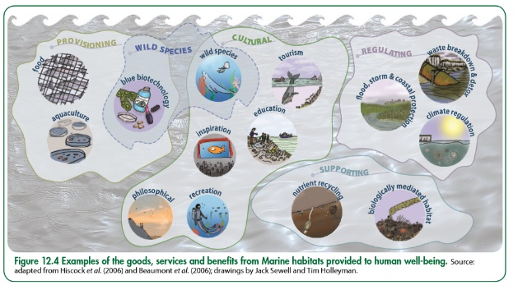

Ecosystems, Biodiversity and Management

**Distribution of Biomes:**

**Marine Ecosystems:**

**Tropical Rainforest Characteristics:**

**Goods and Services:**

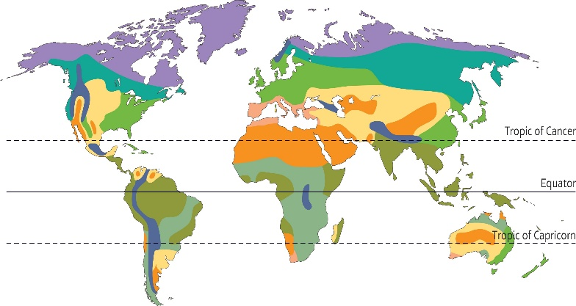

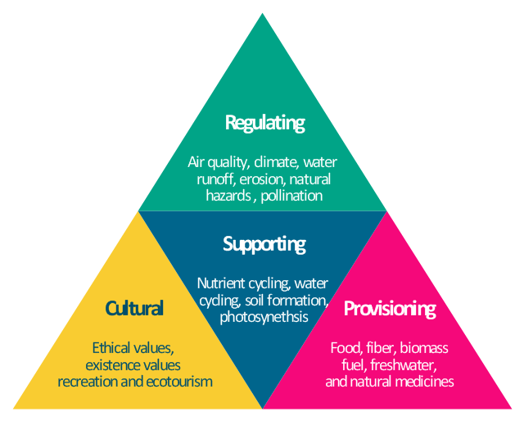

**Climate and Local Factors:**

**Distinctive UK Ecosystems:**

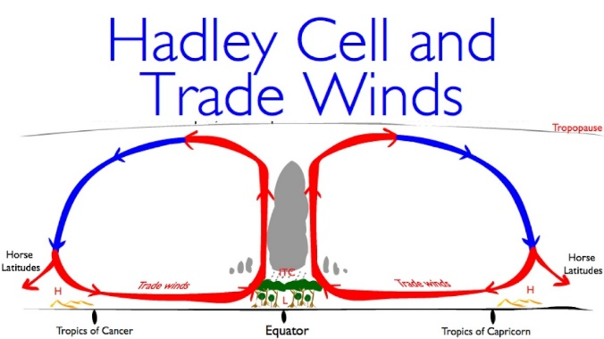

[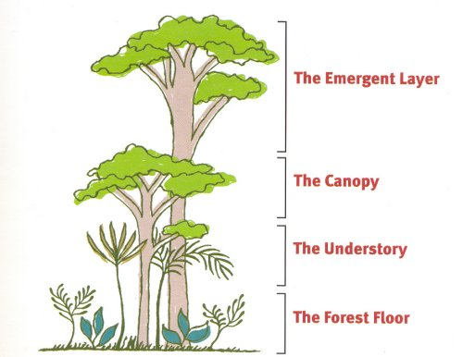](http://www.bbc.co.uk/education/clips/zkdnvcw)

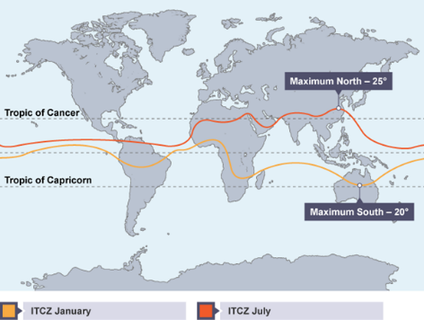

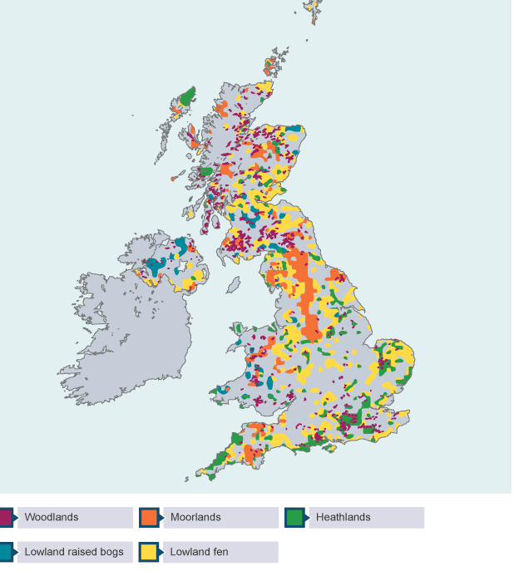

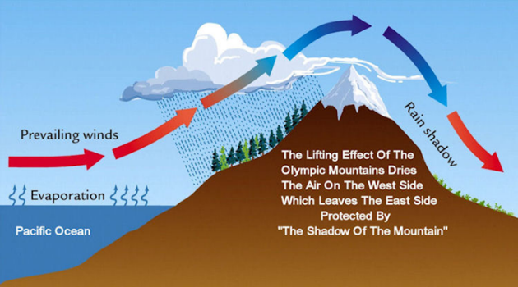

**Tropical Rainforest Deforestation:**

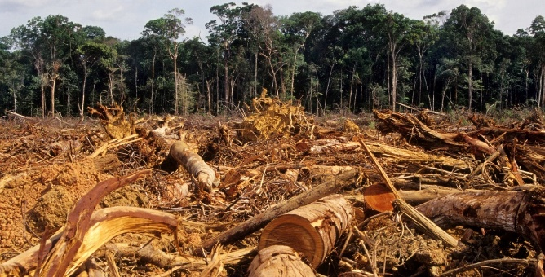

**Tropical Rainforest Goods/Services:**

**Tropical Rainforest Nutrient Cycle:**

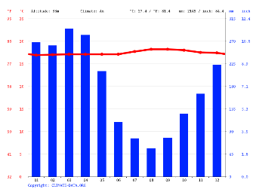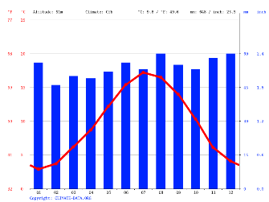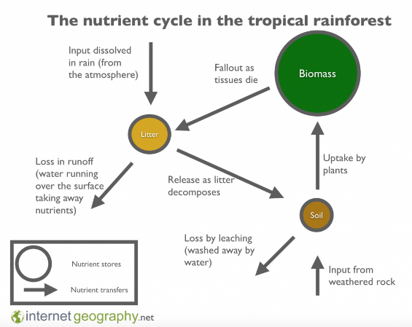

**Deciduous Woodland Goods/Services:**

**Sustainable Forest Management: The New Forest**

**TRF and Deciduous Woodland Comparison (Nutrient Cycle/Climate):**

**Deciduous Woodland Characteristics:**

**Sustainable Rainforest Management (Costa Rica):**