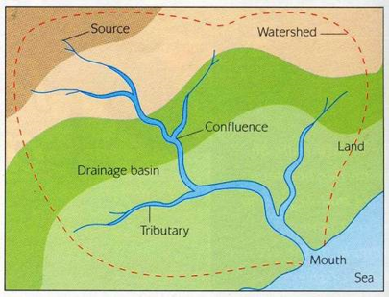

**Factors Affecting Discharge:**

**Hydrological Cycle and Drainage Basin:**

Changing Landscapes

of the UK

**River Processes:**

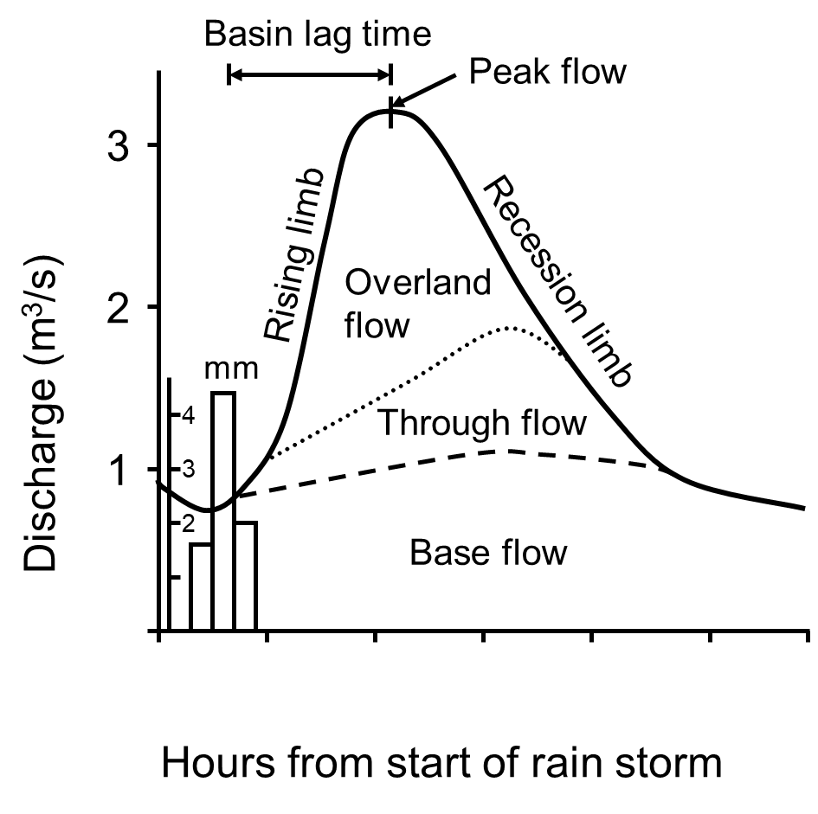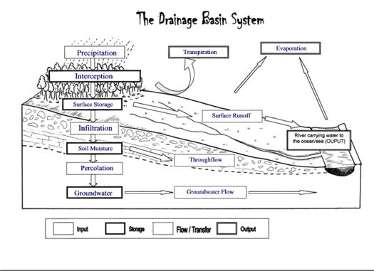

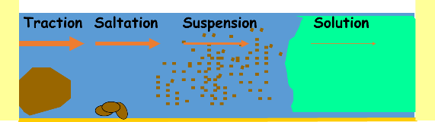

**Long Profile (Bradshaw Model):**

[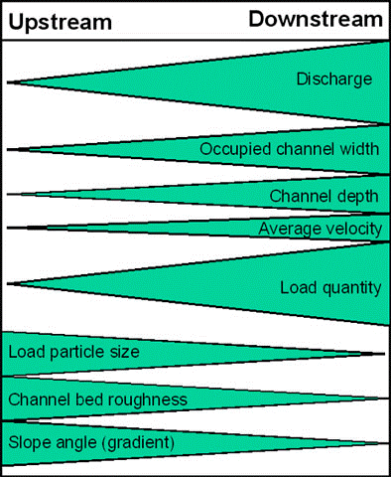](https://www.google.co.uk/url?sa=i&rct=j&q=&esrc=s&frm=1&source=images&cd=&cad=rja&docid=-XsRlxT9LuDT8M&tbnid=KTpDc99mleEhzM:&ved=0CAUQjRw&url=https://sites.google.com/a/wbsg.org.uk/geography/a-level-1/year-13/unit-4a---geography-fieldwork-investigation&ei=0Kx3UeitO4fA0QWUjIHwBQ&psig=AFQjCNE_eeLTnrFShrn6rNKbozLSseq4gQ&ust=1366883872595443)

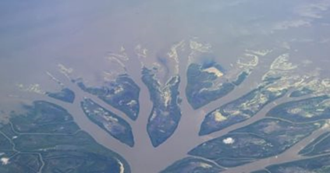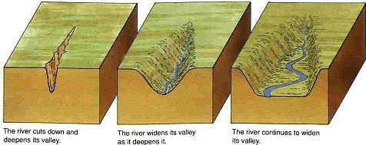

**Lower Course Landforms:**

**Upper Course Landforms:**

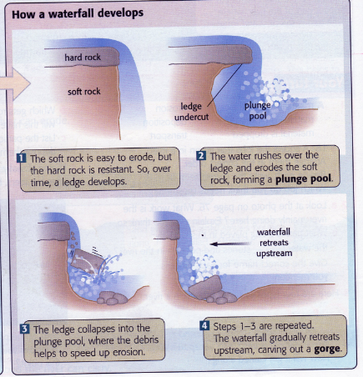

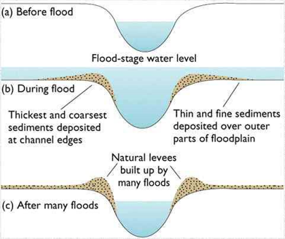

**Causes and Effects of Flooding:**

**Middle Course Landforms:**

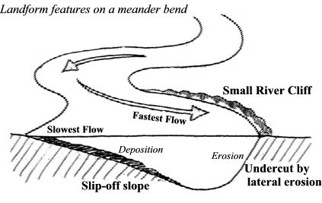

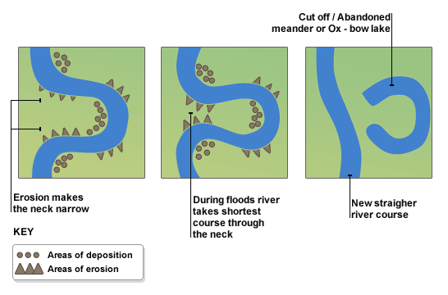

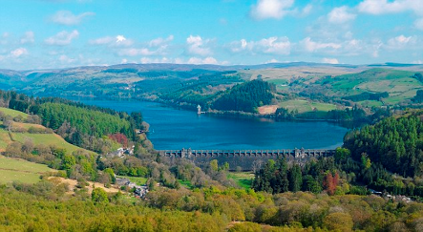

Lake Vyrnwy, Wales

**River Management:**

**River Tees (Case Study):**

**Coastal Processes:**

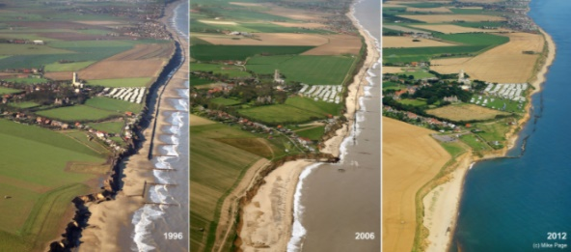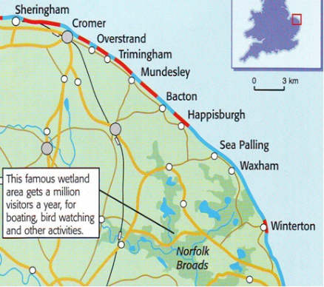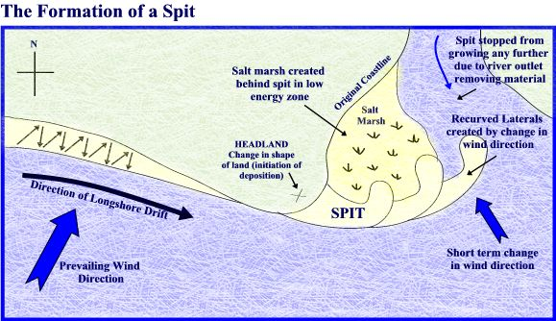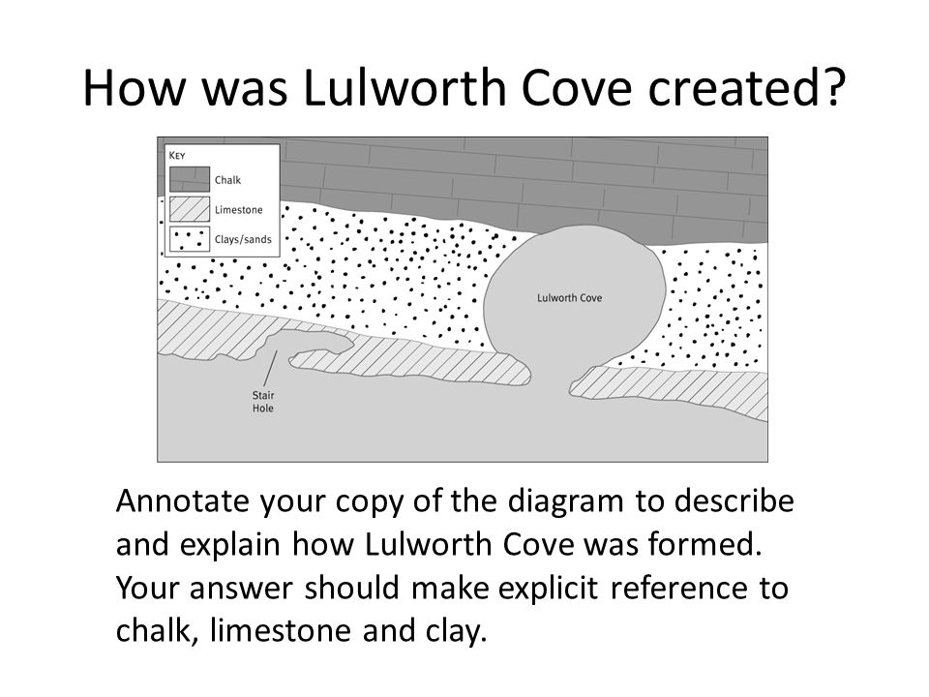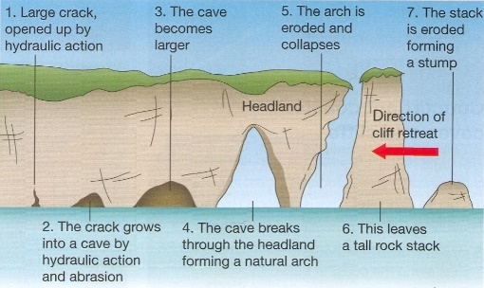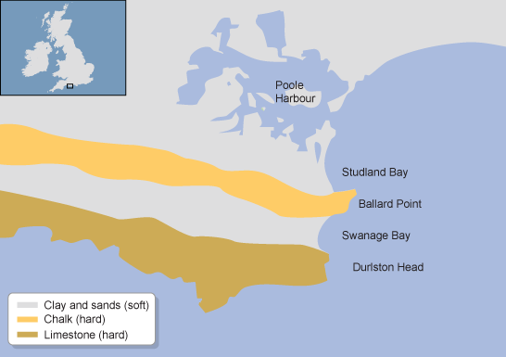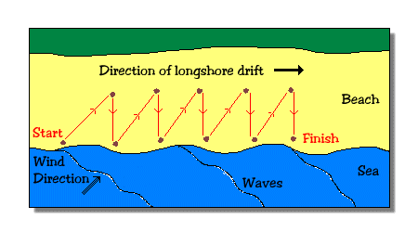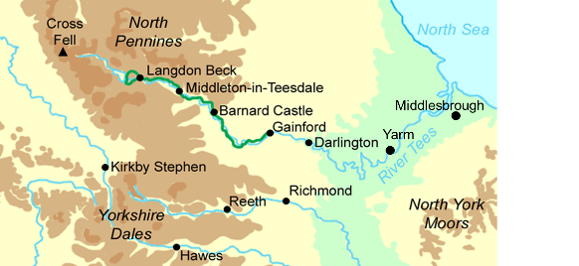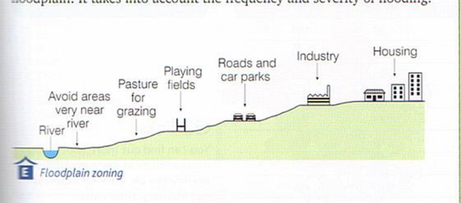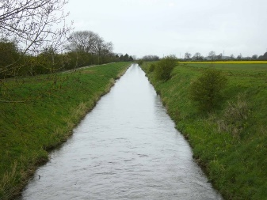

**Happisburgh vs Sea Palling (Case Study):**

**Coastal Management:**

**Coastal Deposition Landforms:**

**Coastal Erosion Landforms:**

**Coastal Threats/Human Activity on the Coast:**

**Weathering and Mass Movement:**