A Level Geography Handbook

Well done for choosing A Level Geography! This handbook provides you all the resources you will need to be a successful A Level student. Please bring it with you to lessons and use it in your homework.

|  |  |
| --- | --- |
| Introduction | Page 2 |
| Specification at a Glance | Page 3-5 |
| Topics Overview | Page 6-14 |
| Assessment Objectives | Page 15 |
| Synoptic themes | Page 16 |
| Exam Command Words | Page 17 |
| Longer Answer Help | Page 18-21 |
| Skills Checklist | Page 22 |
| Wider Study List | Page 23-24 |
| Wider Study Tracker | Page 25 |
| Discovery Worksheets | Page 26-29 |
| Practice Questions | Page 30-38 |

A Level Geography: An Introduction

Welcome to A Level Geography at Wilsthorpe! In the next two years you will study topics in Physical and Human Geography that will set you up as an academic learner with critical thinking skills.

As with any other department, our expectations of you during this course are high.

* Be punctual to lessons.
* Notify teachers if you know you are going to be absent and catch up on any work missed.
* Keep up to date with work and complete tasks to the best of your ability.
* Read around the subject and make sure you keep up to date with current affairs by watching the news regularly.
* Communicate with your teachers and check your emails frequently for correspondence from them.
* Be organised and keep your work carefully filed so that you can access your notes easily.
* Be active in the lessons – get involved in discussions, ask questions and offer answers. All of you will learn better if you can hold discussions about what we are learning about.

|  |  |
| --- | --- |
| Physical Geography | Human Geography |
| Mr Smith  [smithb@wilsthorpe.derbyshire.sch.uk](mailto:smithb@wilsthorpe.derbyshire.sch.uk) | Mr Roper  [roperm@wilsthorpe.derbyshire.sch.uk](mailto:roperm@wilsthorpe.derbyshire.sch.uk)  Miss Blackburn  [blackburna@wilsthorpe.derbyshire.sch.uk](mailto:blackburna@wilsthorpe.derbyshire.sch.uk) |

We all absolutely love teaching A Level Geography and hope that you will love the course as much as we do!

A Level Geography: Specification at a Glance

Our exam board is **EdExcel.**

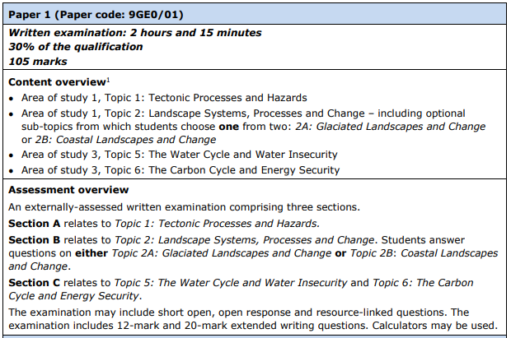

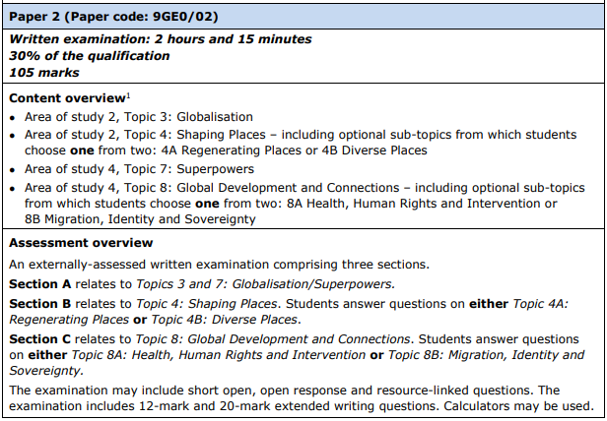

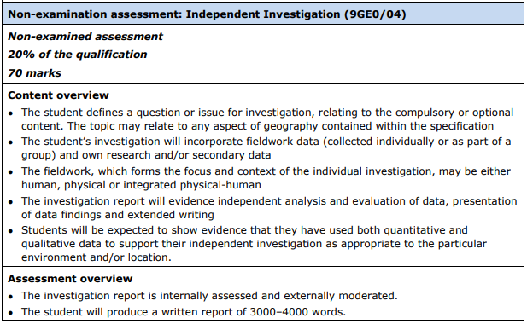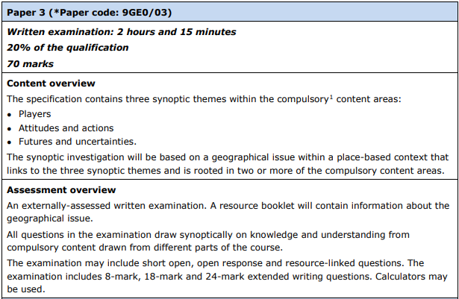

You will also be required to complete four days of residential fieldwork – details will be confirmed by your teachers in advance of this trip.

**What will I need to answer in the exam?**

The table below shows the number of essay questions with the command words that your exam will be made up of. An explanation of what the assessment objectives are can be found on page 15 of this booklet.

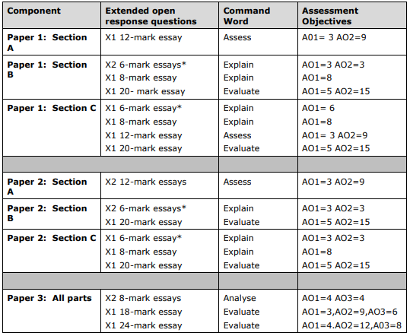

A Level Geography: Topics

Each topic includes an overview which tells you why the topic is useful to modern Geography. It will also highlight links between this topic and others in the specification, which is very helpful for preparing you for Paper 3.

There are 3-4 enquiry questions per topic which your lessons will be structured around. You should use these enquiry questions when you are revising to structure your work and make sure you have covered all of the key ideas.

Paper One: Physical Geography (Year 12 Content)

**Topic 1: Tectonic Processes and Hazards**

EQ1: Why are some locations more at risk from tectonic hazards?

* The global distribution of tectonic hazards can be explained by plate boundary and other tectonic processes
* There are theoretical frameworks that attempt to explain movements
* Physical processes explain the causes of tectonic hazards

EQ2: Why do some tectonic hazards develop into disasters?

* Disaster occurrence can be explained by the relationship between hazards, resilience and disaster
* Tectonic hazard profiles are important to an understanding of contrasting hazard impacts, vulnerability and resilience
* Development and governance are important in understanding disaster impact and vulnerability and resilience

EQ3: How successful is the management of tectonic hazards and disasters?

* Understanding the complex trends and patterns for tectonic disasters helps explain differential impacts
* Theoretical frameworks can be used to understand the prediction, impact and management of tectonic hazards
* Tectonic hazard impacts can be managed by a variety of mitigation and adaptation strategies, which vary in their effectiveness

**Topic 2B: Coastal Landscapes and Change**

EQ1: Why are coastal landscapes different and what processes cause these differences?

* The coast and wider littoral zone has distinctive features and landscapes
* Geological structure influences the development of coastal landscapes at a variety of scales
* Rates of coastal recession and stability depend on lithology and other factors

EQ2: How do characteristic coastal landforms contribute to coastal landscapes?

* Marine erosion creates distinctive coastal landforms and contributes to coastal landscapes
* Sediment transport and deposition create distinctive landforms and contribute to coastal landscapes
* Subaerial processes of mass movement and weathering influence coastal landforms and contribute to coastal landforms

EQ3: How do coastal erosion and sea level change alter the physical characteristics of coastlines and increase risks?

* Sea level change influences coasts on different timescales
* Rapid coastal retreat causes threats to people at the coast
* Coastal flooding is a significant and increasing risk for some coastlines

EQ4: How can coastlines be managed to meet the needs of all players?

* Increasing risk of coastal recession and coastal flooding have serious consequences for affected communities
* There are different approaches to managing the risks associated with coastal recession and flooding
* Coastlines are now increasingly managed by holistic integrated coastal zone management (ICZM)

Paper Two: Human Geography (Year 12 Content)

**Topic 3: Globalisation**

EQ1: What are the causes of globalisation and why has it accelerated in recent decades?

* Globalisation is a long-standing processes which has accelerated because of rapid developments in transport, communications and businesses
* Political and economic decision making are important factors in the acceleration of globalisation
* Globalisation has affected some places and organisations more than others

EQ2: What are the impacts of globalisation for countries, different groups of people and cultures and the physical environment?

* The global shift has created winners and losers for people and the physical environment
* The scale and pace of economic migration has increased as the world has become more interconnected, creating consequences for people and the physical environment
* The emergence of a global culture, based on Western ideas, consumption and attitudes towards the physical environment, is one outcome of globalisation

EQ3: What are the consequences of globalisation for global development and the physical environment and how should different players respond to its challenges?

* Globalisation has led to dramatic increases in development for some countries, but also widening the development gap extremities and disparities in environmental quality
* Social, political and environmental tensions have resulted from the rapidity of global change caused by globalisation
* Ethical and environmental concerns about unsustainability have led to increased localism and awareness of the impacts of a consumer society

**Topic 4B: Diverse Places**

EQ1: How do population structures vary? An in-depth study of the local place in which you live/study and one contrasting place

* Population structure varies from place to place and over time
* Population characteristics vary from place to place and over time
* How past and present connections have shaped the demographic and cultural characteristics of your chosen places

EQ2: How do different people view diverse living spaces?

* Urban places are seen differently by different groups of people because of their lived experience of places and their perception of those places
* Rural places are seen differently by different groups of people because of their lived experience of places and their perception of those places
* There is a range of ways to evaluate how people view their living spaces

EQ3: Why are there demographic and cultural tensions in diverse places?

* Culture and society is now more diverse in the UK
* Levels of segregation reflect cultural, economic and social variation and change over time
* Changes to diverse places can lead to tension and conflict

EQ4: How successfully are cultural and demographic issues managed?

* The management of cultural and demographic issues can be measured using a range of techniques
* Different urban stakeholders have different criteria for assessing the success of managing change in diverse urban communities
* Different rural stakeholders have different criteria for assessing the success of managing change in diverse rural communities

Paper One: Physical Geography (Year 13 Content)

**Topic 5: The Water Cycle and Water Insecurity**

EQ1: What are the processes operating within the hydrological cycle from global to local scale?

* The global hydrological cycle is of enormous importance to life on Earth
* The drainage basin is an open system within the global hydrological cycle
* The hydrological cycle influences water budgets and river systems at a local scale

EQ2: What factors influence the hydrological system over short and long term timescales?

* Deficits within the hydrological cycle result from physical processes but can have significant impacts
* Surpluses within the hydrological cycle can lead to flooding, with significant impacts for people
* Climate change may have significant impacts on the hydrological cycle globally and locally

EQ3: How does water insecurity occur and why is it becoming such a global issue for the 21st century?

* There are physical causes and human causes of water insecurity
* There are consequences and risks associated with water insecurity
* There are different approaches to managing water supply, some more sustainable than others

**Topic 6: The Carbon Cycle and Energy Security**

EQ1: How does the carbon cycle operate to maintain planetary health?

* Most global carbon is locked in terrestrial stores as part of the long-term geological cycle
* Biological processes sequester carbon on land and in the oceans on shorter timescales
* A balanced carbon cycle is important in sustaining other earth systems but is increasingly altered by human activities

EQ2: What are the consequences for people and the environment of our increasing demand for energy?

* Energy security is a key goal for countries, with most relying on fossil fuels
* Reliance on fossil fuels to drive economic development is still the global norm
* There are alternatives to fossil fuels but each has costs and benefits

EQ3: How are the carbon and water cycles linked to the global climate system?

* Biological carbon cycles and the water cycle are threatened by human activity
* There are implications for human wellbeing from the degradation of the water and carbon cycles
* Further planetary warming risks large-scale release of stored carbon, requiring responses from different players and different scales

Paper Two: Human Geography (Year 13 Content)

**Topic 7: Superpowers**

EQ1: What are superpowers and how have they changed over time?

* Geopolitical power stems from a range of human and physical characteristics of superpowers
* Patterns of power change over time and can be uni-, bi- or multi-polar
* Emerging powers vary in their influence on people and the physical environment, which can change rapidly over time

EQ2: What are the impacts of superpowers on the global economy, political systems and the physical environment?

* Superpowers have a significant influence over the global economic system
* Superpowers and emerging nations play a key role in international decision making concerning people and the physical environment
* Global concerns about the physical environment are disproportionately influenced by superpower actions

EQ3: What spheres of influence are contested by superpowers and what are the implications of this?

* Global influence is contested in a number of different economic, environmental and political spheres
* Developing nations have changing relationships with superpowers with consequences for people and the physical environment
* Existing superpowers face ongoing economic restructuring, which challenges their power

**Topic 8B: Migration, Identity and Sovereignty**

EQ1: What are the impacts of globalisation on international migration?

* Globalisation has led to an increase in migration both within countries and among them
* The causes of migration are varied, complex and subject to change
* The consequences of international migration are varied and disputed

EQ2: How are nation states defined and how have they evolved in a globalising world?

* Nation states are highly varied and have very different histories
* Nationalism has played a role in the development of the modern world
* Globalisation has led to the deregulation of capital markets and the emergence of new state forms

EQ3: What are the impacts of global organisations on managing global issues and conflicts?

* Global organisations are not new but have been important in the post-1945 world
* IGOs established after the Second World War have controlled the rules of world trade and financial flows
* IGOs have been formed to manage the environmental problems facing the world, with varying success

EQ4: What are the threats to national sovereignty in a more globalised world?

* National identity is an elusive and contested concept
* There are challenges to national identity
* There are consequences of disunity within nations

Non-Examined Assessment (NEA)

The purpose of this is to test your skills in independent investigation. You are required to undertake an independent investigation that involves fieldwork. The focus of this must be derived from the EdExcel specification and should be 3000-4000 words.

You will define a question or issue relating to the content of the course and then will collect fieldwork data, research and secondary data. Your report will give evidence of independent analysis and evaluation of data, presentation of your data findings and extended writing. You can focus on human or physical Geography, or have a combination of the two.

The investigation must:

* Be based on a question/issue defined and developed by you individually
* Address aims, questions or hypotheses relating to the course content
* Incorporate field data and evidence from investigations
* Draw on your own research
* Be based on independent context, analysis and summary of your findings and data
* Include an individual conclusion which is communicated with extended writing and data presentation

|  |  |  |
| --- | --- | --- |
| **Assessment Objective** | **What does that mean?** | **How can I demonstrate this in my answer?** |
| **AO1** – Demonstrate knowledge and understanding of places, environments, concepts, processes, interactions and change at a variety of scales | Use real life examples to support your argument. Use a broad range of examples from different places and contexts. | Answers should show knowledge that is relevant to the question throughout. The range of examples you give should be detailed and developed well (*point, example, explain, link*). It should be clear from your reference to the example that you understand the events of the case study you are referencing. |
| **AO2** – Apply knowledge and understanding in different contexts to interpret, analyse and evaluate geographical information and issues | Link your real life examples to your geographical knowledge. Refer to the theory using terminology. | Your answer should make connections between the example you have given and why it links to the theory suggested in the question. You will include key terms in your answer. Your answer should be critical so that it argues against the question as well as in support of it (balance). You need to link your ideas back to the title. |
| **AO3** – Use a variety of quantitative, qualitative and fieldwork skills to   * Investigate geographical questions and issues * Interpret, analyse and evaluate data and evidence * Construct arguments and draw conclusions | **INDEPENDENT INVESTIGATION** **ONLY**  Show the examiner that you know why you do fieldwork (introduction), why your methods are appropriate for helping you answer your question (methodology), analyse your findings effectively and have a conclusion which draws your NEA together. | |

Assessment Objectives

In your exams, your answers will be marked using 3 core assessment objectives.

Synoptic Themes

The course contains three synoptic themes. These are broad ideas that are designed to help you make links between different themes, ideas and concepts. These are particularly helpful for preparing for Paper 3, but the more you can make links across the different parts of the course, the easier you will find it to formulate exam answers.

These themes can also be used when writing a conclusion to your answers to ensure you have been detailed in your judgements.

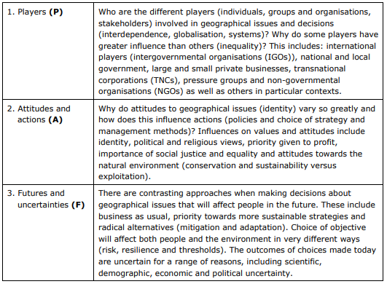

Exam Command Words

Like in your GCSE, the A Level has a variety of command words. You are at a huge advantage if you understand what these words are asking you to do!

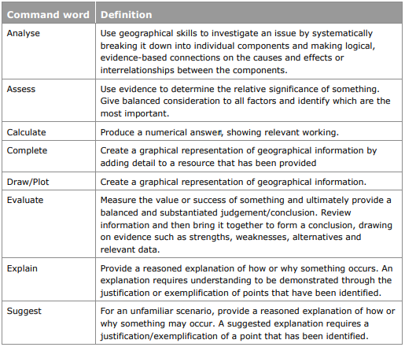

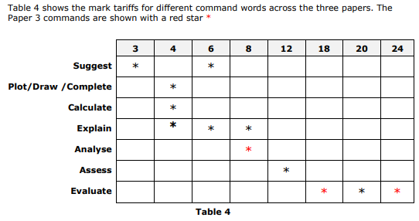**How many marks is each question worth?**

Longer Answer Help

**Assess**

* **12 marks on papers 1 and 2 – 3 marks for AO1, 9 marks for AO2**
* **The exam board says:** “Assess” is used for extended writing questions in which the student is required to use evidence from located examples or a case study to determine the relative significance of something. This is done by considering all the factors and identifying which are the most important; for example, the relative impact of two things or the extent to which something happens in different circumstances. “Assess” does **not** require a conclusion although “Assess the importance of…” or “Assess the relative importance of…” may lead students to a clear conclusion.
* **We say:** How important and reliable are each of the factors you are discussing? Which are the most and least important in supporting or disproving the idea you are being asked about? This does **not** need a conclusion, but you can add one if it helps you.
* The pyramid below shows you a way you can plan structure into your answer.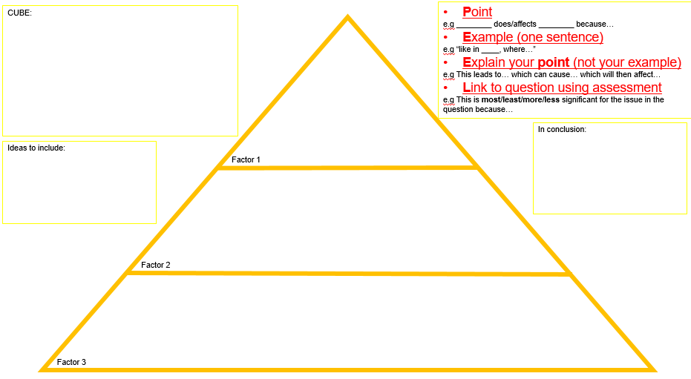

**ASSESS – Have I…**

* Used at least three real life examples?
* Made one point to support the idea the question is leading me to?
* Made two points to challenge the idea the question is leading me to?
* Used the word significant, influence or important?
* Included a sentence to say whether that point has a more or less significant impact than the other points I’ve made?
* Linked your last sentence in the paragraph back to the language in the question?

**Evaluate**

* **20 mark essays across Papers 1 and 2 – 5 marks for A)1, 15 marks for AO2**
* **18 marks on Paper 3 – 3 marks for AO1, 9 marks for AO2 and 6 marks for AO3**
* **24 marks on Paper 3 – 4 marks for AO1, 12 marks for AO2 and 8 marks for AO3**
* **The exam board says:** “Evaluate” is used for extended writing questions in which the student must appraise things by measuring the value or success of something and ultimately come to a substantiated judgement/conclusion. This is done by analysing and reviewing information and then bringing it together to develop a definitive conclusion, substantiated by drawing on evidence such as advantages, disadvantages, strengths, weaknesses, alternatives and relevant data/details from located examples and/or case study. In other words, the student will come “to a view” and offer evidence to support that “view”. Evaluation will be judgemental but not necessarily unequivocal. Recognising that there is always a counter-argument available is an important part of evaluation.
* 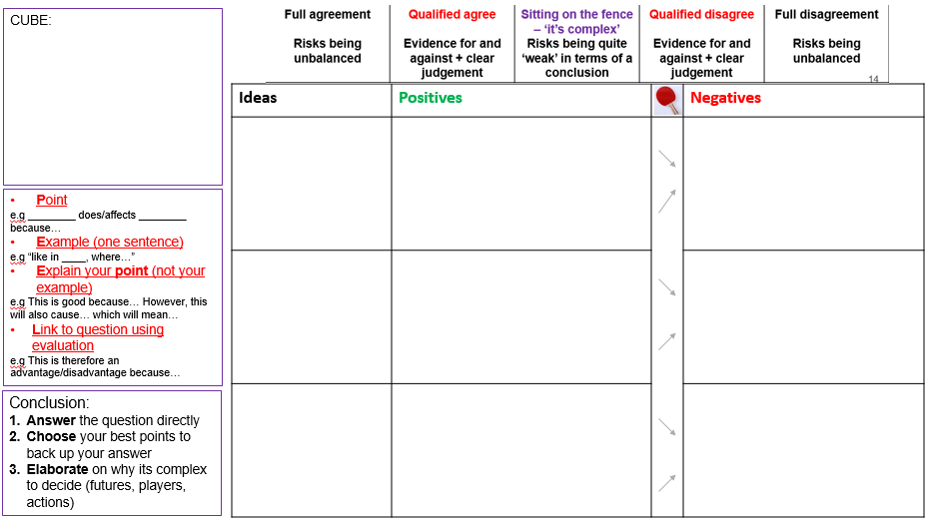**We say**: What are the positives and negatives of the issue? What is the best impact? What are the alternative ways this could happen? How could the existing methods be improved? Needs a **conclusion**.

**EVALUATE – Have I…**

* Used a small introduction to define key words mentioned in the title?
* Got three main paragraphs, plus an intro and conclusion?
* Used a real life example in each of my paragraphs?
* Explained at least one advantage and one disadvantage of each point I have made?
* Ended each paragraph with a sentence to suggest if that idea is mainly positive or negative?
* Finished my question with a conclusion which summarises the main positives, main negatives and has a judgement to answer the question?

**Generic Support**

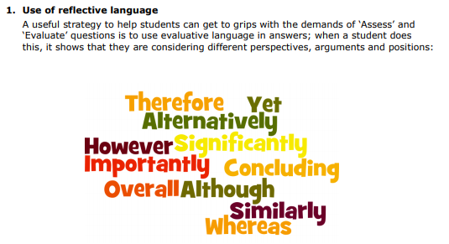

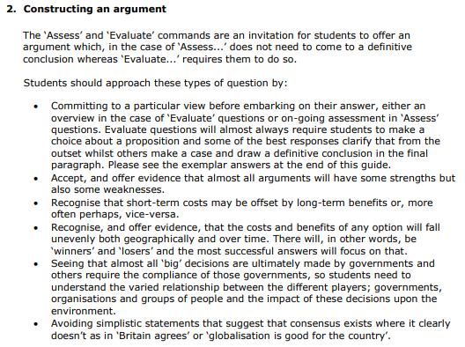

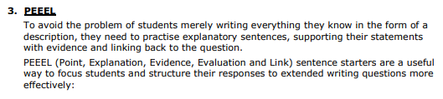

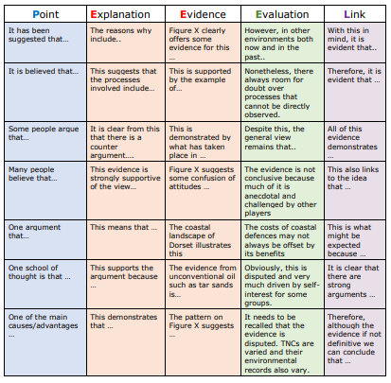

Skills Checklist

|  |  |  |
| --- | --- | --- |
| **Geographical Skills** | **Practice** | **Confident** |
| Use of quantitative and qualitative data |  |  |
| Use of primary and secondary sources |  |  |
| Image and text analysis (qualitative) |  |  |
| Data analysis (quantitative) |  |  |
| Geographical Information Systems |  |  |
| Map analysis |  |  |
| Gini Coefficient/Lorenz Curve |  |  |
| **Statistical Skills** |  |  |
| Correlation |  |  |
| Line of best fit |  |  |
| Sampling |  |  |
| Data presentation e.g dispersion diagrams, satellite images, kite diagrams, linear scales, bar/line graphs, pie charts |  |  |
| T-tests |  |  |
| Spearman’s Rank |  |  |
| **Mathematical Skills (see “Maths in Geography” booklet)** |  |  |
| FDP conversions |  |  |
| Simplifying ratios |  |  |
| Ratio to fraction conversions |  |  |
| Percentage of amounts |  |  |
| Calculator use |  |  |
| Averages |  |  |
| Quartiles and interquartile range |  |  |
| Density |  |  |
| Frequency tables |  |  |
| Histograms |  |  |
| Scatter diagrams |  |  |
| **Fieldwork Skills** |  |  |
| Defining research questions |  |  |
| Practical techniques and why they are used |  |  |
| Fieldwork data presentation techniques |  |  |
| Evaluation |  |  |

Reading List

As an A Level Geographer, you are expected to read around the subject. Below are some useful resources to help you start this process and allow you to gain more context about what we will be learning in lessons and help you start your NEA research.

**Books**

The Almighty Dollar – Dharshini David

Prisoners of Geography - Tim Marshall (anything by Tim Marshall!)

If Only They Didn’t Speak English – Jon Sopel

Factfulness – Hans Rosling

Six Degrees – Mark Lynas

Titles are frequently added to this site:

<https://www.internetgeography.net/wider-reading-in-geography/>

Silent Spring – Rachel Carson

The Good Immigrant – Nikesh Shukla

Guns, Germs and Steel – Jared Diamond

Don’t Go There – Adam Fletcher

Collapse – Jared Diamond

No Logo – Naomi Klein (an eBook can be found at: <https://owd.tcnj.edu/~allyn/No%20Logo%20-%20Naomi%20Klein.pdf>)

Tsotsi – Athol Fugard

Earth in the Balance – Al Gore

Under a Pole Star – Stef Penney

The Women’s Atlas – Joni Seager

The Skeptical Environmentalist – Bjorn Lomborg

There is No Planet B – Mike Berners-Lee

Books by Yuval Noah Harari

Books by Bill Bryson

**Magazines/Journals**

National Geographic Geography Review GA The Economist

Time Society Now Geography and You

**TV/Documentaries**

Blue Planet Human Planet Seven Worlds, One Planet Chernobyl

Walking the Nile/Amazon/Americas Don’t Panic: End Poverty

Don’t Panic: The Truth About Population 7.7 Billion and Counting

Race Across the World Panorama Simon Reeve: The Americas

Stacey Dooley: Fashion’s Dirty Secrets Before the Flood Africa

Into the Inferno The Future of Water

See this site for a full list with online access: <https://www.internetgeography.net/wider-watching-in-geography/>

**Podcasts**

Shared Planet with Monty Don The Guardian The Economist Radio

The Inquiry Science in Action The Things That Made England

A VerySpatial Podcast Two Minute Briefing: The Telegraph News

See here for full list with online access: <https://www.internetgeography.net/wider-listening-in-geography/>

**Apps**

The Economist: World In Figures Mark O’Travel iGeology Google Earth iNaturalist Map Master The Extra Mile

United Nations Environmental Water 1der Earthquake

Wider Reading Tracker

Use the document below to help you structure your notes for your wider reading. Additional copies can be provided by your teachers!

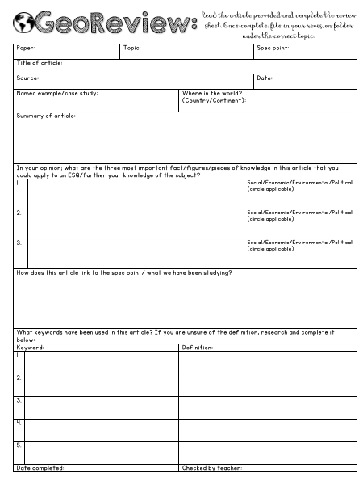

Discovery Worksheets

The sheets below include all the key ideas and themes you will be learning about in the A Level course. They are useful for revision and for NEA preparation.

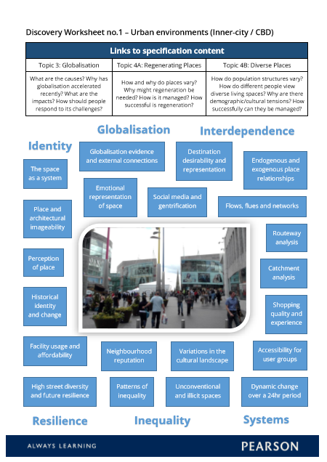

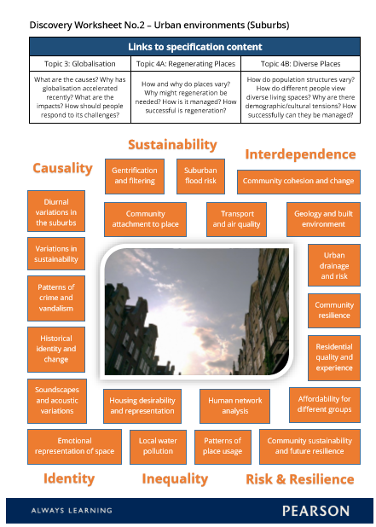

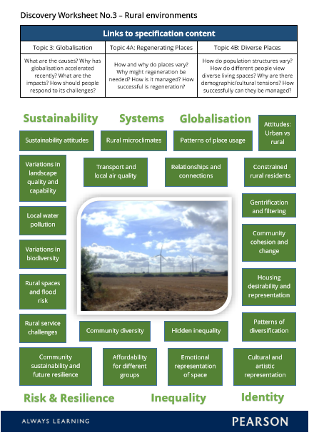

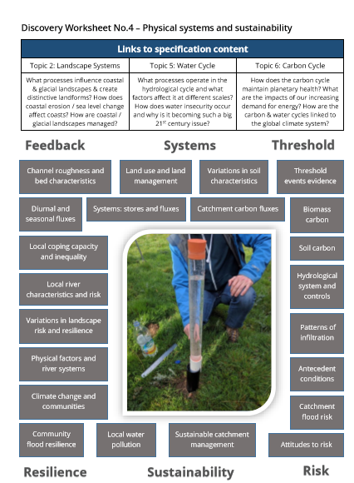

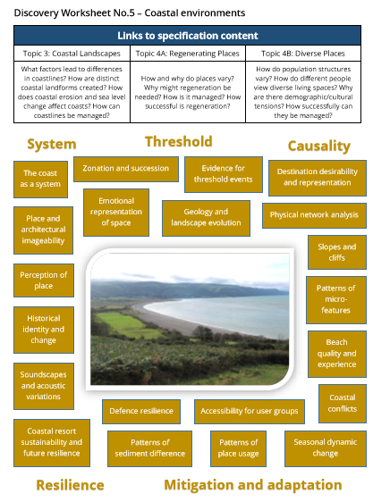

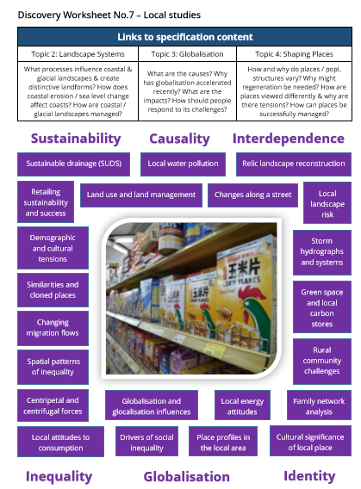

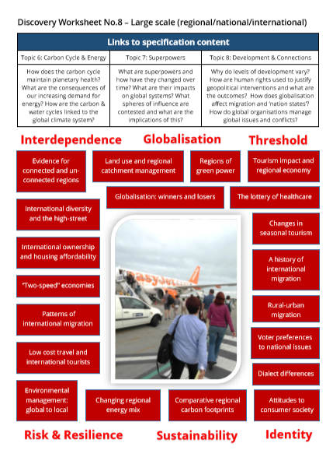

Practice Questions

**Tectonics**

1. Name one stage of the hazard management cycle. (1)
2. Explain two strategies that are used to modify vulnerability to volcanic hazards. (4)
3. Using a named location, explain how hydro-meteorological hazards can contribute to a tectonic disaster. (6)
4. Assess how prediction can contribute to the management of tectonic hazards. (12)
5. Explain two reasons why the number of reported earthquakes has risen since 1960. (4)
6. Explain the causes of tsunamis. (6)
7. Assess the significant of earthquake hazard profiles in relation to the effectiveness of management strategies. (12)
8. Assess the importance of governance in the successful management of tectonic mega-disasters (12)
9. Assess the importance of tectonic hazard profiles in understanding the severity of impacts resulting from earthquake events (12)
10. Identify one process that occurs only at destructive plate boundaries (1)
11. Explain two secondary hazards caused by earthquakes (4)
12. Explain the tectonic hazards that may result from volcanic activity (6)
13. Assess whether development and governance are the most important factors in understanding the scale of tectonic disasters (12)
14. Define what is meant by disaster (1)
15. Explain two reasons how a government might influence a community’s resilience. (4)
16. Explain why some earthquakes generate secondary hazards. (6)
17. Assess the factors that contribute to increased impacts from some tectonic hazard events. (12)
18. Explain the reasons why volcanoes are more likely along some plate margins than others (6)
19. Assess the contribution of plate-tectonic theory to our knowledge of the Earth’s structure (12)
20. Explain the causes of one earthquake. (6)
21. Assess the relative importance of the hazards associated with destructive plate margins. (12)
22. Explain the hazards cause by one volcanic eruption. (6)
23. Assess the range of hazards caused by explosive volcanic eruptions. (12)
24. Explain the formation of a tsunami. (6)
25. Assess the severity of the various impacts of tsunami. (12)
26. Assess the reasons why, even within a country, some people are more vulnerable to hazards than others. (12)
27. Assess the importance of the concept of vulnerability in understanding hazards’ impacts. (12)
28. Explain the impacts of one major tectonic disaster. (6)
29. Assess the extent to which a country has been able to meet the pressures placed upon it by a major disaster. (12)
30. Explain why some disasters are economically costly, while others are more costly in terms of human lives. (6)
31. Assess the statement that ‘we are living in a more hazardous world’. (12)
32. Assess the vulnerability of one named country to natural hazards. (12)
33. Assess the extent to which hydro-meteorological hazards can produce very similar impacts to hazards with tectonic causes. (12)
34. Explain the value of Park’s hazard-response curve in understanding the management of the impacts of tectonic hazards. (6)
35. Assess the usefulness of theoretical frameworks in understanding the prediction, impact and management of tectonic hazards. (12)
36. Assess the value of hazard-mitigation strategies. (9)
37. With reference to earthquake waves, explain two reasons why it is difficult for buildings to remain intact during an earthquake event. (4)
38. Explain the link between plate boundary type and the strength of earthquake waves (4).
39. Explain the geographical criteria that can be used to decide if a tectonic event is a hazard, disaster or mega-disaster. (6)
40. Explain the correlation between the magnitude and intensity scales used for measuring earthquakes and their secondary hazards. (4)
41. Compare the tectonic hazard impacts in developed countries with those in developing / emerging countries. (6)
42. Explain how emergency planners and engineers may help to modify the impacts of a tectonic hazards. (6)
43. Explain why insurance companies may be interested in encouraging the accurate prediction of, and effective preparation for, a tectonic hazard. (4)
44. Assess the reasons why earthquakes create more disasters than volcanic eruptions (12)
45. Assess the relative importance of the physical characteristics of volcanic eruptions in creating risk for people (12)

**Coasts**

1. Explain two processes in the formation of offshore bars. (4)
2. Explain how geological structure affects the development of coastal landforms. (6)
3. Assess the importance of lithology in influencing the rate of coastal erosion. (12)
4. State one coastal depositional landform.
5. Suggest one eustatic factor that might have influenced the changes shown in Figure 5. (3)
6. Explain two local factors that increase flood risk for low-lying islands. (4)
7. Explain the physical processes involved in a sediment cell system. (6)
8. Assess whether storm surges pose an increasing risk for some coastlines. (12)
9. Explain how the sediment cell concept contributes to the understanding of coastal systems (8)
10. Evaluate the contribution that changes in sea level make to the formation of coastal landscapes (20)
11. Explain how sub aerial processes contribute to the development of landscapes (6)
12. Explain why hard engineering approaches are still used to protect some coastal environments (8)
13. Evaluate the view that climate change is the most important factors in influencing coastal flood risk (20)
14. State one factor that affects coastal sediment transport (1)
15. Suggest one reason why the wave frequency differs at two locations (3)
16. Explain two coastal depositional processes (4)
17. Explain the factors that create an erosional coastline (6)
18. Assess whether sustainable management schemes are always the most appropriate for managing the risks to coastlines (12)
19. Name one erosion process that occurs at a coast (1).
20. Assess the importance of mass movement in influencing the rate of coastal recession and landform change. (12)
21. Evaluate the extent to which all coastlines can be protected using sustainable management approaches. (12)
22. Explain how geological structure influences the development of coastal landforms. (8)
23. Using examples, explain the characteristics of high-energy coastlines, (6)
24. Referring to examples, explain the problems of classifying coastlines. (8)
25. Explain the relationship between geology and coastal form along a named stretch of coast. (6)
26. Assess the extent to which rates of coastal recession and stability depend on lithology. (12)
27. Compare constructive and destructive waves. (4)
28. Explained how different wave types result in different beach profiles. (6)
29. Explain two processes or erosion that increase in importance during storms. (6)
30. Assess the importance of different erosion processes in the development of cliff features. (12)
31. Explain the characteristics of a ‘drift-aligned’ stretch of beach. (6)
32. Assess the relative importance of depositional processes along a named stretch of coast. (12)
33. Assess the relative importance of different methods of mass movement along one stretch of coast. (12)
34. Explain the difference between eustatic and isostatic change. (4)
35. Assess the contribution of geologically recent eustatic changes to the UK’s coastal landscapes. (12)
36. Assess the relative importance of factors which have led to rapid coastal erosion along a stretch of coastline. (12)
37. Explain the physical and human causes of one flood in a developing country. (8)
38. Evaluate the influence of a country’s level of development in determining the impacts of coastal flooding. (12)
39. Assess the effectiveness of hard-engineering approaches designed to protect the coast from erosion. (12)
40. Evaluate the effectiveness of coastal-management strategies along a stretch of coast. (12)
41. Assess the effectiveness of holistic strategies used to protect a named coast from erosion. (12)   
    Explain how geology is an important influence on the shape (morphology) and features of a coastline. (6)
42. Explain how vegetation can bring stability to low-energy coastlines (6)
43. Explain the difference between low-energy and high-energy coastal environments. (6)
44. Explain why coastal processes may vary from day to day. (6)
45. Explain the formation of a cuspate foreland. (6)
46. Explain how local factors may increase the risk of coastal flooding. (6)
47. Explain the impact of storm surges on lowland coastal areas. (8)
48. Explain the possible social impacts of coastal recession on coastal communities. (6)
49. Explain why UK Government coastal management policies vary from place to place (6)
50. Assess the benefits of soft engineering approaches when managing threatened coasts (12)
51. Evaluate the threats for lowland coastal areas arising from future SLR (12)
52. Assess the severity of the various impacts of tsunami. (12)

**Water Cycle**

1. Explain why river regimes might vary between basins. (6)
2. Explain how physical and human factors contribute to an increased risk of water insecurity. (8)
3. Evaluate the view that some approaches to managing water insecurity are more sustainable than others. (20)
4. Explain the impact climate type can have on soil water availability. (6)
5. Explain how climate change might have significant impacts on the operation of the water cycle. (8)
6. Assess the extent to which some approaches to future water supply management are more sustainable than others. (12)
7. Evaluate the extent to which conflicts might occur between users within a country, and internationally, over the use of water and energy. (20)
8. Explain how the global hydrological cycle operates as a closed system. (6)
9. Explain why a drainage basin can be regarded as an open system. (6)
10. Using examples assess the extent to which the hydrological cycle can influence river systems at a local level. (12)
11. Using examples assess ways in which deficits within the hydrological system can have significant impacts. (12)
12. Using examples assess the extent to which human activities can exacerbate flood risk. (12)
13. Using examples assess the impacts that climate change may have on the hydrological cycle. (12)
14. Evaluate the extent to which water insecurity is the result of physical or human cause. (20)
15. Assess the risks associated with water insecurity. (12)
16. Assess the effectiveness of strategies designed to make water use more sustainable. (12)
17. Explain the meteorological causes of river flooding. (8)
18. Explain why there is an increasing global demand for water. (8)
19. Explain the advantages and disadvantages of a sustainable water management scheme. (6)
20. Assess the significance of environmental and economic impacts caused by river floods. (12)
21. Evaluate the contribution of large-scale schemes to increasing water security. (20)

**Carbon Cycle**

1. Evaluate the extent to which today’s increasing demand for energy is the most important factor modifying the carbon cycle. (20)
2. Explain why energy pathways are prone to disruption. (8)
3. Explain the impact of the changing global consumption of fossil fuels on the carbon cycle. (6)
4. Explain one reason for changing oil production in the USA. (3)
5. Explain how forests influence the water cycle. (6)
6. Evaluate the extent to which mitigation is the most important strategy in tacking climate change. (20)
7. Evaluate the role of different players involved in the carbon cycle. (20)
8. Explain the importance of fluxes to the carbon cycle. (6)
9. Explain the significance of carbon sequestration. (6)
10. Explain why as balanced carbon cycle is important for sustaining other earth systems. (6)
11. Assess the extent to which one of more countries that you have studied is energy secure. (12)
12. Using a named example, assess the geopolitical risks to the world of its reliance on fossil fuels. (12)
13. Evaluate the extent to which alternatives to fossil fuel energy sources provide an energy secure future. (20)
14. Using examples, evaluate the extent to which the carbon cycle and water cycle are being threatened by human activities. (20)
15. Referring to examples, evaluate the implications for human well-being caused by the degradation of the water cycle and carbon cycle. (20)
16. Evaluate the responses from different players to the threat of a large scale release of stored carbon caused by planetary warming. (20)
17. Explain how geological processes store carbon for a long period of time. (8)
18. Explain how plants help to maintain a balance in the carbon cycle. (6)
19. Explain why renewable energy sources have costs in terms of their contribution to energy security. (8)
20. Explain how an increase in drought frequency may affect forests as carbon stores. (8)
21. Explain why there is uncertainty in the projections of future atmosphere CO2 concentrations. (8)
22. Assess the importance of renewable energy sources to achieving a carbon-neutral energy mix. (12)
23. Evaluate the extent to which geological processes control the carbon cycle. (20)

**Globalisation**

1. Define global shift (1)
2. Define the term TNC (1)
3. Suggest one reason why labour costs are significantly cheaper in Bangladesh (3)
4. Explain two ways change in transport have accelerated globalisation (4)
5. Explain how globalisation can result in environmental exploitation in developing countries. (6)
6. Assess the extent to which cultural diffusion caused by globalisation inevitably leads to social and political tension. (12)
7. Explain two ways that national government have contributed to globalisation (4)
8. Explain why some locations remain ‘switched off’ from globalisation (6)
9. Assess the extent to which ethical consumption trends may have reduced the negative consequences of globalisation. (12)
10. Explain why globalisation results in cultural erosion in some parts of the world (4)
11. Assess the impact of TNCs on creating both winners and losers for people and environments (12)
12. Explain one reason why the scale of economic migration has increased (4)
13. Assess why the impact of globalisation will vary within a country, such as the Netherlands (12)
14. Assess the extent to which emerging countries need both ‘hard’ and ‘soft’ power to extend their global influence (12)
15. Explain why different media convey contrasting views on the need for local regeneration schemes (6)
16. Evaluate the relative importance of local and national government decision-makers in the regeneration of either urban or rural areas (20)
17. State an example of a composite index using development (1)
18. Explain why one political factor and one social factor might cause some countries to be ‘switched off’ from globalisation’ (4)
19. Explain how levels of globalisation can be measured using different indicators and indices (6)
20. Assess the role of trade blocs in contributing to the growth of both the global economy and national economies. (12)
21. Define shrinking world. (1)
22. Explain two reasons in which individual states can benefit from trade bloc membership. (4)
23. Explain how the growth of a global culture may help improve opportunities for disadvantaged people in developing counties. (6)
24. Assess the extent to which globalisation is responsible for environmental degradation in developing and developed countries. (12)
25. Explain how changes in technology have speeded up the process of globalisation (6)
26. Explain how technology has contributed to the process of globalisation (6)
27. Explain the term ‘liberalisation’ of trade. (4)
28. Assess the extent to which the globalisation of trade can bring problems as well as benefits. (12)
29. Explain two ways in which TNCS promote globalisation. (4)
30. Assess the role played by TNCS in the globalisation process. (12)
31. Explain why internet usage in sub-Saharan Africa is low compared to the rest of the world. (4)
32. Using examples, explain why some countries are more globalised than others (8)
33. Explain the impacts of the global shift on one country that you have studied. (6)
34. Assess the impacts of the global shift on one named country. (12)
35. Using examples, explain the impacts of international migration on host locations. (12)
36. Assess the role of international migration in the globalised economy. (12)
37. Explain the process of cultural diffusion. (4)
38. Assess the contribution of globalisation to cultural diffusion. (12)
39. Explain why economic and human indicators of development can sometimes give different impression of a country’s level of development. (12)
40. Assess the statement, ‘globalisation produces as many losers as it does winners’. (12)
41. Explain two attempts that have been made to control the spread of globalisation. (4)
42. Assess the nature of social, political and environmental tensions that have resulted from change caused by globalisation. (12)
43. Explain how local groups and NGOs can promote local sourcing of food and other goods. (6)
44. Assess the actions taken by NGOs and local governments in promoting ethical and environmental concerns about unsustainability. (12)
45. Explain how changes in communication and ICT has accelerated globalisation (6)
46. Explain how national government encourage FDI in their economies. (4)
47. Explain why some emerging economies have experienced major environmental problems as a result of the global shift. (6)
48. Explain why globalisation has caused change to built environments in economically emerging countries (4)
49. Explain why it might be considered unethical to buy consumer products made in developing countries (6)
50. Explain how globalisation may change cultural identity (4)
51. Assess the social and economic problems caused by the rapid growth of megacities (12)
52. Assess the role of technology and trade blocs in accelerating globalisation. (12)

**Regenerating Places**

1. Suggest one reason for the growth of employment in tourism in some regions. (3)
2. Explain two reasons why there are variations in people’s attachment to rural places. (4)
3. Explain the consequences of a decline in rural services (6)
4. Explain two reasons why regeneration plans can sometimes lead to conflict between different interest groups. (4)
5. Explain how different strategies have been used to rebrand the post-production countryside. (6)
6. Assess the role of different stakeholders in managing change in areas undergoing regeneration. (12)
7. Explain why different groups would have contrasting views about regenerating vacant land in cities (6)
8. Evaluate the importance of rebranding to the success of rural regeneration (20)
9. Define the term deindustrialized region (1)
10. Explain two reasons why different urban community groups may have contrasting views about regeneration (4)
11. For a local place that you have studied, explain why people’s sense of identity has been influenced by the economic and social change it has experienced. (6)
12. Assess the extent to which economic regeneration brings benefits to rural areas (12)
13. Suggest two methods for assessing whether a place can be classed as ‘successful’. (4)
14. Explain two reasons why there are variations in people’s perceptions of their local place, based on reality or imagination. (4)
15. Explain the consequences of a loss of manufacturing in urban areas. (6)
16. Explain how employment changes have affected your local place. (8)
17. Assess the extent to which economic activity, social factors and quality of life have affected your local place. (12)
18. Explain how increasing connectedness has shaped the economic and social characteristics of a place you have studied (8)
19. Assess how far past and present connections have shaped the economic and social characteristics of a place you have studied. (12)
20. Explain how the identity of one place you have studied has been affected by change. (6)
21. Explain the reason for the economic success of one place you have studied. (8)
22. Evaluate the reasons why some places are ‘economically successful’ while others are not. (12)
23. Using examples, assess the reasons why the degree to which people engage with place varies. (12)
24. Evaluate the reasons why people’s lived experience of places and engagement with them varies. (12)
25. Explain two ways in which the need for regeneration can be identified. (6)
26. Using examples, evaluate the need for regeneration in different places. (12)
27. Using examples, access the role of central government in regeneration. (12)
28. Evaluate the role of central government in regenerating places. (12)
29. Assess the attempts by governments to regenerate rural areas. (12)
30. Evaluate the success of local government policies which aim to attract inward investment to rural areas. (12)
31. Explain the role of local councils in urban regenerations. (6)
32. Evaluate the success of a named urban regeneration process. (12)
33. Assess the success of regeneration in one area that you have studied. (12)
34. Using examples, assess the roles of different players in the urban regeneration process. (12)
35. Assess the reasons why different players have different criteria for judging the success of urban regeneration. (12)
36. Using examples, assess the success of one or more rural regeneration projects. (12)
37. Evaluate the role of different players in the success of rural regeneration projects. (12)
38. Explain two reasons why the function of a place might change over time. (4)
39. Explain why employment factors may create variations in quality of life between places (6)
40. Explain two reasons why levels of engagement in local communities vary (4)
41. Using a named place, explain why some regions are regarded as ‘successful’. (6)
42. Explain two ways in which local national government can affect decision-making about regeneration (4)
43. Explained how the deregulation of capital markets affects growth and investment. (6)
44. Explain two ways in which social measures can be used to assess the success of regeneration schemes. (4)
45. Explain why different stakeholders assess the success of regeneration using contrasting criteria. (6)

**Superpowers**

1. Explain why defence spending is seen as crucial to the development of superpower status (4)
2. Assess to what extent the superpowers’ rising demand for physical resources has led to both environmental and political challenges (12)
3. Explain how ‘soft power’ can be used to maintain superpower status (4)
4. Explain the role of superpowers in international crisis response (4)
5. Assess the extent to which emerging superpowers threaten the economic and political global dominance of the USA (12)
6. Explain how economic restructuring has affected the economies of existing superpowers (4)
7. Assess the importance of military and economic alliance in maintaining superpower status (12)
8. Assess the extent to which geopolitical power stems from a range of countries’ human and physical characteristics. (12)
9. Explain two ways in which nations have maintained power and influence over other countries. (6)
10. Assess to what extent China can claim to be a superpower. (12)
11. Assess the influence of TNCs over the global economic system. (12)
12. Assess the effectiveness of superpowers and emerging nations in playing key roles in international decision-making (12)
13. Assess the extent to which global concerns about the physical environment can be disproportionately influenced by superpower action (12)
14. Using examples, assess the ways in which global influence may be contested politically (12)
15. Referring to examples, assess the changing relationships between existing and emerging superpowers (12)
16. Assess the extent to which the position of the USA as a uni-polar superpower is being questioned. (12)
17. Explain the extent to which neo-colonialism affects geopolitical stability (8)
18. Explain how world systems theory can be used to help explain changing patterns of power (6)
19. Explain why military alliances are an important part of international decision-making (6)
20. Explain the extent to which superpowers influence action on global environmental concerns (8)
21. Explain how tensions can increase between countries over the acquisition of physical resources such as oil (6)
22. Explain how contrasting cultural ideologies may affect the relationships between developing and developed countries (8)
23. Assess the extent to which the USA’s superpower status is threatened by emerging economies such as the BRICS (12)
24. Assess the extent to which the balance between direct and indirect superpower influence has changed over time (12)

**Migration, Identity and Sovereignty**

1. Explain the role of global organizations in managing the global economy (8)
2. Evaluate this statement: ‘In a globalizing world, national sovereignty becomes less important’ (20)
3. Explain why national identity is a complex idea in many countries (4)
4. Explain why IGOs have had varying success in helping to tackle environmental problems (6)
5. Explain why restrictions over international movement of labour vary (8)
6. Evaluate the advantages of low-tax regimes, such as the Isle of Man, for individuals, organizations and countries (20)
7. Explain why sovereign states vary in their level of cultural and political unity (8)
8. Evaluate the following statement: ‘Global organisations have failed to respond effectively to the most important challenges which the world faces’ (20)
9. Explain why globalization and increased international migration are linked. (6)
10. Referring to examples, evaluate the economic, social and political causes of international migration (20)
11. Explain why immigration can cause political tensions (6)
12. Evaluate the factors which may lead to national borders being contested (20)
13. Evaluate the extent to which nationalism has played a role in the development of the modern world (20)
14. Explain how global inequalities may be seen as a threat to the global economic system (8)
15. Evaluate the importance and achievements of one global organization in the post 1945 world (20)
16. Evaluate the extent to which IGOs may lead to an erosion of national economic sovereignty (20)
17. Evaluate the success of IGOs in managing global environmental problems (20)
18. Explain why national identity is an elusive and contested concept (8)
19. Evaluate the contribution of globalization to Western identity (20)
20. Evaluate the consequences of disunity within nations (20)
21. Explain how supranational groups manage migration both within and between countries (6)
22. Explain why migration in the 21st centuries is increasing both within and between countries (8)
23. Suggest how nationalism has shaped the identity of modern nations (6)
24. Explain how globalisation processes have influenced the emergence of new forms of nation state (8)
25. Suggest how the ‘war on terror’ may bring challenges for intergovernmental organizations (6)
26. Explain the role of IGOs in the management of global environmental problems (8)
27. Explain the historical and contemporary influences on national identity (8)
28. Explain the possible causes of disunity within developed and emerging nations (8)
29. Explain the role of national governments in managing migration flows (8)
30. Evaluate this statement: “In a globalised world, nationalism remains a powerful force” (20)