**LUNGS, VENTILATION AND GAS EXCHANGE: REVISION CHECKLIST**

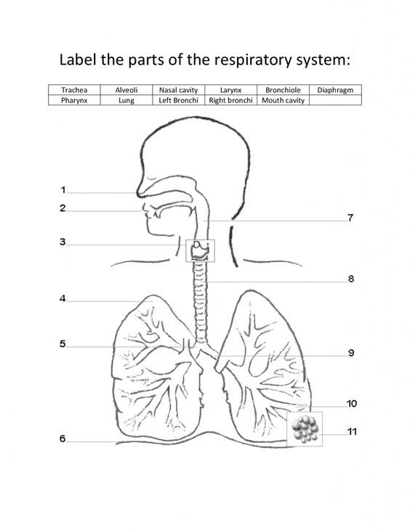

You will need to be able to label the parts of the respiratory system

Starting with air entering the nasal cavity and ending with the alveoli, name the structures that air passes through in the correct order.

**Lungs, gas exchange and ventilation: revision checklist**

|  |  |  |
| --- | --- | --- |
|  | Inhalation | Exhalation |
| Intercostal muscles contract? |  |  |
| Movement of intercostal muscles? |  |  |
| Diaphragm contracts? |  |  |
| Movement of diaphragm |  |  |
| Volume of lungs |  |  |
| Pressure of lungs |  |  |
| Flow of air | IN | OUT |

**Ventilation**

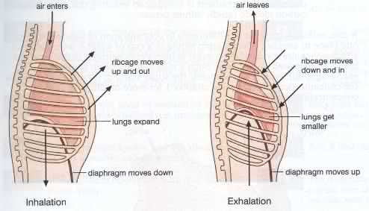

**Alveoli are the site for gas exchange**

O2 diffuses down a concentration gradient from the alveoli into the capillaries; CO2 diffuses down a concentration gradient from the capillaries into the alveoli

|  |  |
| --- | --- |
|  | How this feature ensures efficient diffusion of O2 and CO2 |
| Capillary and alveoli walls made up of a single layer of flattened epithelial cells |  |
| Capillaries are very close to alveoli |  |
| Air is constantly replaced in the alveoli (by breathing) and blood is constantly replaced in capillaries (by blood circulation) |  |
| There are many, small alveoli |  |

