**HEART AND BLOOD: REVISION CHECKLIST**

The **heart** pumps oxygenated blood around the body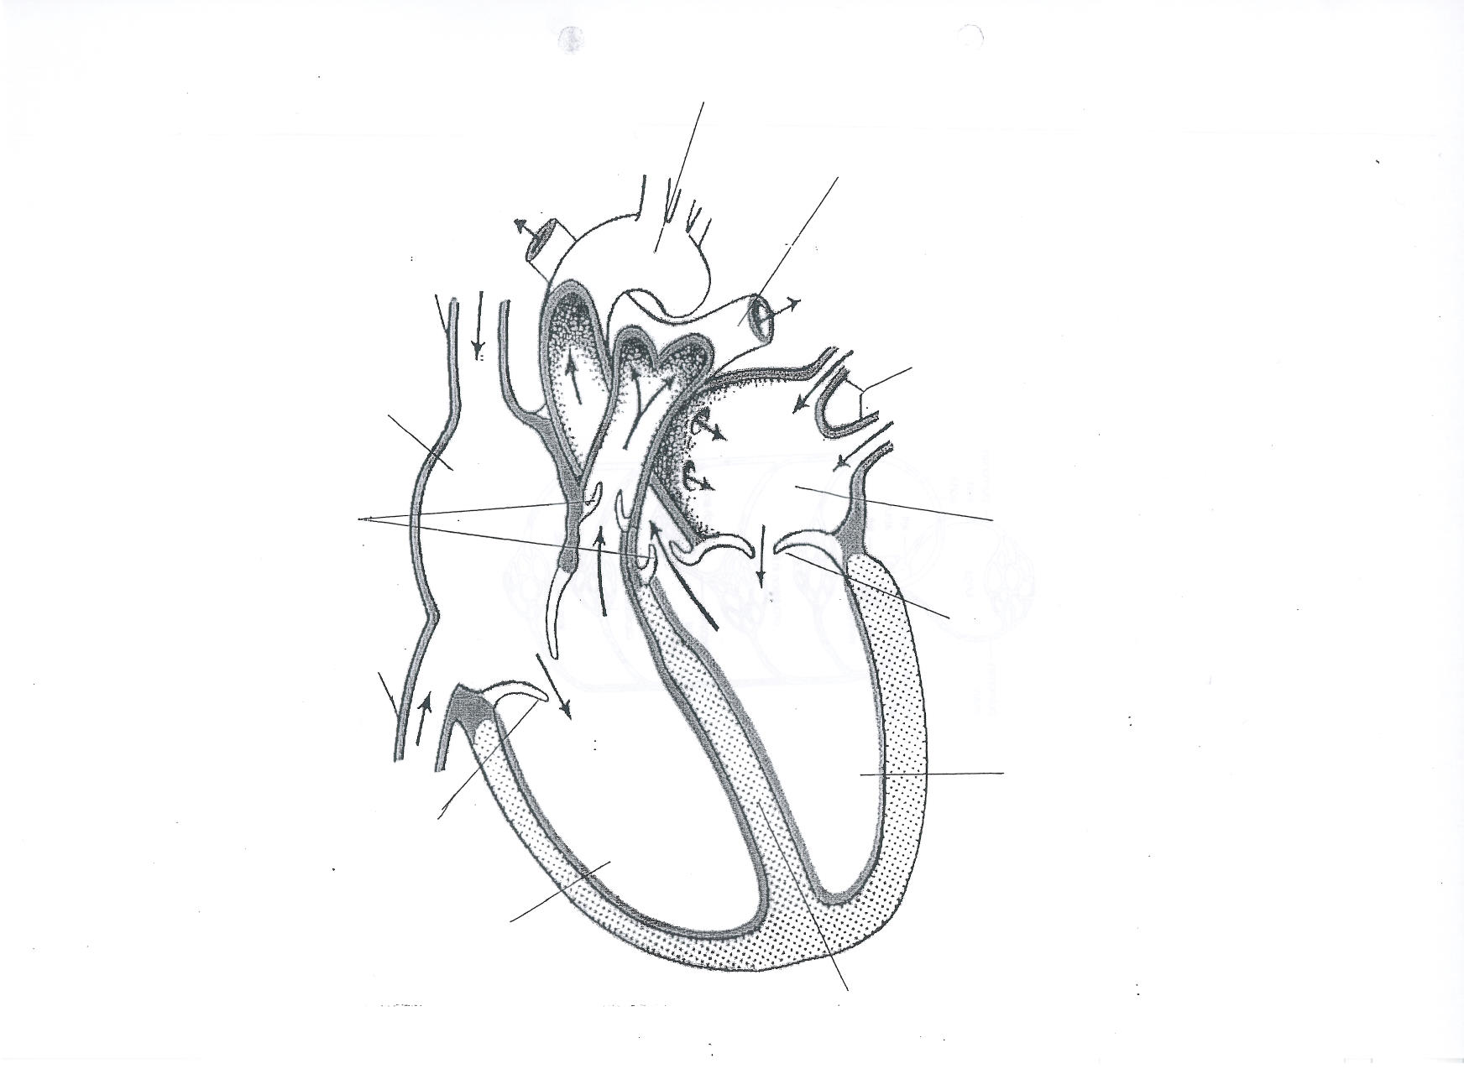

Find out the names of the heart structures

The coronary arteries branch off the aorta. What is the role of the coronary arteries?

Starting with blood returning from the body, list the structures of the heart that blood flow through in the correct order.

**Blood** components

|  |  |
| --- | --- |
|  | Function |
| Red Blood Cells |  |
| White Blood Cells |  |
| Plasma |  |
| Platelets |  |

**Blood vessels**

|  |  |  |  |
| --- | --- | --- | --- |
|  | Function | Structural features | How structural features relate to function |
| Arteries |  |  |  |
| Capillaries |  |  |  |
| Veins |  |  |  |

**Control of heart rate**

Which part of the brain controls heart rate?

Which part of the heart receives input from the heart?

Which branch of the autonomic nervous system SPEEDS UP heart rate?

Which branch of the autonomic nervous system SLOWS DOWN up heart rate?

During exercise, increased respiration produces CO2, which ……………. pH: ……………receptors detect this and send impulses to the brain: how does this change heart rate?

At rest, decreased respiration produces less CO2, which …………………. pH: …………receptors detect this and send impulses to the brain: how does this change heart rate?

Decreased blood pressure is detected by …………….. receptors and impulses are sent to the brain: how does this affect heart rate?

Increased blood pressure is detected by ………………. receptors and impulses are sent to the brain: how does this affect heart rate?

**Exchange of substance between blood and cells (role of tissue fluid)**



How is tissue formed at the arterial end of the capillary bed?

How is tissue fluid reabsorbed at the venous end of the capillary bed?

Where does excess tissue fluid drain?

What are lymph nodes? Name the lymph vessels.