**Cell division**: describe what happens to the chromosomes of a cell during the stages of cell division by mitosis

|  |  |
| --- | --- |
| **Stage** | **Description** |
| Prophase |  |
| Metaphase |  |
| Anaphase |  |
| Telophase |  |
| Cytokinesis |  |

**Definitions**

|  |  |
| --- | --- |
| **Word** | **Definition/ description** |
| Diploid |  |
| Haploid |  |
| Chromatid |  |
| Homologous chromosomes |  |

**Enzymes**

Enzymes are proteins. How does the structure of an enzyme relate to its function? (use the words tertiary structure, active site, complementary, substrate, enzyme substrate complex)

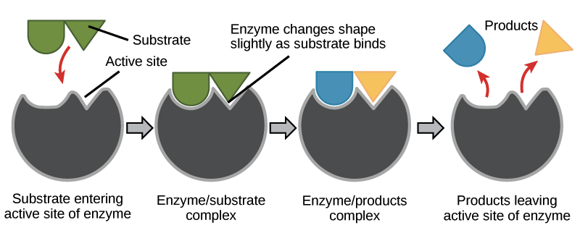

**Cell cycle**

What happens in G1, S and G2 of interphase?

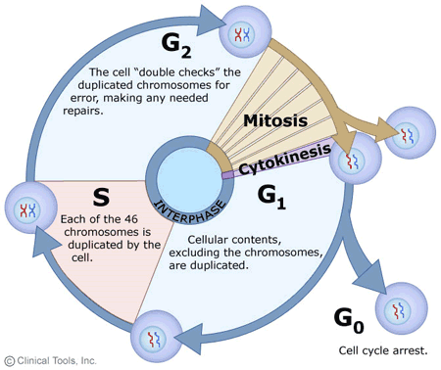

**CELLULAR ACTIVITIES: TOPIC CHECKLIST**

**Respiration**

What is the equation for respiration?

|  |  |  |
| --- | --- | --- |
| Name of stage | Location | Net yield per glucose |
| Glycolysis |  |  |
| Link Reaction |  |  |
| Kreb’s Cycle |  |  |
| Electron transport chain |  |  |