**Cells and transport across cell membranes topic checklist**

|  |  |
| --- | --- |
| ORGANELLE | FUNCTION |
| Nucleus |  |
| Nucleolus |  |
| Mitochondrion |  |
| Rough ER |  |
| Smooth ER |  |
| Golgi apparatus |  |
| Vesicle |  |
| Lysosome |  |
| Ribosome |  |
| Centrosome |  |
| Peroxisome |  |

Find out the structure and function of the cell **organelles** listed above

What molecules is the **plasma membrane** made up of? How are they arranged?

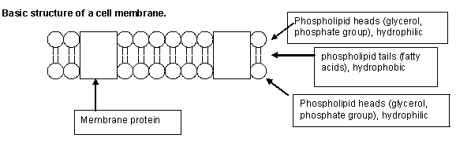

Comparing the ways that molecules get into and out of cells: Fill in the table below (the first one has been completed for you)

|  |  |  |  |
| --- | --- | --- | --- |
|  | Transport mechanism | Use of transport protein? | Use of energy? |
| Simple Diffusion | Down a concentration gradient | No: small molecules with no charge can diffuse straight through the phospholipid bilayer | No, this is a passive process, but molecules will need to have kinetic (movement) energy |
| Facilitated Diffusion |  |  |  |
| Active transport |  |  |  |
| Osmosis |  |  |  |
| Endo- and Exo-cytosis |  |  |  |

How many µm in a mm?

How many nm in a µm?

If the image of a cell structure is 10mm and the magnification is x2000, what is the actual size of the cell structure, in µm.

I

A

M