What is a gene mutation?

Give some examples of mutagenic agents.

What is the difference between acquired and hereditary genetic mutations?

Give some examples of acquired genetic mutations (eg. those caused by mutagenic agents)

Give some examples of hereditary genetic mutations

How would a single base mutation affect the structure and functioning of the protein coded for by that gene? (Answer the questions below to help you answer this question):

What effect would a change in DNA base sequence have on the mRNA base sequence during transcription? How would this affect the amino acid sequence during translation? How would this affect the structure of the resulting protein? How would this affect the functioning of the resulting protein?

**Gene expression and the effect of mutations**

Genes are sections of DNA with a specific base sequence that codes for a protein.

Protein synthesis occurs in two stages: **transcription** (DNA 🡪 mRNA) and **translation** (mRNA 🡪 sequence of amino acids)

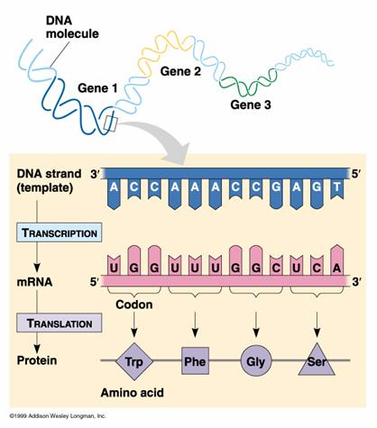

**TRANSLATION**: Describe what is happening in this picture (*Mention: role of the ribosome; mRNA codons; tRNA anticodons; complementary base pairing; amino acids; peptide bonds; polypeptide*)

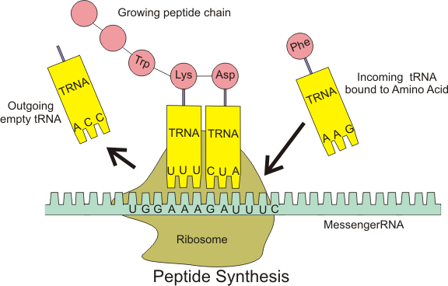

**TRANSCRIPTION**: Describe what is happening in this picture *(Mention: RNA nucleotides; complementary base pairing; role of RNA Polymerase; introns and exons; splicing)*

