**Immune response and immune dysfunction & diagnosis**

**Specific immune response**

Define ‘antigen’:

What is the difference between ‘self antigens’ and ‘non-self antigens’?

Define ‘antibody’:

|  |  |
| --- | --- |
| Stage of response | Description |
| 1 Antigen presentation |  |
| 2 Clonal selection |  |
| 3 Clonal expansion |  |
| 4 Differentiation |  |

*TIPS:* ***1*** *where are pathogen antigens presented? What happens first, before they are presented?* ***2*** *How is B cell selected? What is the role of the T helper cells?* ***3*** *How do the selected B cells increase in number?* ***4*** *Which cells are formed during this stage: what are their roles?*

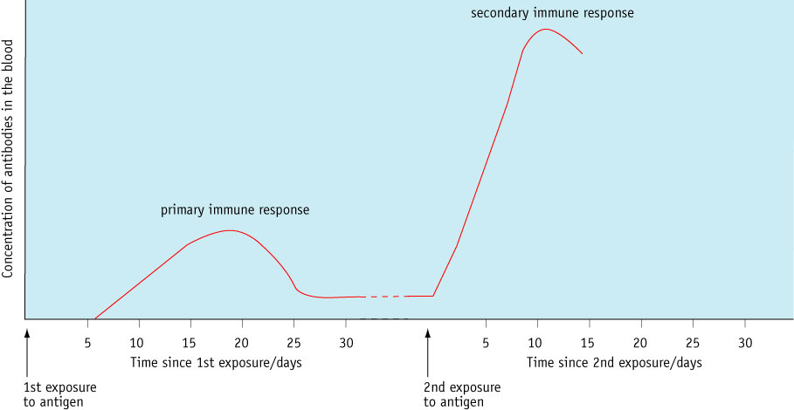

Why is the secondary response faster and ‘stronger’ than the primary response? (*TIP: mention role of the memory cells*)

**Non-specific response: phagocytosis** FILL IN THE MISSING WORDS

Phagocyte (a type of ……………… blood cell) extends its ……………………………… around the pathogen, until it meets either side of the pathogen. The pathogen is now trapped inside a large vesicle type structure, called a ………..………, inside the phagocyte. Organelles inside the phagocyte called …………………………. contain hydrolytic ………………… . These fuse with the ………………………., releasing the enzymes into the …………………………. . The enzymes hydrolyse the pathogen’s molecules, destroying it.

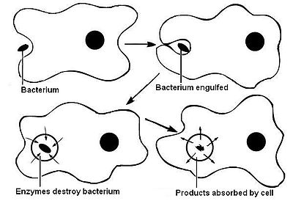

**Immune dysfunction and diagnosis**

|  |  |  |  |  |  |
| --- | --- | --- | --- | --- | --- |
|  | Examples | cause | Diagnostic method | symptoms | treatments |
| Autoimmune diseases | Type 1 diabetes; MS; Chrohn’s; rheumatoid arthritis |  |  |  |  |
| Primary and secondary immunodeficiency diseases | SCID; those associated with HIV, chemotherapy |  |  |  |  |
| Allergies and allergens | Asthmas; anaphylaxis; dermatitis |  |  |  |  |