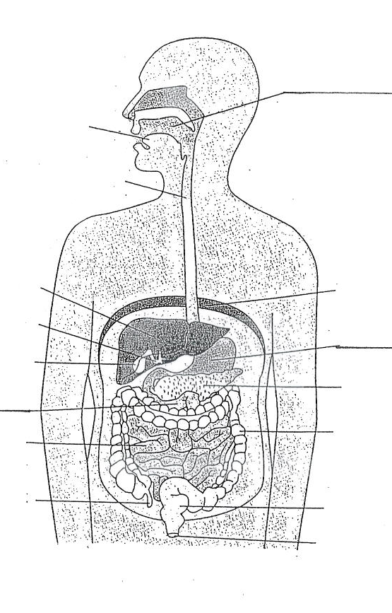

|  |  |  |
| --- | --- | --- |
|  | Function | Structure related to function |
| Stomach |  |  |
| Duodenum (first part of Small Intestines) |  |  |
| Ileum (2nd part of small intestines) |  |  |

**Enzymes and digestion**

|  |  |  |
| --- | --- | --- |
|  | Where in the digestive system they are broken down | Which enzymes are involved (and where are they secreted and what conditions are required) |
| Carbohydrates | Mouth  &… | Salivary amylase: mouth: pH7  &… (list at least 2 more) |
| Proteins |  |  |
| Lipids |  |  |

**DIGESTIVE AND EXCRETORY SYSTEMS: REVISION CHECKLIST**

**The Digestive System**

You will need to be able to label the parts of the respiratory system

Starting with food entering the mouth, name the structures that food passes through in the correct order.

Function of the accessory organs

|  |  |
| --- | --- |
|  | Function |
| Pancreas |  |
| Liver |  |
| Gall bladder |  |

**Role of kidneys in controlling water balance of the body**

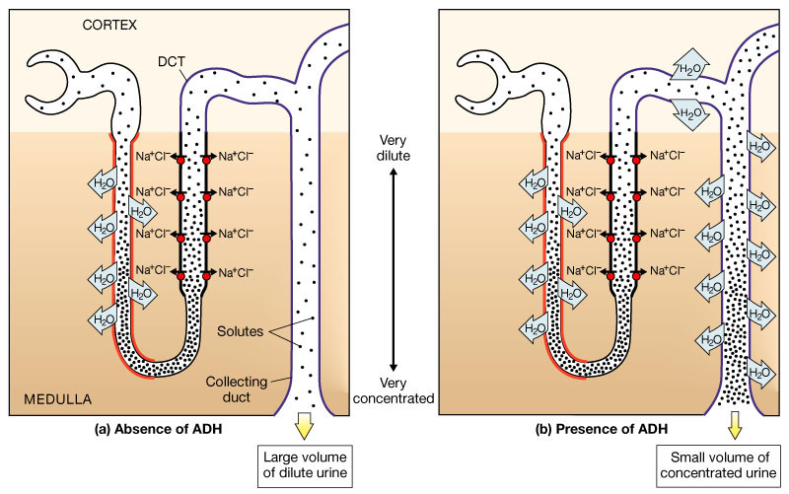

The collecting duct of the kidney nephrons absorbs water.

**If a person is dehydrated:** a …………… volume of water will be re-absorbed back into the body, so ………… water passes out in the urine. This is triggered by the ……………… of ADH from the pituitary gland.

**If a person has drunk a large volume of water:** a ………….. volume of water will be re-absorbed back into the body, so ………. water passes out in the urine. This is triggered by the ……………. Of ADH.

**Function of liver and kidneys**

|  |  |
| --- | --- |
|  | Function |
| Liver |  |
| Kidneys (including nephrons) |  |