|  |  |  |  |  |
| --- | --- | --- | --- | --- |
| **BTEC Unit 2: Responding to a brief Recycle and Represent** | | **Target Level:** | | |
| **NAME:** | | | **TICK** |
| **Activity 1 task list Part A Research** | | | |
| **Task 1:** Understanding the brief, come up with basic concepts and ideas around theme, product, imagery, message | | |  |
| **Task 2:** Primary research: you must be able to take relevant photos, it is a requirement of the assessment | | |  |
| **Task 3:** Secondary research: mood board of images from the internet, books magazines etc | | |  |
| **Task 4:** Research at least 3 or more relevant starting points for your work. This should include:   * A mood board of images * Use the writing framework to discuss one of the images for each artist, making links to the brief and client expectations. * Add a title and present appropriately | | |  |
| **Task 5:** Create studies in the style of the artists exploring visual communication e.g. how have they applied marks? What can you tell me about the formal elements? (Colour, line, tone, pattern, texture, 2D shape and 3D form) What can you tell me about the composition? | | | SCAN |
| **Activity 1 task list Part B Explore a range of media with skill, ideally 5** | | | |
| **Task 6:** Idea generation (Use primary and secondary evidence to support your ideas) | | |  |
| **Task 7:** Create outcomes exploring a range of media, material, technique, and process. Show skill and refinement. You should aim to explore at least 5 media. | | |  |
| **MEDIA/MATERIAL**  Watercolour, Acrylic, Oil Pastel, Chalk, Biro, Fine liner, Dip pen and ink, Tonal pencils, Charcoal, Graphite, Soluble Graphite, Pencil Crayon, Watercolour pencil, Felt tip, Alcohol Markers, Brusho, Marbling inks, Tissue Paper, Cartridge Paper, Sugar paper, Watercolour Paper, Mount board, Cardboard, Canvas, Wooden board, Recycled media, Clay, Modroc, Wire | **TECHNIQUES/Process**  Painting, Drawings, Sculpture, Sgraffito, Collage, Assemblage, Montage, Photomontage, Lino Printing, Etching, Mono print, Collagraphy, Gelli Print, Photography, Photoshop, Ceramics, Weaving, Stencil Art, Batik, Sculpture, T-shirt transfer, Sewing/Stitching, Felt tip wash. | | |
| **Task 8:** Review outcomes, talk about formal elements, make connections to the brief and research | | | SCAN |
| **Activity 1 task list Part C Final outcome** | | | |
| **Task 9:** Create 2 mini outcomes showing refinement and improving the idea. | | |  |
| **Task 10:** Review the outcome critically, how could it be improved? Does it link to your research and the brief? | | |  |
| **Task 11:** Plan for the final outcome. This can be mocked up before the exam. Final ideas, plan your final ideas in your book so you can write the development review. Planning out your ideas before completing the development review as you can visualise what your intentions are. exploring composition, colour schemes, media etc. | | |  |
| **Activity 2 DEVELOPMENT REVIEW MUST BE COMPLETED BEFORE YOU CAN START THE FINAL OUTCOME** | | | |
| **Task 12:** Development review. To be completed in exam conditions | | |  |
| **Activity 3 Final Response** | | | |
| **Task 13:** EXAM – Complete final outcome(s) in a 10h controlled assessment | | | SCAN |
| **Activity 4: Record and communicate skills development (PORTFOLIO) 4 LESSONS TO COMPLETE** | | | |
| **Task 14:** PRESENT an art and design portfolio of no more than 8 slides. Select and present only the best work that showcases your designs, ideas, and process | | |  |

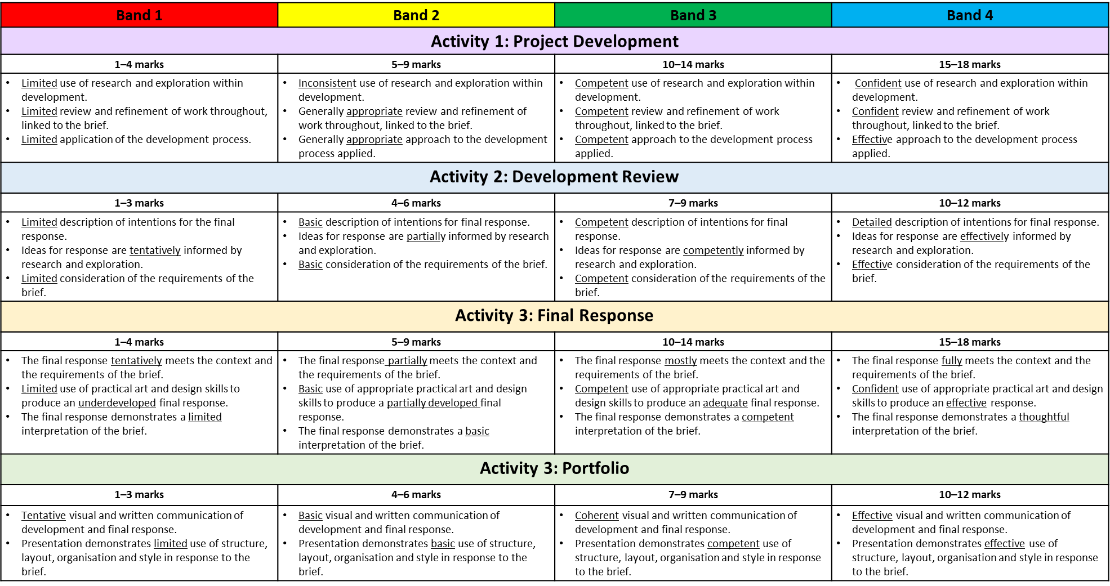

**BRIEF**

A new arts centre, gallery and sculpture park is preparing to open. One of its aims is highlighting the amount of waste produced both locally and internationally, promoting ethical and environmental messages about waste and recycling. All the artworks to be displayed will be created by artists and designers in response to the waste we produce. The arts centre is hoping to appeal to younger generations and is preparing to launch with an exciting exhibition called **Recycle and Represent**.

The arts centre is inviting young creatives to respond to the theme by carefully considering and reimagining how we think about waste. They are targeting 14–18-year-olds as their intended audience.

Creative practitioners are being asked to produce a portfolio of work and a development review.

**The final response must:**

**• use images or language appropriate for the audience**

**• celebrate the importance of the theme Recycle and Represent**

**• present a positive and informed message.**

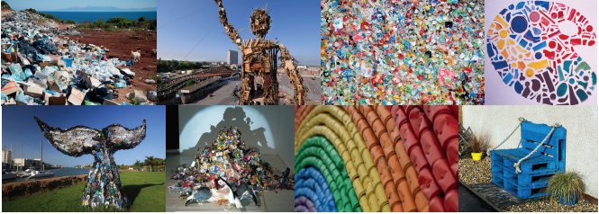

The following images have been provided by the arts centre to help illustrate the theme and suggest possible starting points. You do not need to include them in your response to the brief. You should base your response on your own investigation of the theme Recycle and Represent

**COMPONENT 2: Responding to a brief**

**Weekly Target Plan (11 WEEKS)**

|  |  |  |  |
| --- | --- | --- | --- |
| **Week** | **Classwork** | **Homework** | **Check** |
| WK A  11 |  |  | Activity 1 A RESEARCH  ❑ |
| WK B  10 |  |  | Activity 1 A RESEARCH  ❑ |
| WK A  9 | Scan Check Point |  | Activity 1 A RESEARCH  ❑ |
| WK B  8 |  |  | Activity 1B IDEAS and EXPLORE  ❑ |
| WK A  7 |  |  | Activity 1B IDEAS and EXPLORE  ❑ |
| HALF TERM | | | |
| WK B  6 |  |  | Activity 1B IDEAS and EXPLORE  ❑ |
| WK A  5 | Scan Check Point |  | Activity 1B IDEAS and EXPLORE  ❑ |
| WK B  4 |  |  | Activity 1C Outcome Exploration  ❑ |
| WK A  3 |  |  | Activity 1C Outcome Exploration  ❑ |
| WK B  2 |  |  | Activity 1C Outcome Exploration  ❑ |
| EASTER END OF TERM | | | |
| WK A  1 | DEVELOPMENT REVIEW  Scan Check Point |  | Activity 2: Development Review  ❑ |

|  |  |  |  |
| --- | --- | --- | --- |
| **EXAM Day 1: Plan what work you will complete on the day**  You will be assigned a seating position / exam conditions | |  | EXAM  ❑ |
| P1 |  | | Target met  ❑ |
| P2 |  | | Target met  ❑ |
| P3 | ­ | | Target met  ❑ |
| P4 |  | | Target met  ❑ |
| P5 |  | | Target met  ❑ |
| **EXAM Day 2: Plan what work you will complete on the day**  You will be assigned a seating position / exam conditions | |  | EXAM  ❑ |
| P1 |  | | Target met  ❑ |
| P2 |  | | Target met  ❑ |
| P3 |  | | Target met  ❑ |
| P4 |  | | Target met  ❑ |
| P5 |  | | Target met  ❑ |

|  |  |  |  |
| --- | --- | --- | --- |
| **Week** | **Classwork** | **Homework** |  |
| WK A | Exam week MON & TUE  PORTFOLIO 2 DAYS OF LESSONS |  | Task 4:Portfolio  ❑ |
| WK B | PORTFOLIO: 2 DAYS OF LESSONS |  | Task 4:Portfolio  ❑ |
| UPLOAD DEADLINE 10 MAY **– YOU WILL NOT BE ABLE TO DO ANY MORE WORK PAST THIS DATE** | | | |

|  |  |  |  |  |
| --- | --- | --- | --- | --- |
| **BTEC Unit 2: Responding to a brief Recycle and Represent** | | **Target Level:** | | |
| **Activity 1 task list Part A Research** | | | |
| **Task 1:** Understanding the brief, come up with basic concepts and ideas around theme, product, imagery, message | | |  |
| **Task 2:** Primary research: you must be able to take relevant photos, it is a requirement of the assessment | | |  |
| **Task 3:** Secondary research: mood board of images from the internet, books magazines etc | | |  |
| **Task 4:** Research at least 3 or more relevant starting points for your work. This should include:   * A mood board of images * Use the writing framework to discuss one of the images for each artist, making links to the brief and client expectations. * Add a title and present appropriately | | |  |
| **Task 5:** Create studies in the style of the artists exploring visual communication e.g. how have they applied marks? What can you tell me about the formal elements? (Colour, line, tone, pattern, texture, 2D shape and 3D form) What can you tell me about the composition? | | | SCAN |
| **Activity 1 task list Part B Explore a range of media with skill, ideally 5** | | | |
| **Task 6:** Idea generation (Use primary and secondary evidence to support your ideas) | | |  |
| **Task 7:** Create outcomes exploring a range of media, material, technique, and process. Show skill and refinement. You should aim to explore at least 5 media. | | |  |
| **MEDIA/MATERIAL**  Watercolour, Acrylic, Oil Pastel, Chalk, Biro, Fine liner, Dip pen and ink, Tonal pencils, Charcoal, Graphite, Soluble Graphite, Pencil Crayon, Watercolour pencil, Felt tip, Alcohol Markers, Brusho, Marbling inks, Tissue Paper, Cartridge Paper, Sugar paper, Watercolour Paper, Mount board, Cardboard, Canvas, Wooden board, Recycled media, Clay, Modroc, Wire | **TECHNIQUES/Process**  Painting, Drawings, Sculpture, Sgraffito, Collage, Assemblage, Montage, Photomontage, Lino Printing, Etching, Mono print, Collagraphy, Gelli Print, Photography, Photoshop, Ceramics, Weaving, Stencil Art, Batik, Sculpture, T-shirt transfer, Sewing/Stitching, Felt tip wash. | | |
| **Task 8:** Review outcomes, talk about formal elements, make connections to the brief and research | | | SCAN |

|  |  |  |  |
| --- | --- | --- | --- |
| **Mock Exam day: Plan what work you will complete on the day** You will be assigned a seating position / exam conditions | |  | EXAM  ❑ |
| P1 |  | | Target met  ❑ |
| P2 |  | | Target met  ❑ |
| P3 | ­ | | Target met  ❑ |
| P4 |  | | Target met  ❑ |
| P5 |  | | Target met  ❑ |