BTEC Component 1 MOCK: NARRATIVE |  | Target Level:
NAME: |  |  | TICK
Task 1 Investigation
T1: Understanding the brief, come up with basic concepts and ideas around theme, product, imagery, message

T2: Research at least 3 or more relevant starting points for your work. This should include:
- A mood board of images
- Use the writing framework to discuss one of the images for each artist, making links to the brief and client expectations.
- Add a title and present appropriately
T3: Secondary research: mood board of images from the internet, books magazines etc to use with T4
T4: Create studies in the style of the artists exploring visual communication e.g. how have they applied marks? What can you tell me about the formal elements? (Colour, line, tone, pattern, texture, 2D shape and 3D form) What can you tell me about the composition? Use research from T3 |  |  | SCAN
Task 2 Idea generation
T5: Idea generation: A page of at least 3 initial ideas taking inspiration from artist research (Use primary and secondary evidence to support your ideas)
T6: Primary research: you must be able to take relevant photos, it is a requirement of the assessment
T7: Create outcomes which explore a range of media, material, technique, and process.
Show skill and refinement in exploring each media. You should aim to explore at least 3 media.
MEDIA/MATERIAL  Watercolour, Acrylic, Oil Pastel, Chalk, Biro, Fine liner, Dip pen and ink, Tonal pencils, Charcoal, Graphite, Soluble Graphite, Pencil Crayon, Watercolour pencil, Felt tip, Alcohol Markers, Brusho, Marbling inks, Tissue Paper, Cartridge Paper, Sugar paper, Watercolour Paper, Mount board, Cardboard, Canvas, Wooden board, Recycled media, Clay, Modroc, Wire | TECHNIQUES/Process  Painting, Drawings, Sculpture, Sgraffito, Collage, Assemblage, Montage, Photomontage, Lino Printing, Etching, Mono print, Collagraphy, Gelli Print, Photography, Photoshop, Ceramics, Weaving, Stencil Art, Batik, Sculpture, T-shirt transfer, Sewing/Stitching, Felt tip wash.
T8: Review outcomes using the writing frameworks talk about formal elements, make connections to the brief and research |  |  | SCAN
Task 3 Development and creation
T9: Idea generation: A page of at least 3 final ideas taking inspiration from artist research and experimentation (Use primary and secondary evidence to support your ideas)
T10: Create at least 2 mini outcomes showing exploration of media and refinement and improving the idea.
T11: Review the outcome critically, how could it be improved? Does it link to your research and the brief? Use the writing framework to help. Make note of what will improve on the next outcome. Explore composition, colour scheme, media etc
DEVELOPMENT REVIEW MUST BE COMPLETED BEFORE YOU CAN START THE FINAL OUTCOME
T12: Development review. To be completed in exam conditions
T13: EXAM – You have 5 hours to complete the final outcome. Once complete it is complete review it. Make connections to the brief and research. Successes and failure.
Task 4: Presentation
T14: PRESENT an art and design portfolio of no more than 8 slides. Select and present only the best work that showcases your designs, ideas, and process

COMPONENT 1: Responding to a brief
Weekly Target Plan (8 WEEKS)

Week | Classwork | Homework | Check
WK A  8 | 1 LESSONS ON UNDERSTANDING THE BRIEF (T1)  2 LESSONS ON RESEARCH TO FIND IMAGES AND COMPLETE WRITE UPS (T2) | T2 – PUT PAGES TOGETHER | Task 1 INVESTIGATE
WK B  7 | 3 LESSONS ON MEDIA EXPLORATION INCLUDING SECONDARY RESEARCH (T3, T4) | T2 – PUT PAGES TOGETHER | Task 1 INVESTIGATE
WK A  6 | Scan Check Point  3 LESSONS ON MEDIA EXPLORATION IN THE STYLE FO THE ARTIST (T4) | T2 – PUT PAGES TOGETHER | Task 1 INVESTIGATE
WK B  5 | 2 LESSONS ON IDEA GENERATION AND ANNOTATION (T5)  1 LESSON ON PRIMARY RESEARCH (T6) | Present work in your book | Task 2  IDEA GENERATION
WK A  4 | 3 LESSONS ON MEDIA EXPLORATION AND REVIEW (T7, T8) | Present work in your book | Task 2  IDEA GENERATION
WK B  3 | Scan Check Point  3 LESSONS ON MEDIA EXPLORATION AND REVIEW (T7, T8) | Present work in your book | Task 2  IDEA GENERATION
HALF TERM
WK A  2 | 1 lesson on final idea generation (T9)  2 lessons on mini outcomes and review (T10, T11) | Complete mini outcomes | Task 3 DEVELOPMENT AND CREATION
WK B  1 | 3 lessons on mini outcomes and review (T10, T11) | Complete mini outcomes | Task 3 DEVELOPMENT AND CREATION
WK A  0 | DEVELOPMENT REVIEW (2h) T12  MOCK EXAM WEEK  Scan Check Point |  | Task 3 DEVELOPMENT AND CREATION
WK B | ART EXAM TUESDAY 25TH JUNE (5h)  Portfolio  Create powerpoint for presentation (T14) |  | Task 4 PRESENT
WK A | Portfolio  Create powerpoint for presentation (T14) |  | Task 4 PRESENT
EXAM Day 1: Plan what work you will complete on the day  You will be assigned a seating position / exam conditions |  |  | EXAM
P1 |  |  | Target met
P2 |  |  | Target met
P3 |  |  | Target met
P4 |  |  | Target met
P5 |  |  | Target met

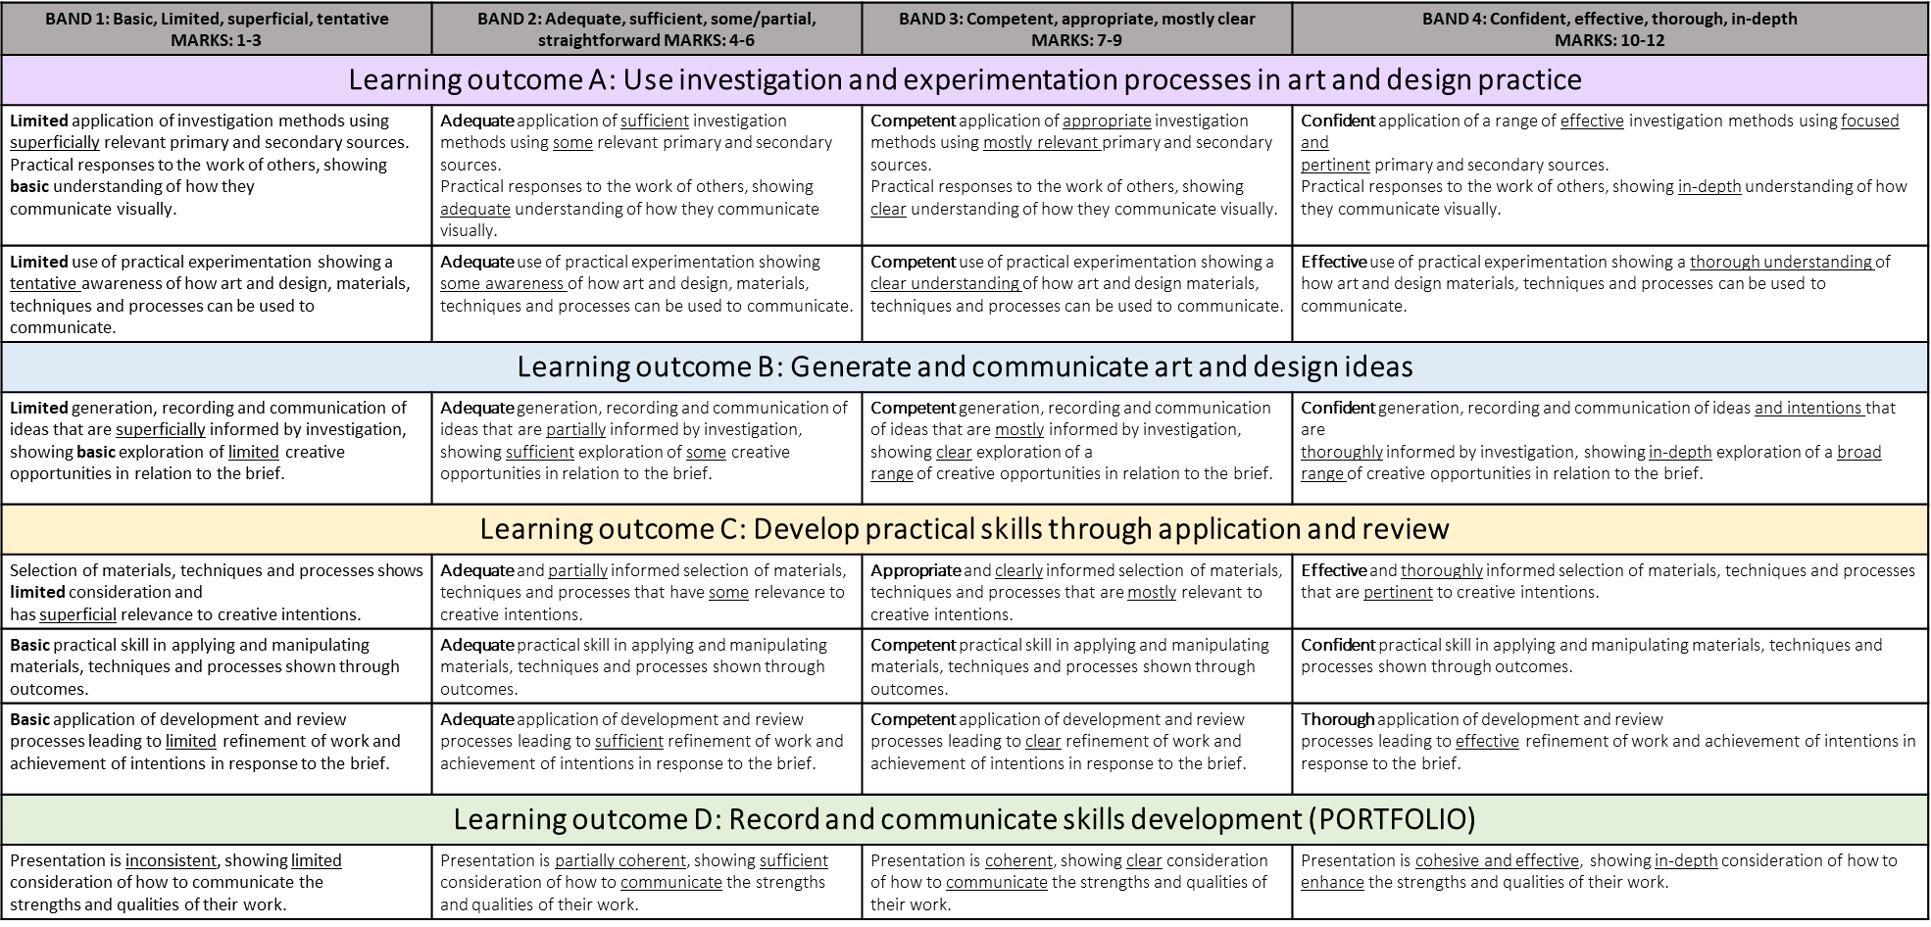

BRIEF
Narrative- Brief: The national library service is promoting the benefits of creative storytelling and is creating a touring exhibition based on the theme Narrative, displaying art and design work that tells a story. Their aim is to promote the idea of visual communication through the exhibition of creative work in response to the theme Narrative. The library service is holding an open competition for submissions of work in any art and design form that relates to the theme.
The theme Narrative is commonly found in art and design work where the power of the visual image is used to ignite imaginations, evoke emotions and capture universal cultural truths and aspirations. Art and design has the ability to narrate a story across diverse cultures, preserving it for future generations. Use this as a starting point to develop and create an outcome or outcomes that reflect the theme.

