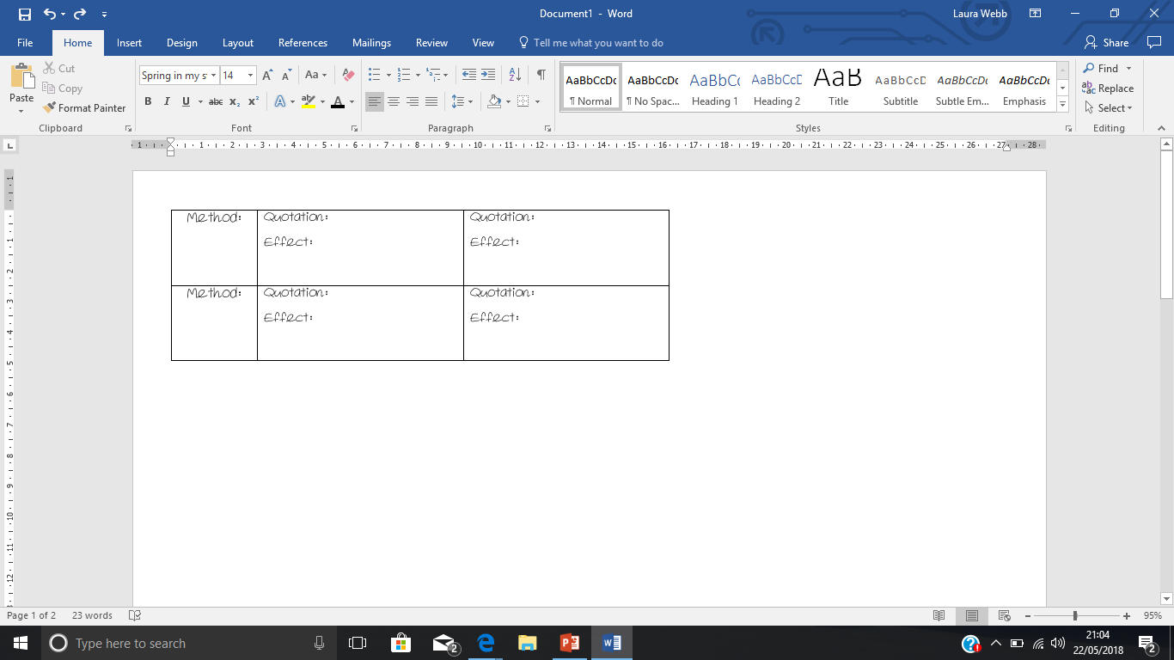Section C: Unseen Poetry

The School in August

The cloakroom pegs are empty now,

And locked the classroom door,

The hollow desks are lined with dust,

And slow across the floor

A sunbeam creeps between the chairs

Till the sun shines no more.

Who did their hair before this glass?

Who scratched 'Elaine loves Jill'

One drowsy summer sewing-class

With scissors on the sill?

Who practised this piano

Whose notes are now so still?

Ah, notices are taken down,

And scorebooks stowed away,

And seniors grow tomorrow

From the juniors today,

And even swimming groups can fade,

Games mistresses turn grey.

-Philip Larkin

First Day at School

A millionbillionwillion miles from home

Waiting for the bell to go. (To go where?)

Why are they all so big, other children?

So noisy? So much at home they

Must have been born in uniform

Lived all their lives in playgrounds

Spent the years inventing games

That don't let me in. Games

That are rough, that swallow you up.

And the railings.

All around, the railings.

Are they to keep out wolves and monsters?

Things that carry off and eat children?

Things you don't take sweets from?

Perhaps they're to stop us getting out

Running away from the lessins. Lessin.

What does a lessin look like?

Sounds small and slimy.

They keep them in the glassrooms.

Whole rooms made out of glass. Imagine.

I wish I could remember my name

Mummy said it would come in useful.

Like wellies. When there's puddles.

Yellowwellies. I wish she was here.

I think my name is sewn on somewhere

Perhaps the teacher will read it for me.

Tea-cher. The one who makes the tea.

-Roger McGough

Point/ Quotation/Analysis

Point/ Quotation/Analysis

Point/ Quotation/Analysis

Overall:

27.1 In ‘First Day at School’ how does the poet present the speaker’s experience of school?

27.2 In both ‘First Day at School’ and ‘The School in August’ the speakers describe their attitudes to school.

What are the similarities and/or differences between the ways the poets present these attitudes?

Section C: Unseen Poetry

27.2 In both ‘First Love’ and ‘Valentine’ the speakers describe the feeling of falling in love.

What are the similarities and/or differences between the ways the poets present these feelings?

Valentine

My heart has made its mind up

And I'm afraid it's you.

Whatever you've got lined up,

My heart has made its mind up

And if you can't be signed up

This year, next year will do.

My heart has made its mind up

And I'm afraid it's you.

-Wendy Cope

First Love

Falling in love was like falling down the stairs

Each stair had her name on it

And he went bouncing down each one like a tongue-tied lunatic

One day of loving her was an ordinary year

He transformed her into what he wanted

And the scent from her

Was the best scent in the world

Fifteen he was fifteen

Each night he dreamed of her

Each day he telephoned her

Each day was unfamiliar

Scary even

And the fear of her going weighed on him like a stone

And when he could not see her for two nights running

It seemed a century had passed

And meeting her and staring at her face

He knew he would feel as he did forever

Hopelessly in love

Sick with it

And not even knowing her second name yet

It was the first time

The best time

A time that would last forever

Because it was new

Because he was ignorant it could ever end

It was endless

-Brian Patten

Point/ Quotation/Analysis

Point/ Quotation/Analysis

Point/ Quotation/Analysis

Overall:

27.1 In ‘First Love’ how does the poet present the speaker’s experience of falling in love?

Section C: Unseen Poetry

Extract from Geography Lesson

Our teacher told us one day he would leave

And sail across a warm blue sea

To places he had only known from maps,

And all his life had longed to be.

The house he lived in was narrow and grey

But in his mind's eye he could see

Sweet-scented jasmine clinging to the walls,

And green leaves burning on an orange tree.

He spoke of the lands he longed to visit,

Where it was never drab or cold.

I couldn't understand why he never left,

And shook off the school's stranglehold.

-Brian Patten

AgeingSchoolmaster

And now another autumn morning finds me

With chalk dust on my sleeve and in my breath,

Preoccupied with vague, habitual speculation

On the huge inevitability of death.

Not wholly wretched, yet knowing absolutely

That I shall never reacquaint myself with joy,

I sniff the smell of ink and chalk and my mortality

And think of when I rolled, a gormless boy,

And rollicked round the playground of my hours,

And wonder when precisely tolled the bell

Which summoned me from summer liberties

And brought me to this chill autumnal cell

From which I gaze upon the april faces

That gleam before me, like apples ranged on shelves,

And yet I feel no pinch or prick of envy

Nor would I have them know their sentenced selves.

With careful effort I can separate the faces,

The dull, the clever, the various shapes and sizes,

But in the autumn shades I find I only

Brood upon death, who carries off all the prizes.

-Vernon Scannell

Point/ Quotation/Analysis

Point/ Quotation/Analysis

Point/ Quotation/Analysis

Overall:

27.1 In ‘Ageing Schoolmaster’ how does the poet present the speaker’s feelings of old age?

27.2 In both ‘Ageing Schoolmaster’ and ‘Geography Lesson’ the speakers describe school teachers.

What are the similarities and/or differences between the ways the poets present these teachers?

Section C: Unseen Poetry

Attack

At dawn the ridge emerges massed and dun

In the wild purple of the glow'ring sun,

Smouldering through spouts of drifting smoke that shroud

The menacing scarred slope; and, one by one,

Tanks creep and topple forward to the wire.

The barrage roars and lifts. Then, clumsily bowed

With bombs and guns and shovels and battle-gear,

Men jostle and climb to meet the bristling fire.

Lines of grey, muttering faces, masked with fear,

They leave their trenches, going over the top,

While time ticks blank and busy on their wrists,

And hope, with furtive eyes and grappling fists,

Flounders in mud. O Jesus, make it stop!

-Siegfried Sassoon

-Wendy Cope

Dulce et Decorum Est

Bent double, like old beggars under sacks,

Knock-kneed, coughing like hags, we cursed through sludge,

Till on the haunting flares we turned our backs,

And towards our distant rest began to trudge.

Men marched asleep. Many had lost their boots,

But limped on, blood-shod. All went lame; all blind;

Drunk with fatigue; deaf even to the hoots

Of gas-shells dropping softly behind.

Gas! GAS! Quick, boys!—An ecstasy of fumbling

Fitting the clumsy helmets just in time,

But someone still was yelling out and stumbling

And flound’ring like a man in fire or lime.—

Dim through the misty panes and thick green light,

As under a green sea, I saw him drowning.

In all my dreams before my helpless sight,

He plunges at me, guttering, choking, drowning.

If in some smothering dreams, you too could pace

Behind the wagon that we flung him in,

And watch the white eyes writhing in his face,

His hanging face, like a devil’s sick of sin;

If you could hear, at every jolt, the blood

Come gargling from the froth-corrupted lungs,

Obscene as cancer, bitter as the cud

Of vile, incurable sores on innocent tongues,—

My friend, you would not tell with such high zest

To children ardent for some desperate glory,

The old Lie: Dulce et decorum est

Pro patria mori.

-Wilfred Owen

Point/ Quotation/Analysis

Point/ Quotation/Analysis

Point/ Quotation/Analysis

Overall:

27.1 In ‘Dulce et Decorum Est’ how does the poet present the speaker’s experience of war?

27.2 In both ‘Dulce et Decorum Est’ and ‘Attack’ the speakers describe their experiences of war.

What are the similarities and/or differences between the ways the poets present these experiences?

Section C: Unseen Poetry

27.2 In both ‘Text’ and ‘It’s Complicated’ the speakers describe their attitudes to texting.

What are the similarities and/or differences between the ways the poets present these attitudes?

It’s Complicated

I am here,

you are there,

it really is perplexing.

We cannot touch,

in real time much,

there’s nothing quite as vexing.

Like sex fulfilled

in bits and bytes,

and endless late night texting.

-Michael Faudet

-Robert Frost

Text

I tend the mobile now

like  an injured bird

We text, text, text

our significant words.

I re-read your first,

your second, your third,

look for your small xx,

feeling absurd.

The codes we send

arrive with a broken chord.

I try to picture your hands,

their image is blurred.

Nothing my thumbs press

will ever be heard.

-Carol Anne Duffy

Point/ Quotation/Analysis

Point/ Quotation/Analysis

Point/ Quotation/Analysis

Overall:

27.1 In ‘Text’ how does the poet present the speaker’s experience of texting and communicating?