Name:

Paper 1 – Question 5

50% of the English GCSE is based on your writing. Therefore, your writing needs to be strong, if you are going to secure a strong grade.

How confident are you with these skills? | Green | Amber | Red
Content / ideas
I can come up with some good ideas in response to the task.
Paragraphing
I can use a range of paragraph lengths in my writing.
Structure
I can structure my writing effectively with creative openings / endings.
Range of techniques
I can use a range of techniques automatically in my writing.
Sentence structure
I can use a range of sentence structures / lengths / styles
Vocabulary
I can use sophisticated and mature vocabulary.
Punctuation
I can use punctuation accurately and to shape the meaning of the text.
Spellings
I spell words correctly including unfamiliar words.

What does the exam question look like?
You will be given a choice.

You can either write a piece based on a picture or write a piece inspired by a title.

The key thing is to be creative and descriptive.

The picture or the title is only the starting point, so you don’t have to endlessly write about the picture or title.

Be imaginative!
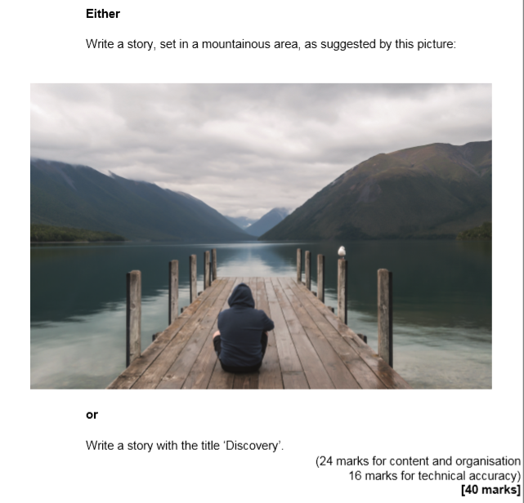

Concrete Example
This example was based on a photograph of a bus at nighttime.

Q5. The bus trundled on through the rainbow stress, ablaze with all the colours of the rainbow and more. The reds, oranges and yellows scalded your helpless corneas. It was late at night, you have worked a twelve hour, non-stop shift and all you wanted to do was sleep, but the epileptic night mare continued as the bus grinded to a halt whenever it was commanded to by the green man.

You glance around, you identify three distinct types of people on this bus. Firstly, there are people like you: possibly sleep-deprived, probably depressed and definitely disappointed about how their life turned out. They just want to get home, some lucky enough to return to families, but not lucky enough to return before they shut their eyes for the rest of the night. Secondly, there are people who are just about to start the night shift. They had only awakened in the previous hour. You could spot them because they were rubbing their eyes, often had toothpaste smearing the mouths and always had the trust Starbucks or Costa in hand. Finally, there was the party people. Day shift and night shift are united in the way that they hate the party people. Put simple, they are the worst. When we are barely keeping our eyes open and the night shift are still half-asleep – the party people arrive and they shout as if a bomb had gone off directly next to their stupid ears. They have their stupid chants that make them sound like a social activist with an IQ only high enough to pronounce one syllable words, with the occasional two syllable words slipping and snaking its way through the stupid filter.

Eventually they get off to go to their clubs, bars, pubs, house parties and other loud escapes from the real world. The night shift also depart, half-ready and half-asleep to start their shift. The only person left is you. Newton’s prism party of colours ends as we pull away from the main city. All that remains is the black of the sky, grey of the buildings and the orangey light from the thirty year street lights. Bus soon even these begin to fade, a black mist cumulates in front of your eyes and your brain stops trying. You fell asleep on the bus again.

Your writing will be assessed on two things content (ideas / techniques / structure / paragraphing) and technical accuracy (spellings / vocabulary / sentence structure / punctuation use).

What can you say about the content (ideas / techniques / structure / paragraphing) of the writing?

What can you say about the technical accuracy (spelling / vocabulary / sentence structure / punctuation) of the writing?

Note: This piece of writing got a high mark and they only wrote three paragraphs in 45 minutes.
One of the big problems we find with students is the wording of the question. They look at the word ‘suggested’ and they think they have to analyse the picture, so we end up getting rubbish writing that sounds like:

He is sat on his own which suggests that he is lonely and doesn’t have any friends. There is no sun, which suggest that it is a cold day in winter. He isn’t facing us, which could suggest that he thinks he is ugly.

As you can see, this is absolute rubbish. Compare that to this example and see what they have done wrong.

He stared out at the water. Its waves lapped at his feet gently, quietly and softly as if it knew of the trouble he had experienced. A tear escaped down his face. No more. He wanted no more.

We have to be creative for this question. Before we start looking at the question, let’s have a go at being creative. Here are some possible pictures. Imagine the examiner has asked you to make a story with them. Annotate each picture with a possible story.

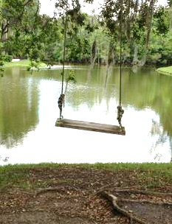

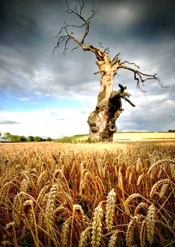



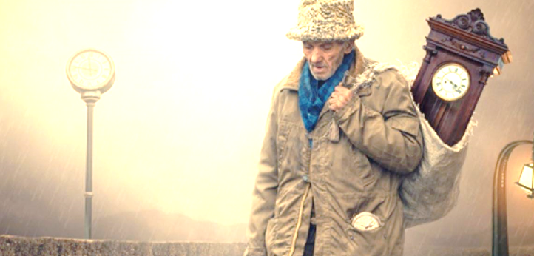

[A] What if the picture was of a setting?

We think that the exam question in the final exam could be one of a few things.

- A picture of a setting
- A picture of a person or an object
- A title

Therefore, we are going to look at planning for each of these in turn, starting with the setting picture.

We are recommending that you use the box method. When you get the picture, draw four boxes over the picture. Draw boxes on this picture.

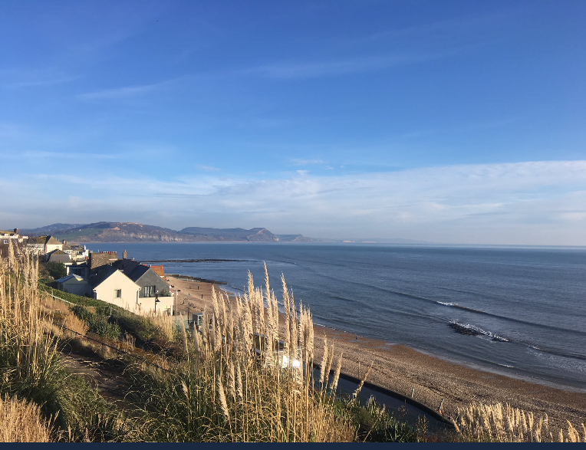

Now, think about how you could extend those boxes and build them into a paragraph. Describing is not listing everything you could see. Describing is helping a reader imagine or see or feel the experience.

Box 1

Box 2

Box 3

Sentences
Sentence development – a key factor in your mark is your use of sentence structure and vocabulary. Therefore, we have included a number of sentence openings to help you develop your use of sentences.

Prepositions (or adverbial phrases) are one way to start your writing effectively: above, across, around, beside, beneath, between, near, by, under, over, up, down, inside, outside.

In the background / In the foreground / In the distance / In in the middle / In the front / In the centre

In the background, lights flickered like errant seagulls.
In the centre, a man slowly dozed.

My examples

Along / Amid / Among / Amongst

Along the sea, waves gently skipped and danced.
Amid the chaos, a tree stood silently.

My examples

Inside / Outside

Inside the building, there was no life.
Outside all life had disappeared.

My examples

Close / Closer / Closest

Close to the sky was a single cloud.
Closer still was an airplane full of passengers heading to a warmer climate.
Closest to me was loud man ranting and raving.

My examples

To the left .. . To the right …

To the left was endless sand and rocks. To the right was cool calm sea.

My examples

_______________________________________________________________________________________________

The content of the ideas is only part of the writing. Your ideas are not enough to make it a great piece of writing, which is the mistake a lot of students. They think their ideas are brilliant enough to not worry about things. The structure of your ideas is really, really important.

Look at these approaches to writing a paragraph describing a setting.

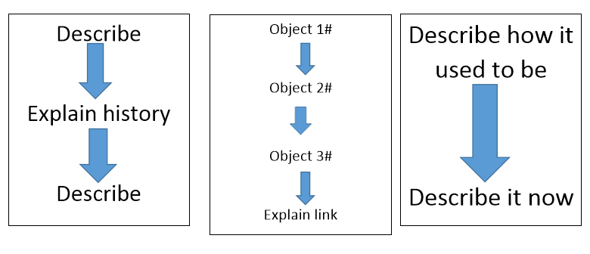

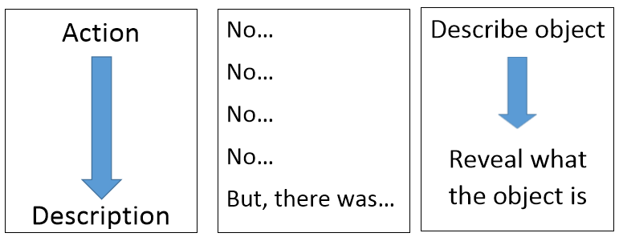

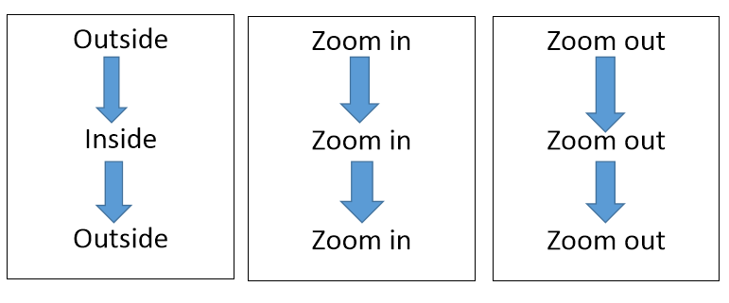

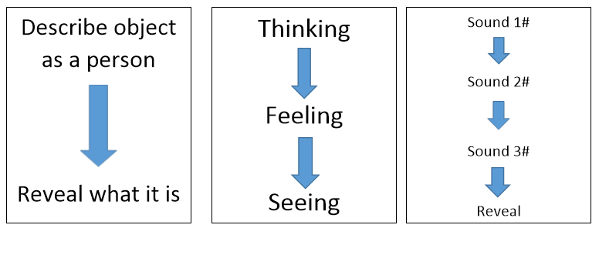

Pick which three would be best for the beach picture.
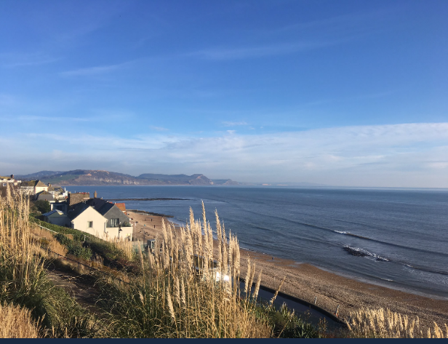

_______________________________________________________________________________________________

Now, we are going to have a practice for a new picture. Plan for how you’d respond to this picture. Remember to draw boxes.
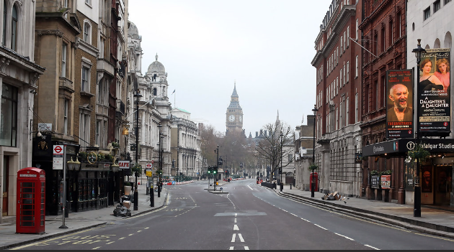

Paragraph | What part of the setting are you going to focus on? | How are you going to structure your paragraphs? Use the example paragraph structures from the previous page. | What mood are going to create in this paragraph? | What words / techniques will you use to create this mood?
1
2
3

Top Tips:
- Aim to have an emotional journey in your writing. Change the mood across the text.
- Aim to have a cyclic structure – make the start and end link together somehow
- Make the reader feel something – really feel something!

We want stylish and interesting writing. These are little ways you can make your writing stylish. You only want one or two to make your writing interesting and stylish.

Describe a sound and then reveal what is causing it.
Describe normality and then spot something that isn’t normal.
Describe something that isn’t really there and is just imagined by the narrator.
Describe the feeling of the place. Don’t describe anything else, just the feeling. It feels like a day … It feels like when a …
Describe an object but make it sound like something else. Then reveal what it really is.
Describe the movement of an object or part of the object. Give a list of verbs describing the action.
Something is blocking your view of the object. Describe what’s blocking your view and describe the tiny glimpse you get of the object you want to see.
Describe how an object’s appearance changes the closer you get to it.
Describe the lack of something. There isn’t a … or a … or a …
Describe the texture of an object before revealing what it is.
Describe a nice object and then an unpleasant object.
Describe a change in the room.
Describe the main source of light and how it touches things in the setting.
Describe a moment of silence.
Describe an object and then comment on how it links to/reflects the owner of the room.
Describe a change in temperature and the narrator’s exploration of the source of the change.
Describe the light and how it falls. Then describe it falling on an object.
Describe an object through colours. Then reveal what it is.
Describe three objects using the same phrase.
Describe an object as if it were a person.
Describe how an object links, or doesn’t link, to another item next to it.
Describe how an object reminds the narrator of something that happened to them.
Describe how an object reminds the narrator of a similar object from their past.
Describe the main source of light and how it touches things in the room.
Describe a moment of silence.
Describe a sound and then reveal what is causing it.
Describe the light and how it falls. Then describe it falling on an object.

Circle which three you could use for the picture of a London street.

Grade 8/9 work on developing an alienation effect through your writing. Make the setting seem unusual or unfamiliar. Often, in writing we are making things familiar to reader when they know what it looks like. This doesn’t make the most effective writing. Try to make the familiar seem unfamiliar or alien.

Developing skills

All these skills are in the following paragraph. See if you can find all the different elements discussed.

Like Zeus on Mount Olympus, the clock kept its watchful eye on the dots far below. Each dot paced, rushed and sped through the crowded streets in the midday sun. Each one shielding his or her eyes from the blazing sun. Its immenseness reflected in glasses, spectacles and sunglasses. The sun was in the opposite direction to the clock. It was a clash of titans as each one wanted to be noticed. The people, like mindless clones, were oblivious to the battle taking place across the street.

Lighting / Sound effects

Light or sound effects are one of the easiest things for students to write about, but often they are left out because they can’t see it in the photograph. The photograph will always be a starting point. The Examiner is not looking for the picture to be described accurately. It is the starting point and you can go off and be creative.

Think about the source of light / sounds

Streetlights …
The sun …
The moon…
The stars …
Shopfronts ….
Light bulbs

Think about the verb to describe it – blazes, kisses, comforts, beams, shines, smothers, covers, drowns
[Note you can easily personify the light]

Think about the object it affects.

The streetlights tease light in strips on the ground so people appear and disappear regularly.
Sunlight kisses and wraps itself around the stones.

Think about other bits to do with light:

Shadows dance / spread ..
Darkness hides…
Brightness uncovers ...
Light fades…
Light brightens…
Reflections mirror …

The trick is to be stylish and interesting. There will be no doubt you will be able to use light in your picture. Just be creative with how you use light or sound.

Don’t : Boom. Bang went the trucks as the moved through the street.
Do: A loud noise blasted and bashed the ears like a determined boxer in the last round of his life.

Verbs for actions

The bus trundled on through the rainbow stress, ablaze with all the colours of the rainbow and more.

Vocabulary is key to making a mood or effect in your writing. Look at the word ‘trundled’ here. It creates a sense of laziness and possibly clumsiness of the bus. The word ‘ablaze’ creates a sense of excitement and energy, which contrasts to the lazy bus.

As you write, think about the choice of verbs and adjectives you use. A quick bit of thinking could transform a sentence without adding much.

Waves crashed against / pummeled / attacked / raged war against the rocks.

Think about how you could change the verbs for better ones here.

The rain fell to the ground.
The sun shone down.
The grass moved in the wind.

Cycle through nouns

A problem most students have is that they stick with the same noun all the way through the writing. Let’s say a student is describing a tree. It is not uncommon for a student to repeat the word tree in every line. The tree … The tree .. Vary the nouns you use to name and describe something. Have a go with these examples:

Car: vehicle, mini, automobile, object, lump of metal, speeding blur, red dot,
Tree:
House:
Man:

Embedded clauses – or comma sandwich
Again, sentences structure is really important. We cannot stress to you how important sentence structure is. Here is a sentence structure we want you to get in your writing.

The church, which stood for years untouched, had been attacked by painters,
A child, who was a picture of innocence, sat silently.
The rain, if it persisted, would wash away the sand.
The road, like a strip of leather, wounded its way down the street.

Greek Myths / Allusions
Okay, it doesn’t have to be just Greek myths. It can also be a religious image from the bible or a reference to a biblical story. Think about what kind of effect you could create with these images. Or what could you compare.

Like Poseidon Like Mary
Like Medusa Like the Angel Gabriel
Like the Minotaur Like Goliath
Like Hercules Like a good Samaritan
Like Cerberus Like Adam and Eve
Like Hades Like the prodigal son

You could even go one further and make references to characters in Shakespeare plays and stories studied in English. What could Miss Havisham be used for? What about Macbeth?
Practice – remember this could be an example you remember for the exam.

Write a description of a setting suggested by this picture.

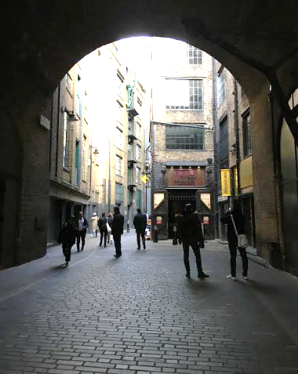

Aim for three paragraphs.

Planning Space:

_______________________________________________________________________________________________

_______________________________________________________________________________________________

_______________________________________________________________________________________________

_______________________________________________________________________________________________

_______________________________________________________________________________________________

_______________________________________________________________________________________________

_______________________________________________________________________________________________

_______________________________________________________________________________________________

_______________________________________________________________________________________________

_______________________________________________________________________________________________

_______________________________________________________________________________________________

_______________________________________________________________________________________________

_______________________________________________________________________________________________

_______________________________________________________________________________________________

_______________________________________________________________________________________________

_______________________________________________________________________________________________

_______________________________________________________________________________________________

_______________________________________________________________________________________________

_______________________________________________________________________________________________

_______________________________________________________________________________________________

_______________________________________________________________________________________________

_______________________________________________________________________________________________

_______________________________________________________________________________________________

_______________________________________________________________________________________________

_______________________________________________________________________________________________

_______________________________________________________________________________________________

_______________________________________________________________________________________________

_______________________________________________________________________________________________

_______________________________________________________________________________________________

_______________________________________________________________________________________________

_______________________________________________________________________________________________

_______________________________________________________________________________________________

_______________________________________________________________________________________________

_______________________________________________________________________________________________

_______________________________________________________________________________________________

_______________________________________________________________________________________________

_______________________________________________________________________________________________

_______________________________________________________________________________________________

_______________________________________________________________________________________________

_______________________________________________________________________________________________

_______________________________________________________________________________________________

_______________________________________________________________________________________________

_______________________________________________________________________________________________

_______________________________________________________________________________________________

_______________________________________________________________________________________________

[B] What if the picture was of a person?

We are recommending that you use the box method. When you get the picture, draw four boxes over the picture. Draw boxes on this picture.
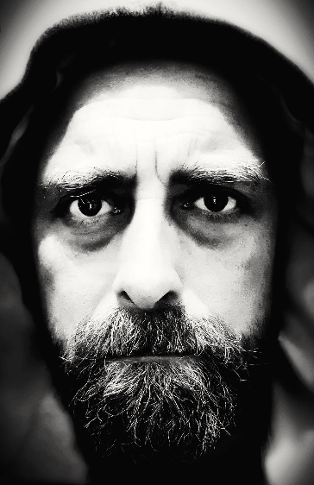

Now, think about how you could extend those boxes and build them into a paragraph. Describing is not listing everything you could see. Describing is helping a reader imagine or see or feel the experience.

Box 1

Box 2

Box 3

Time Sentences
Sentence development – a key factor in your mark is your use of sentence structure and vocabulary. Therefore, we have included a number of sentence openings to help you develop your use of sentences.

Earlier…. During…. Currently… After… Afterwards

Earlier, a leaf fell to the ground, unnoticed and forgotten.

Currently, a man was struggling to put a month’s worth of shopping into his car’s boot.

My examples

Instantly … Initially…. Immediately… Occasionally…

Instantly the mood changed from somber to joy.

Occasionally, a curious duck poked its head over the reeds.

My examples

Until … Since…. Before…. After… Soon …
Until the sun went down, the animals hid and cowered from humans.

Since morning, they have slept.

After the last hour of the day, bedlam starts.

My examples

Sometimes… Somewhere…. Somehow… Someway….

Sometimes a ray of light hit the ground.

Somewhere near a car screeched.

Somehow nobody noticed it.

My examples

_______________________________________________________________________________________________

Right, like last time, we are going to start by being creative. You don’t need to describe everything. Just what is interesting.

Look at these pictures and decide on these two things.

What is this person’s story?
What would be interesting to describe on the picture?


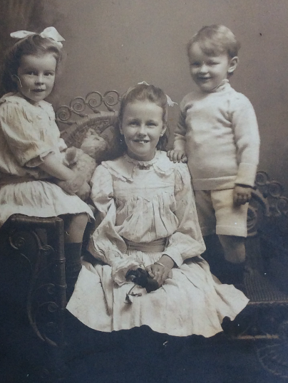
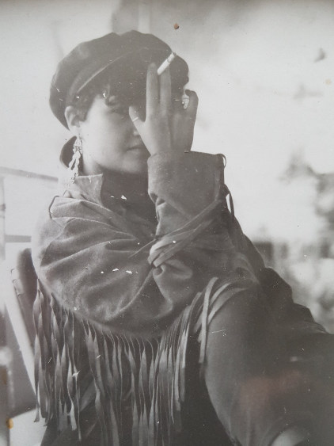

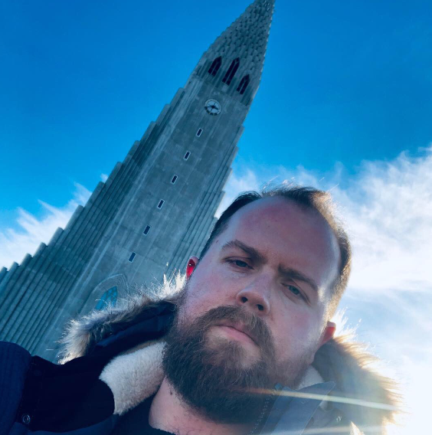
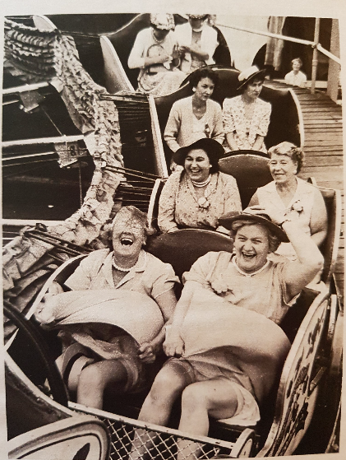

Now, we are going to have a practice for a new picture. Plan for how you’d respond to this picture. Remember to draw boxes.

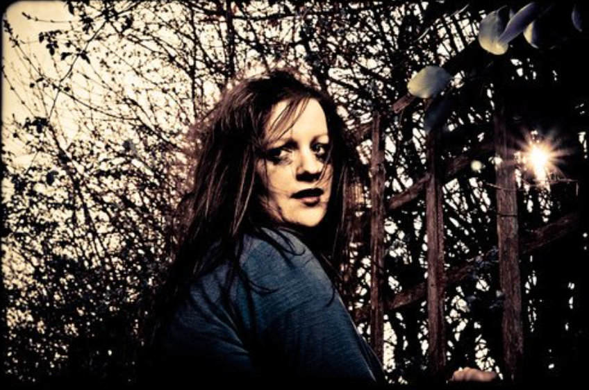

Paragraph | What part of the picture are you going to focus on? | How are you going to structure your paragraphs? | What mood are going to create in this paragraph? | What words / techniques will you use to create this mood?
1
2
3

Top Tips:
- Aim to have an emotional journey in your writing. Change the mood across the text.
- Aim to have a cyclic structure – make the start and end link together somehow
- Make the reader feel something – really feel something!
- Remember to describe and not just explain things!

We want stylish and interesting writing. These are little ways you can make your writing stylish. You only want one or two to make your writing interesting and stylish.

Describe the sound of their footsteps.
Describe their shoes.
Describe the way the character walks / sits / writes opens a door.
Describe the smell of the character.
Describe their voice. Focus on what makes their voice different to others.
Describe their reputation.
Describe an action. It must be something kind, cruel or odd they do.
Describe their perfume, aftershave or deodorant.
Describe their hands as they do something.
Describe the silhouette of the person.
Describe how other characters feel about him /her.
Describe how the character treats people.
Describe the character’s relationship with their family.
Describe the character through their relationship with others in the room.
Describe the temperature of the character and how that links to them as a person.
Describe what makes the character sad or happy. Tom is happiest most when he eats chips, while watching his favourite film.
Describe how other characters treat this person.
Describe their hair. Be specific about colour, texture and the way it has been cut.
Describe the clothes the character is wearing, but focus on the colours or where the items were bought from.
Describe the colour they are wearing and why they wear that particular colour.
Describe the accessories they wear. It could be a watch or an earring.
Describe how the clothes link to their hair in some way.
Describe how the character is an ugly version of someone famous.
Describe their personality.
Describe how the character looks at an object or a person. How do they look at it?
Describe their eyes. Include the colour, size of the pupil and the way they move.
Give the character’s name and they explain how the name is a good match for the character.
Describe what they are not like. He was not tall, not thin and not clever.
Describe what this person used to be like. They used to be fun, keen and friendly.
Describe the character’s reaction to something.
Describe the one thing that makes this character contrast with all the others in the room / place.
Use a line of dialogue to show the character’s personality.
Describe how the character contrasts with the room they are in.
Describe the character’s attempts to hide in the room

Circle which three you could use for the picture of the woman.

Grade 8/9 - work on developing a sense of realism. Work hard to make them seem a real person. Focus on tiny clues about the person.

Developing skills

All these skills are in the following paragraph. See if you can find all the different elements discussed.

Her eyes spoke pain. Two dark windows revealed a lifetime of misery, a lifetime of neglect, a lifetime of crushed hope. The eyes held your gaze, sight and view. Like some Renaissance painting she bewitched you. She was like a modern day Mona Lisa – except, this time it wasn’t an enigmatic look people were puzzling over. Instead, people puzzled over the conundrum of her pain. What was its source?

Vocabulary (adjectives)

All too often, people are lazy with adjectives. They go for the most obvious word to describe. Let’s describe the grass. I know what word which I will use to describe it. Yes, green. The green grass. Wow! That’s so original. We are trained to use these obvious words in our writing. It seems more natural to use ‘green’ rather than ‘yellowing’ to describe grass, but which one is more effective.

Think about what adjectives you could use before these nouns.

face
eyes
smile
hair
teeth

You could experiment and use an adjective that describes a mood. You could have tired eyes, determined eyes, or even dejected eyes. It is all about crafting your ideas and words.

Also be clever with your adjectives and nouns. Your writing will have lots of nouns so experiment with how you use adjectives before the noun.

nose noun n
endless nose adjective noun a n
endless and dominating nose adjective and adjective noun a and a n
short, stubby nose adjective, adjective noun a, a n
sharp, pointed and thin nose adjective, adjective and adjective noun a, a and a n
sharp, pointed, thin nose adjective, adjective, adjective noun a, a, a n

Metaphors and Similes

Metaphors are great to help create the mood or a desire effect. Use of one or two is enough to show the Examiner that you can use them. Remember, if you really want to show off, use an extended metaphor – the same one throughout the text. Or develop a metaphor in great detail and explore it in your paragraph.

Shoulders like Her mouth was a
Hands like His eyes were
Posture like His face was a
Head like Her hair was a

Repetition

Repetition is great way to make something about a character clear to the reader and it also saves you writing loads. As a rule, stick to repetition in threes.

A word.

Her endless hair reflected her endless heartache and endless anger towards the man that caused the pain.

A sentence opening

A woman with a hidden secret. A woman with a heart broken. A woman with nothing to lose.

A phrase

The misery of life couldn’t hide her misery of love and her misery of loneliness.

Texture

It is quite surprising how students will write about endless smells and stuff, but they rarely talk about the texture of things.

The smooth The flaky
The rough The firm
The bumpy The grooved
The dry The jagged
The sharp-edged The stubbly
The swollen The withered
The angular The blistered

Lists

We know that sentence structure is a key thing for improving a grade and lists are a great way to change the way your sentences are structured.

Start with a list

Pride, contentedness and joy were painted on her face.

End with a list

Her skin held a magical quality to it as if it was translucent, transparent and transforming.

Use more than one list

Her bewitching, enchanting and mesmerizing eyes captured, enthralled and hypnotized men.

List verbs

Pain was etched, marked, scraped on her face.

Practice – remember this could be an example you remember for the exam.

Write a description of a person suggested by this picture.

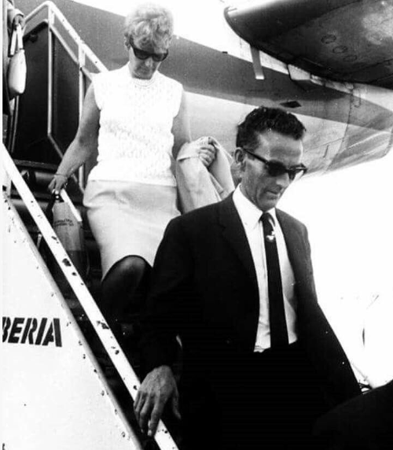

Aim for three paragraphs.

Planning Space:

______________________________________________________________________________________________

_______________________________________________________________________________________________

_______________________________________________________________________________________________

_______________________________________________________________________________________________

_______________________________________________________________________________________________

_______________________________________________________________________________________________

_______________________________________________________________________________________________

_______________________________________________________________________________________________

_______________________________________________________________________________________________

_______________________________________________________________________________________________

_______________________________________________________________________________________________

_______________________________________________________________________________________________

_______________________________________________________________________________________________

_______________________________________________________________________________________________

_______________________________________________________________________________________________

_______________________________________________________________________________________________

_______________________________________________________________________________________________

_______________________________________________________________________________________________

_______________________________________________________________________________________________

_______________________________________________________________________________________________

_______________________________________________________________________________________________

_______________________________________________________________________________________________

_______________________________________________________________________________________________

_______________________________________________________________________________________________

_______________________________________________________________________________________________

_______________________________________________________________________________________________

_______________________________________________________________________________________________

_______________________________________________________________________________________________

_______________________________________________________________________________________________

_______________________________________________________________________________________________

_______________________________________________________________________________________________

_______________________________________________________________________________________________

_______________________________________________________________________________________________

_______________________________________________________________________________________________

_______________________________________________________________________________________________

_______________________________________________________________________________________________

_______________________________________________________________________________________________

_______________________________________________________________________________________________

_______________________________________________________________________________________________

_______________________________________________________________________________________________

_______________________________________________________________________________________________

_______________________________________________________________________________________________

_______________________________________________________________________________________________

_______________________________________________________________________________________________

_______________________________________________________________________________________________

_______________________________________________________________________________________________

Story

[C] What if you just had a title to work with?

The write ‘a story based on a title question’ looks easier than it seems. The titles will be ambiguous so you could write about anything you wanted to.

Look at these possible titles:

The Journey
The Discovery
The Surprise
The Disappointed Moment
A time when you were nervous
A time when you were excited

The title of the story will be totally ambiguous so you could decide on a story now and just change a few things so that

Look at this short summary of a story. Think about how you could adapt it so it fits the title.

A London taxi driver is driving around London.

He picks up a passenger.

The passenger explains who they are and the reason for their destination.

They arrive at their destination.

The passenger leaves.

Often, when students write a story for the exam, they write what is usually a film plot. You have roughly three or four paragraphs, so you haven’t got enough room to fit in a reworking of a Marvel movie or create a zombie apocalypse.

As a rule for story writing, think of your story being a short five minute film or a music video story. Short, sharp and intelligent. Therefore, you need some quick rules.

Rules

- Set the story in one place – and make sure you describe the place in detail
- Only have two or three characters – describe these characters and make them unique and contrast with each other
- Stick to one moment of action – follow this structure – before + action + after
- Stick to one or two time frames
- How you tell the story is more important than the actual story – that means style, mood, atmosphere and description are incredibly important
- Stick to a few lines of dialogue – four maximum – they want a story and not a script

These are some of the past questions. Think about how you could follow the rules.

Write a story with the title ‘Discovery’.

2 characters = 1 setting = 1 moment of action=

Describe life as you imagine it in 200 years’ time

2 characters = 1 setting = 1 moment of action=

Write a story about a time when things turned out unexpectedly.

2 characters = 1 setting = 1 moment of action=

Write a story about two people from very different backgrounds

2 characters = 1 setting = 1 moment of action=

Planning:

Sometimes, the picture will be part of the story element. Plan a story idea using this stimulus.

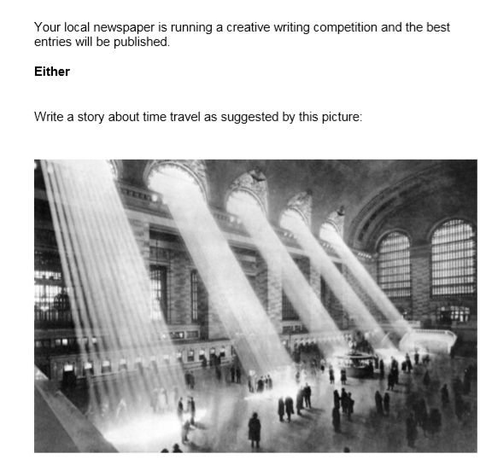

2 characters = 1 setting = 1 moment of action=

Opening:

Middle:

Ending:

Concrete Example

This is an example based on the question:

Write a story about a time when things turned out unexpectedly.

Sprinkles of snowflakes fell down in front of her, covering the weathered stones beneath her feet. Only the moonlight illuminated her surroundings, glimmering between the tangled branches of the naked forest behind her. She shivered. Nearly there, she thought to herself as she clung to the tattered cloak around her shoulders. The path forked ahead, with the right path leading directly through a village.

As she approached she peered into a market; the smell of freshly baked bread still lingered.

The cry of a distant crow pierced through the air as an icy chill rushed to greet her. She traced her fingers along the fresh coat of snow that covered a wooden surface. I’ll be safe her, she thought.

Behind her the suns rays were beginning to arise, breaking through the frosted wind and clinging to everything it could touch. She closed her eyes and let out a deep breath.

Suddenly, a burst of light. A high pitched screech shot through her head and the growl of an angry hound lingered.

She froze, knowing there was no where left to hide.

They had found her.

Examiner’s comment.
Content and Organisation (AO5): Convincing communication, with 'fable-like' tone convincingly matched to purpose and audience.
Technical Accuracy (AO6): Full range of sentence forms for effect, with sentence demarcation consistently secure and consistently accurate.

Content and Organisation (AO5): Lower Level 4: 19 /24 marks
Technical Accuracy (AO6): Level 4: 14/16 marks

You’ll notice that there isn’t much written, but what is written is effective and detailed.

Highlight the following on the story:

- Descriptive writing of the setting
- Description that allows us to understand the character
- Writing to create a mood
- Vocabulary chosen for effect
- A variety in sentence structure.

Circle what you’d like to steal from this example.

Concrete Example

This is an example based on the question:

Write a story about a time when things turned out unexpectedly.

Frail. Weak. Helpless.

The soft shell of what was once a man sits peacefully; sunken into worn cushions shrouded in a thick knitted blanket. His wife made it. Before she died. Plumes of grey – white hair lace the edges of his mouth, and wrinkles – just remains of smiles, laughs and cigarettes. They crawled, like ivy, amongst his face; encapturing it as if to restrain the memories that he clung onto.

It appeared he had not washed in a while, as the white cast of his translucent skin had grown dull. There was something about his eyes, however – streams of blue contrasted with the stark white. Like glass, it was easy to see that this man had not always been so vulnerable.

Tick. Tock.

The rhythm of the clock was often the only thing to be heard within his small bungalow – apart from the permeating cough caused by his habitual smoking. Years of doing so had yellowed his teeth and finger nails, blackened about his eyes. The man sits, stares, sputters. Who knew a few casual cigarettes with friends could do such harm. He sits, lucid transparent tubing running from his arm to the bag which was set up on the shelf.
Cancer.

It had riddled his body, stripping him of his dignity, leaving him frail, weak and helpless.

Examiner’s comment.

Content and Organisation (AO5): Convincing communication, with tone convincingly matched to purpose and audience. Varied and effective structural features, with elements of conscious crafting.
Technical Accuracy (AO6): High level of accuracy in spelling and a full range of sentence forms for effect.

Content and Organisation (AO5): Lower Level 4: 21/24 marks
Technical Accuracy (AO6): Level 4: 14/16 marks

Highlight the following on the story:

- Descriptive writing of the setting
- Description that allows us to understand the character
- Writing to create a mood
- Vocabulary chosen for effect
- A variety in sentence structure.

Circle what you’d like to steal from this example.

Sentence development – a key factor in your mark is your use of sentence structure and vocabulary. Therefore, we have included a number of sentence openings to help you develop your use of sentences.

Like all …. Like a

Like all streets, it was full of cars of every shape and size.

Like a swollen beach ball, the man waddled down the path.

My examples

Too much…. Too little… Too few… Too quiet…

Too much light spilled across the table.

My examples

The more …. ,the more… , the more …. ,

The more the train rocked, the more the view was obscured, the less I could see.

My examples

Slowly and silently, …

Dangerously and carelessly, the driver continued his journey.

My examples

List start

Blue, green and yellow was all the eye could see.

Soft, sharp, gentle pebbles spilled across the shore. .

My examples

Developing skills

All these skills are in the following paragraph. See if you can find all the different elements discussed.

His eyes searched to meet her eyes.
‘Why didn’t you say something?’
‘I thought it was obvious. It would take a blind person not to notice what is standing before them, ’she barked ay him like a drill sergeant.
He felt humiliated. Weak. Powerless. His embarrassment was made worse by the fact that the couple opposite them kept looking away, smirking into their napkins.
He had to do something. Something to change the situation. Change her view of him. Change her.

Dialogue

The basic mistake that students makes is with dialogue. Often they think a good piece of writing is full of dialogue. In fact, it often doesn’t need it. Better to suggest that have loads of dialogue.

If you need to have dialogue, then keep it to a maximum of four lines. Then, describe around the dialogue how the characters behave and act.

Tips for dialogue:
- Don’t make the dialogue polite – endless ‘hello’ and ‘how are you?’ are boring to read
- Make sure the dialogue conflict – one person is angry and the other person is happy – this makes things interesting
- Make sure the dialogue is realistic. Avoid make its sound unrealistic by being too informal or informal – ‘Wot are ya playing at?’ / ‘I am really unhappy with the way you are talking to me. Please desist.’
- We don’t always say what we mean when we talk. Make the characters say one thing and mean something else – ‘ I am really pleased you did that.’ - no they are not.
- Don’t overuse ‘said’. It should be clear who said what without you needed to repeat ‘said’ fifty times.
- Remember – you need punctuation at the end of the dialogue and the end of the sentence. ‘Hello,’ said the man.
- A new line for each time a different person speaks,

Complete the following using the advice given:

‘________________________________________________?’ said .

‘_______________________________________!’ responded .

_____________________________________________________________________________

_____________________________________________________________________________

Character actions and body language – show not tell

Avoid explicitly saying what a character is thinking or feeling, but suggest through their actions.

Don’t: The teacher was angry.

Do: The teacher’s stare was cold and he raised his body to its full height.

Rather than be obvious and showing of what a character is feeling or feeling, use subtle clues to show what your character is thinking.

Have a go at these:

Obvious body language Subtle body language

Watching a clock – bored

Rolling eyes – fed up

Biting nails – nervous

Tapping foot – restless

Now, have a look at the dialogue in the previous section and see what bits of body language you could add to make the character’s feelings and thoughts apparent to the reader.

One word sentences and one sentence paragraphs

You need to understand that it is fine, acceptable and good to use one word sentences and one sentence paragraphs.

Frail. Weak. Helpless.

And don’t forget other bits of punctuation:
Ellipsis (…) to show you have forgotten something
Colon (:) to show when you are introducing something or a list: tah dah!
Brackets ( ) to add more information to a sentence
Semicolon (;) to add two closely linked sentences together
Sarcasm inverted commas – they are ‘really’ effective.

Structural devices

Be clever with how you present and structure your ideas. Examiners want something interesting and told in an interesting way. Some interesting approaches to structuring ideas:

Swap the perspective – tell the same event from two different perspectives

Foreshadow the ending from the start – aim for a cyclic structure

Having a running motif or idea across the story – it could be something as simple as cracks. A crack in a pavement. A crack in glass. A crack in society. A crack in a relationship.

Build up to something at the end – drop clues across the text that lead to the ending

Slow the pace to increase anticipation

Either:
Write a story inspired by this picture.

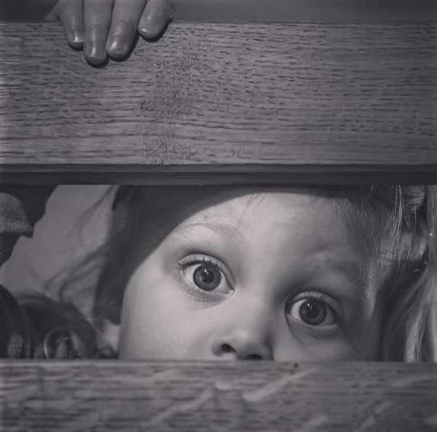

Or:
Write a story about a time when you felt angry.

Plan

_______________________________________________________________________________________________

_______________________________________________________________________________________________

_______________________________________________________________________________________________

_______________________________________________________________________________________________

_______________________________________________________________________________________________

_______________________________________________________________________________________________

_______________________________________________________________________________________________

_______________________________________________________________________________________________

_______________________________________________________________________________________________

_______________________________________________________________________________________________

_______________________________________________________________________________________________

_______________________________________________________________________________________________

_______________________________________________________________________________________________

_______________________________________________________________________________________________

_______________________________________________________________________________________________

_______________________________________________________________________________________________

_______________________________________________________________________________________________

_______________________________________________________________________________________________

_______________________________________________________________________________________________

_______________________________________________________________________________________________

_______________________________________________________________________________________________

_______________________________________________________________________________________________

_______________________________________________________________________________________________

_______________________________________________________________________________________________

_______________________________________________________________________________________________

_______________________________________________________________________________________________

_______________________________________________________________________________________________

_______________________________________________________________________________________________

_______________________________________________________________________________________________

_______________________________________________________________________________________________

_______________________________________________________________________________________________

_______________________________________________________________________________________________

_______________________________________________________________________________________________

_______________________________________________________________________________________________

_______________________________________________________________________________________________

_______________________________________________________________________________________________

_______________________________________________________________________________________________

_______________________________________________________________________________________________

_______________________________________________________________________________________________

_______________________________________________________________________________________________

_______________________________________________________________________________________________

_______________________________________________________________________________________________

_______________________________________________________________________________________________

_______________________________________________________________________________________________

_______________________________________________________________________________________________

_______________________________________________________________________________________________

_______________________________________________________________________________________________

Vocabulary

Light and darkness | Sounds | Texture
Verbs | Positive adjectives | Negative adjectives
Colours

Key tips. Things to remember to do with your writing:
[1] Don’t use ‘crash’, ‘bang’, ‘boing’ or ‘beep’ unless you want your writing to sound like a four year old’s writing.
Instead extend the onomatopoeia with more detail about the sound.
The mutter of …
The moan of …
The rustle of ….
The hiss of ….
[2] Describe the light, reflections or shadows and you can connect things together in a paragraph. It touches everything.
Shadows pass across the various rows of books.
The reflection in the glass shows a couple sat at the table.
Light blinds the trees to the small creatures collecting underneath them.
[3] Repetition is the one technique you probably want to use more than others.
Repetition can be anything – a word / idea / sentence / adjective / phrase. Repetition is sign that you are being playful with your writing.
The cold mist smothered the cold visitors to the park.
Tears fell, tumbled, spilled down her face.
[4] Give the detail that nobody spotted. Spot something minor, insignificant that nobody will think to spot.

The chewing gum under the table.
The smudge of dirt on the carpet.
The oddly shaped stone on the beach.
[5] Build a world and create a backstory to things. And not just people. Everything has a history.
The chewing gum under the table clung with pure determination. An errant student deposited it when the teacher punished his best friend from chewing. With her back to the board, he secreted away. Over time, the chewing gum found several friend. Each one different. There was a range of colours and flavours sat together.
[6] Your paragraphs don’t need to have hundreds of techniques in them, but it is best to do one or two of them really well.
If you want something to be effective, develop and extend it. The sentence with a list, metaphor, simile and personification is throwing everything at the reader, hoping one of them is good. Take one and extend it. Use it to make the reader really feel something. Metaphors, similes and personification do sometimes need explaining and developing.
The trees sighed as the leaves blew in the wind. Its sigh echoed off the other tress. They looked equally glum and gloomy. However, they remained silent. That one, brave tree was the only vocal one in a sea of silence.

[7] Use a one sentence paragraph to shift the focus / tone / mood.
The trees sighed as the leaves blew in the wind. Its sigh echoed off the other tress. They looked equally glum and gloomy. However, they remained silent. That one, brave tree was the only vocal one in a sea of silence.
A secret was hidden.

[8] Avoid starting sentences, if you can help it, with ‘it’, ‘this’, ‘the’ and ‘there’. They are the default way to start a sentence when describing things. They can’t not be used, but be mindful you don’t use them for every sentence.

Cycle through different sets of words at the start of a sentence. Use them to structure a paragraph. [Warning – don’t use it for every paragraph.]

Prepositions: Beneath…. Near …. Under…. By……
Pronouns: You …. He … She … They ….
Adverbs: Quickly…. Steadily… Slowly…. Surprisingly…
Verbs: Running…. Falling…. Sitting….
[9] Remember your quotations from literature. You have some readymade tools for writing. Feed them into the writing and do not just drop them in as a whole quote.

In every face and in every eye, I could see the misery of life. Something held them together like some mind forged manacle.
The chewing gum sat as solitary as an oyster, waiting to be picked up.
Like star-crossed lovers, the raindrops fell.
[10] If you decide to go for the story option, remember that the plot is not as important as the setting and the characters. Describe the setting and characters.

In fact, your story should be a description with a story within it. 20% story. 80% setting.

[11] Build into your writing contrasts, conflicts and changes.
Rather than describe everything, focus on things that will cause contrast, change or conflict to a setting.
The noisy children will contrast with the lazy, sleeping sunbathers on a beach.
A soaking wet dog will cause conflict when it runs about the beach.
Rain will change the mood on the beach.
Focus on conflicting aspects in the setting and think about them clashing.

[12] Stop before you select a verb. There is always a better verb and make sure you give each verb appropriate thought and time.

The waves smashed the shore.
The waves pummelled the shore.
The waves battered the shore.
[13] Pairs are underused in writing. Use pairs of adjectives to help you describe things in detail.

The cold and lonely figure stood motionless in the barren and wet field.

Cars spun and twisted in the road as they moved and swerved to avoid the pigeon.

[14] Give the objects and things in the description an interesting personality. Instead of just personifying things, give them a real and identifiable personality trait.

The waves played their favourite game and chased the sand away from the rocks.

The wind, fed up of being ignored, pushed and shoved at everything and anything it could find.

The gulls rarely lifted their heads. Instead their glum eyes and dour beaks rested on the ground.

[15] Aim for an overall mood to the piece. Be creative with the mood. Avoid obvious ones like happy, relaxing, boredom, fear.
Try things like apathy, confusion, panic, monotony, supportive, jealousy.

[16] Aim to have a motif across the piece to build connections across the text.
Take the idea of falling. I could repeat that in several things in a description of a supermarket. The skill is to think how I can weave these ideas together.
Falling prices. An object falling off a shelf. A poster that has fallen over. Coin falling into a hand.
A person falling over with their shopping. Items falling out of a bag.

