|  |
| --- |
| **CONTENT, FORM, PROCESS, MOOD:** will provide a structured framework to help you look at and discuss works of art. The sample questions aren’t prescriptive or exhaustive. Please answer what you can and ask for help for those that you do not understand. |

|  |  |
| --- | --- |
| **What is the subject matter of the work? What is it about, does it tell a story?** | **Is there any obvious symbolism or hidden meaning?** |
| **Was the subject matter observed first hand, from memory, or imagination / fantasy?** | **Is it representational, realistic, or is there some distortion or abstraction?** |

|  |  |
| --- | --- |
| **How has the work been arranged? Describe it.** | **Does any colour dominate the picture, or do a few balance each other?** |
| **What colours have been used?** | **Is there one main shape, or are there many linking together to make the composition?** |
| **Do the colours harmonise or contrast?** | **Are there recurring shapes, lines, rhythms, forms which create the design of the work?** |
| **What textures can be seen in the work?** | **Is the design of the work pleasing overall, or only in parts?** |

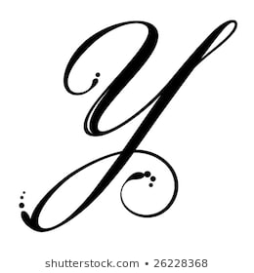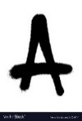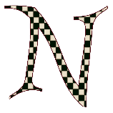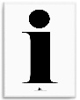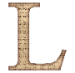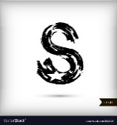

‘How to Analyse / Discuss Work’

|  |  |
| --- | --- |
| **How has the work been arranged? Describe it.** | **Does any colour dominate the picture, or do a few balance each other?** |
| **What colours have been used?** | **Is there one main shape, or are there many linking together to make the composition?** |
| **Do the colours harmonise or contrast?** | **Are there recurring shapes, lines, rhythms, forms which create the design of the work?** |
| **What textures can be seen in the work?** |  |
| **Is the design of the work pleasing overall, or only in parts?** |  |

‘How to Analyse / Discuss Work’

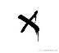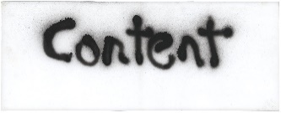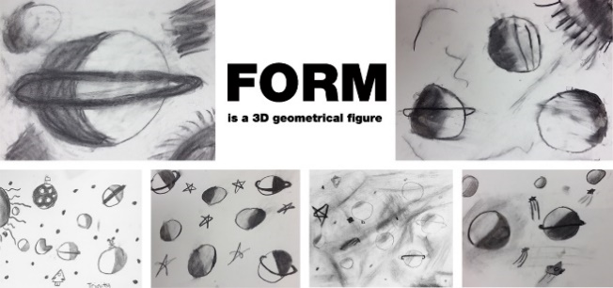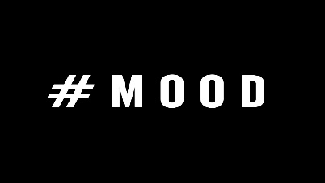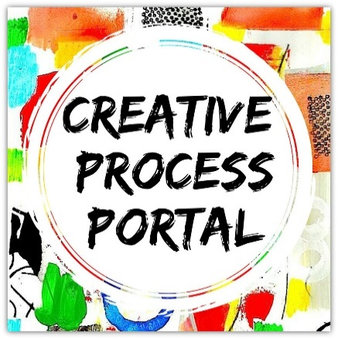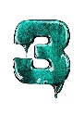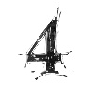

|  |  |
| --- | --- |
| **Does the work affect you?**  **Give reasons?** | **How do you think the artist felt whilst making the work?** |
| **Does it capture a mood or emotion that you have experienced?** | **How does the work make you feel? What is it in the work that affects you?** |
| **Does the work feel quiet/noisy, calm, busy, soothing, disturbing, happy / sad, relaxed/angry in its mood?** | |

|  |  |
| --- | --- |
| **How was the work made and what with?** | **Was the work done quickly or over a long period of time?** |
| **What materials, tools, and processes did the artist use?** | **Was it done outside or in the studio?** |
| **How and where might the artist have carried out supporting studies – sketches, photographs, collages, stencils and maquettes / models?** | **What skills did the artist have to produce the work?** |

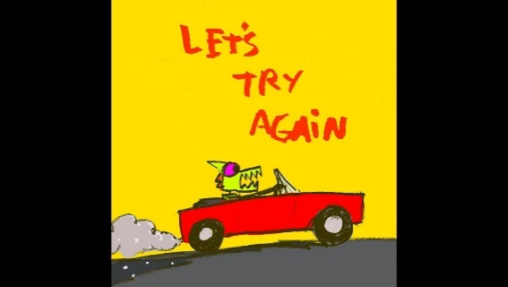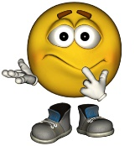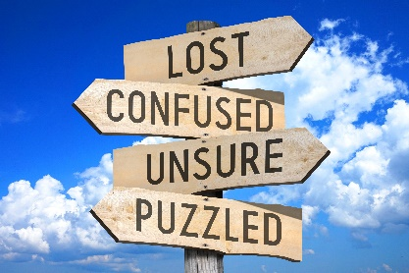****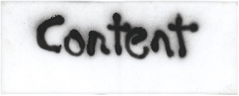

1. Give some general background information about the artist/designer
2. What do you see, what is the style, what is the image? Describe it literally.
3. What does it make you think of, feel, or realise?
4. What do you think the artist / designer is trying to communicate?
5. How does the image communicate this message?
6. What emotions are represented?
7. What would you like to know about it?
8. What do you like and dislike about it? Why?
9. How do you think it may have been achieved?
10. **What ideas can you take from it, what aspects would you like to use in your own work?**

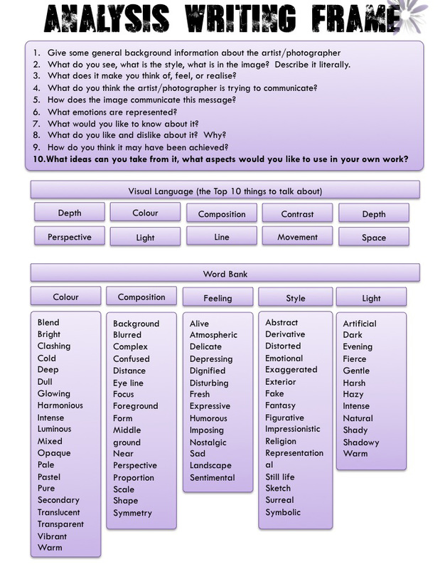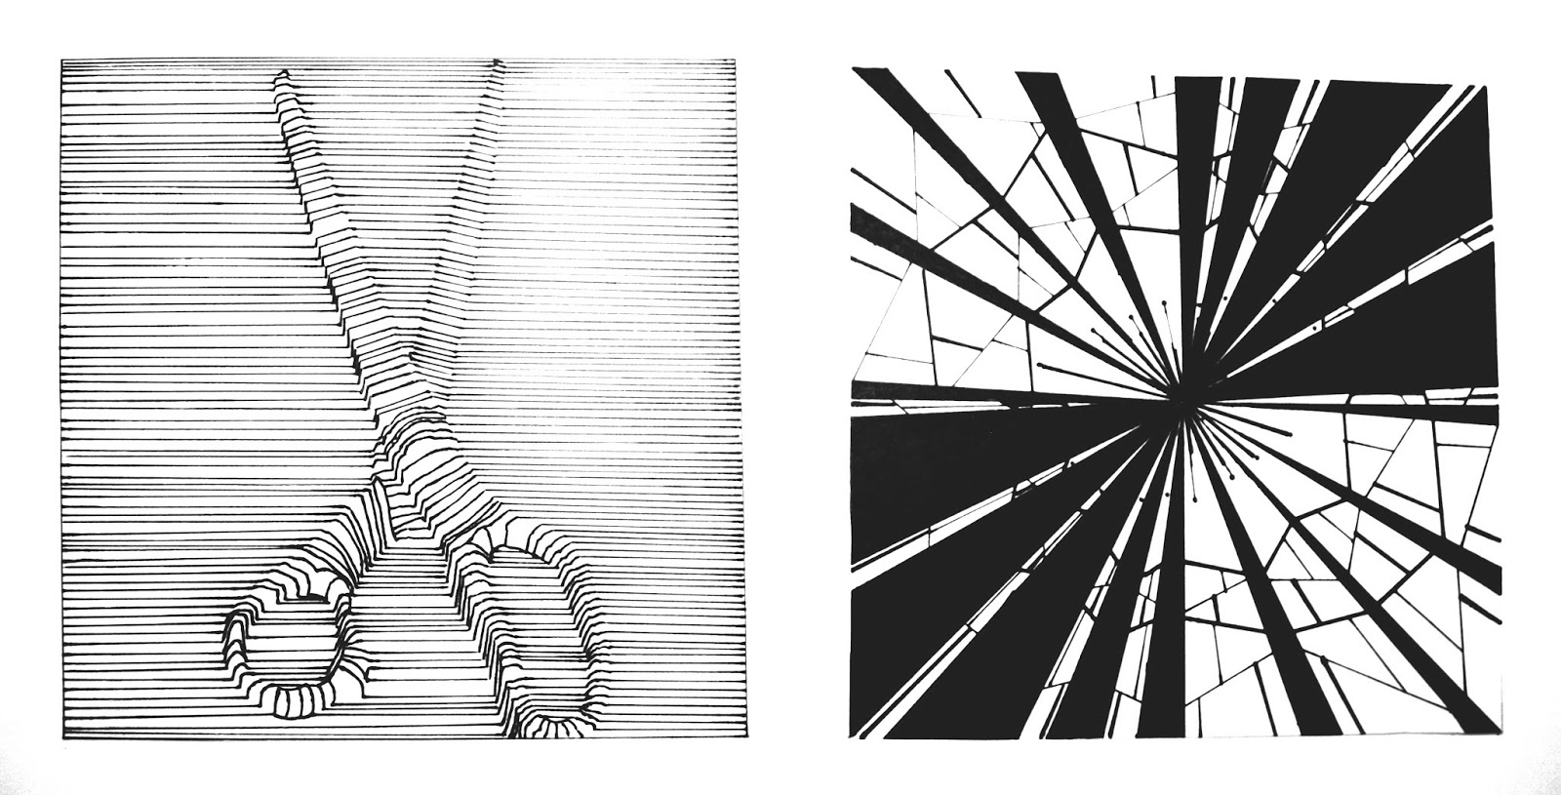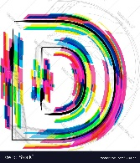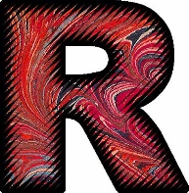

Unsure of what some of these words mean?

1. Look them up in a dictionary
2. Ask a friend if they know what they mean
3. Check them out on google
4. Ask your teacher / family member



|  |  |  |  |
| --- | --- | --- | --- |
| **Do you want to improve upon your analysis?**  Add more detail & focus on answering some of the questions below: Don’t forget those keywords!! | | | |
| **Analysing Observational Drawings** | **Analysing Artists’ Work** | **Analysing Topic Developments (Development squares (Croquis) / designs / patterns)** | **Analysing Samples / Experiments and Technique Applications** |
| **Start with**: title, date, subject matter | **Start with:** title, date, subject matter, and when the work was produced. | Where have your development squares come from and how / why have they been developed? | Why have you chosen to develop this design? |
| **Continue with:**  Comment on your use of line / tone / shape / texture / form – how have they assisted your drawing/s? | **How was the work produced?** What techniques have been used? E.g. Drawing, Printing, Appliqué, Batik, Stitching etc. Have they been successful? How has the artist used these techniques to enhance their work? | Have your observational drawings / artists’ research etc influenced your developments?  Please explain how. | Have you chosen the most suitable technique application? Give reasons.  Does your technique application compliment your design choice? Why / how? |
| **What could you improve on your observational drawings?** Give reasons for your choices: colour – blend your colours more, shape – make it more realistic, tone – to create more depth and provide more shape? | **What does it look like?** – Layout / Composition, Style of lines, Types of colours, Shapes, Themes, etc. | Would they be suitable for a range of products?  Give reasons.  Have they been designed to fit into a range of designs along the same theme? Think about an interior design setting? Or a fashion range? | Have you applied your technique to an impressive standard? What improvements could be made?  Did anything go wrong? |
| Has the piece of work been influenced by anything? |
| **Does your observational drawing provide any pattern that could be developed into a design?** | Does the piece of work look like anybody else’s work? Make links of reference to this work if it does. | Why have you chosen a colour scheme? If you haven’t chosen a colour scheme – why not? | Would you further develop this technique to fit into your design work? |
| **How effective would this pattern be if it was to be put into repeat?** Give reasons. | What mood does the piece convey?  Happy/sad etc.? | Are your designs too similar to one another? Give examples.  How could they be further developed so they do not look repetitive? | Would additional technique applications improve your piece / raise your standards? |
| **Would the whole observation drawing look effective in repeat?** Give reasons. | Are there any social, religious or political or economic issues related to this piece?  Has the piece any meanings? Explain these. | Would you by them as a range for an interior setting? Give reasons. Explain why or why not. | Will you take forward your sample to use in your final piece? Give reasons. |
| Would your observational drawing be suitable to develop into any textile techniques? Which techniques? Why these techniques? | What textures are there on the piece?  How have they been created?  Are they appropriate to the subject matter? | Would they be suitable for fashion designs? Give reasons. | Have you used Photoshop in your work?  Have the developments from this helped with your sampling? Give reasons. |
| Is your technique application (use of line, tone, colour etc) neat / smooth or is it requiring improvements? Answer in detail. | How do you think the artist was feeling when they were producing this piece?  How does this piece make you feel?  What do you like / dislike about the piece? Give reasons. | **What techniques could you use to develop these designs?** Would you choose a range of techniques that cover print and stitch or would one discipline be more suitable? Give reasons. | What research have you done to inspire your thought process for sampling and final ideas? |
| Would a combination of materials / inks / charcoals etc provide a more interesting and effective piece? Give reasons. | How could you transfer the artists’ style of working in to your own work?  What would you have to think about? Why? | Have you selected certain colours to link in to your theme or have you been inspired by additional factors that have informed your design choices?  Would your design work better to a limited colour scheme?  Give reasons | Have you looked at appropriate materials for your outcome, and your subject matter? Please explain. |
| Does your drawing look realistic? Has it turned out how you expected it to? Give reasons. | Why did you choose to study this artist? Are they studying the subject matter you have selected?  Do you like the techniques that they have used / or the outcome? Have the colours influenced your artist selection? | Does your design layout compliment your choice of theme?  Is your layout to crowded?  Is it too plain / empty / blank? Give reasons. | Is your composition / layout of your design appropriate for your end outcome?  Has the placement of imagery been successful on your piece (especially fashion items)  Please give reasons for your answers. |
| Would your observational drawing be suitable to develop into any textile techniques? Which techniques? Why these techniques? | How are you going to produce your own work in your artists’ style?  What images of your own will you use and why? How will you make this piece your ‘own’? | Give your personal views of your work. Include your likes and dislikes. | How could you further embed your development work into your sampling and final piece? Have you answered all assessment objectives? |
| **Final Piece Evaluation** | | | |
| What were you trying to achieve with this piece? | How did you make the piece? What methods and techniques did you use? | Does it look like the piece you designed? If not, why was it not successful? | Give reasons for your design layout and choice of colours. |
| Have you selected the correct technique applications for your final piece? Give reasons. | Did it turn out like you imagined? | Who inspired you to design this piece? | Do you think alternative colour ways would have improved your final piece/s? |
| How might you continue your study after producing this piece? | What have you learnt from producing this piece? | Please include a bibliography of the sources you have used for your work. | |





Congratulations!! You have completed your analysis!